*Florida International University*

*School of Computing and Information Sciences*

Software Engineering Focus

Final Deliverable

CodeVR 1.0

A Virtual Reality Application for Interactive Programming

**Team Members:**  Andres J. Chalela, Miguel A. Jardines Jr, Rolf Kinder Gilet

**Product Owner(s)**: Dr. Francisco Ortega

**Mentor(s)**: Dr. Francisco Ortega, Dr. Juan Caraballo

**Instructor**: Dr. Masoud Sadjadi

The MIT License (MIT)

Copyright (c) *2018 Florida International University*

Permission is hereby granted, free of charge, to any person obtaining a copy of this software and associated documentation files (the "Software"), to deal in the Software without restriction, including without limitation the rights to use, copy, modify, merge, publish, distribute, sublicense, and/or sell copies of the Software, and to permit persons to whom the Software is furnished to do so, subject to the following conditions:

The above copyright notice and this permission notice shall be included in all copies or substantial portions of the Software.

THE SOFTWARE IS PROVIDED "AS IS", WITHOUT WARRANTY OF ANY KIND, EXPRESS OR IMPLIED, INCLUDING BUT NOT LIMITED TO THE WARRANTIES OF MERCHANTABILITY, FITNESS FOR A PARTICULAR PURPOSE AND NONINFRINGEMENT. IN NO EVENT SHALL THE AUTHORS OR COPYRIGHT HOLDERS BE LIABLE FOR ANY CLAIM, DAMAGES OR OTHER LIABILITY, WHETHER IN AN ACTION OF CONTRACT, TORT OR OTHERWISE, ARISING FROM, OUT OF OR IN CONNECTION WITH THE SOFTWARE OR THE USE OR OTHER DEALINGS IN THE SOFTWARE.

***Abstract***

*This document presents the information necessary to gain a good understanding of the FIU OpenHID CodeVR 1.0 Virtual Reality (VR) Application. As technology develops over time, the need for more people in Computer Science grows rapidly. The goal of the CodeVR project is to address the issue of the lack of software developers joining the field, and ultimately help more students feel confident in pursuing a career in Computer Science. Users in the CodeVR environment will be able to interact with pre-designed animations that will showcase the flow of execution of common sorting algorithms as visual representations. The application provides a hand tool for an interactive user experience and more flexible interactions with objects in the virtual environment. The 3D virtual objects that a user can interact with are based off a custom CodeVR language which was implemented specifically for this project. Additionally, this release of CodeVR 1.0 features a source to source compiler that allows generated CodeVR source code to be translated into Python.*

**Table of Contents**

# 

**Introduction** **6**

Current System 7

Purpose of New System 7

**User Stories** **8**

Implemented User Stories 8

Sprint 2 9

Sprint 3 27

Sprint 4 48

Sprint 5 64

Sprint 6 79

Pending User Stories 98

**Project Plan** **101**

Hardware and Software Resources 101

Sprint Planning 103

Sprint 2 103

Sprint 3 104

Sprint 4 105

Sprint 5 106

Sprint 6 107

Sprint 7 108

**System Design** **109**

Architectural Patterns 109

System and Subsystem Decomposition 110

Deployment Diagram 111

Design Patterns 113

**System Validation** **114**

**Glossary** **135**

**Appendix** **136**

Appendix A - UML Diagrams 136

Appendix B - User Interface Design 170

Appendix C - Sprint Review Reports 174

Sprint 1 Retrospective Meeting Minutes 174

Sprint 2 Review Meeting Minutes 175

Sprint 2 Retrospective Meeting Minutes 175

Sprint 3 Review Meeting Minutes 177

Sprint 4 Review Meeting Minutes 179

Sprint 4 Retrospective Meeting Minutes 179

Sprint 5 Review Meeting Minutes 181

Sprint 5 Retrospective Meeting Minutes 181

Sprint 6 Review Meeting Minutes 183

Sprint 6 Retrospective Meeting Minutes 183

Appendix D - User Manuals, Installation/Maintenance Document, Shortcomings/Wishlist Document and other documents 185

**References** **186**

# 

# Introduction

By 2024, US employers will be unable to fulfill approximately 1 million computing positions. As technology advances and evolves at a progressive pace, the capability to meet customer demands in the software industry ultimately depends on the number of inspired individuals who decide to join and work in the Computer Science (CS) field. Although the Software Developer/Engineer position is ranked as one of the top positions on various lists of top jobs in the United States, it is not a common career path chosen amongst collegiate students. Due to common misconceptions, young CS students are afraid of “the challenges” involved in mastering the field. These challenges that are often faced by students include learning the fundamental concepts of programming.

Learning the fundamentals can indeed be very abstract, complex, and can ultimately take a while to visualize and put into practice. Therefore, the FIU OpenHID CodeVR 1.0 project tackles the issue that students face with understanding and visualizing programming concepts by allowing them to interact with such programming concepts and constructs in an interactive 3D environment. For example, the concept of Inheritance becomes easier to understand if we represent the parent and child object instances as a pair of visual objects in the VR environment. By then highlighting the parent’s and child’s shared properties to provide instant perception of the state and behavior of the objects, a user can quickly make the association regarding how the super-class and sub-class are related.

Additionally, CodeVR 1.0 also features a custom implemented domain specific language and source to source compiler. The CodeVR language gives textual representation to the 3D programming objects that are manipulated in the virtual environment, and allows the application to give the user the capability to view the source code that would be generated via the objects they interact with. The source to source compiler features the capability of allowing users to export their generated CodeVR source code and convert it directly into the source code of another supported language of their choosing. This release of CodeVR 1.0 only supports conversion into a limited subset of Python source code as a proof of concept. In future iterations, the compiler would also allow a user to import their generated source code into the application and interact directly with the generated 3D objects in a virtual environment.

The overall purpose of the CodeVR project is to provide a proof of concept platform where young students feel confident to learn how to code by interacting, visualizing, and customizing the state and behavior of a program through the properties of the 3D objects available in the environment. By increasing a student’s confidence via interactive virtual programming, their knowledge of the core CS and programming basic principles are reinforced over time, leading to a lower student attrition rate in the CS field.

## Current System

In prior semesters, the CodeVR team first solved the problem of generating and displaying a set of 3D shapes which represent the main programming components from the importation of a simple Python source code which is accessible to the user when requested from a standalone TCP Server written in Python. Although the shapes displayed to the user were specific to the Python Source Code, the system only showed 3D objects with no associations between them. The major challenge which had not been addressed, was to provide a specific shape to each major component in a class and show the visual representations of the multiple connections to other components. The mapping from each class component to a unique 3D shape increases the complexity of the application.

## Purpose of New System

The purpose of this CodeVR release is to allow users to experience and visualise the behavior of data structures (e.g., array of integers being sorted) as they are modified during the execution of Sorting Algorithms. Using the implemented CodeVR tools, such as the hand tool, the 3D shape generator tool, the object relation tool, and the execution tool, users will be able to generate and manipulate 3D virtual shape objects which represent coding elements. A user will have the ability to generate relationships between 3D elements, be able to pick up, move, and drop elements, and lastly execute functions or program to visualise the behavior and have a better understanding of how each element interact with each other to form a whole. CodeVR 1.0 also includes the implementation of its own domain specific language and source to source compiler. The CodeVR language is implemented to represent the different 3D shapes that are supported within the CodeVR virtual environment. The implemented language allows users to generate textual CodeVR source code via the generated 3D objects and to export it to the source to source compiler. The compiler processes the CodeVR source code and translates it into another high level language, although this iteration only supports Python. Having such a language and compiler implemented would ideally allow future iterations of the project to have users import source code from a supported language to generate and visualize objects in the 3D environment.

# 

# User Stories

The following section provides the detailed user stories that were implemented in this iteration of the CodeVR project. These user stories served as the basis for the implementation of the project’s features. This section also shows the user stories that are to be considered for future development.

## Implemented User Stories

The following table contains the user stories implemented throughout the course of the CodeVR 1.0 project.

|  |  |
| --- | --- |
| Sprint | Completed User Stories |
| 2 | #670 - Complete Parser Implementation (Phase 1)  #667 - VR Controller Menu (Research & Implementation)  #666 - Embedded Python Server Execution  #668 - Implementation of Different Shapes |
| 3 | #690 - 3D Shape Animation (Structure Architecture)  #704 - CodeVR Compiler Implementation (Lexer Phase) #694 - Update CodeVR Menu  #691 - Predefined 3D shape generator tool |
| 4 | #688 - Grab and Drop Functionality  #710 - CodeVR Compiler Implementation (Parser Phase)  #711 - 3D Algorithm Animation (Physics) |
| 5 | #692 - Relationship Functionality  #724 - CodeVR Language Application (Phase 1)  #719 - 3D Cube Actors Flow Synchronization (Phase 1) |
| 6 | #739 - Relationship Functionality (Phase 2)  #743 - 3D Cube Actors Flow Synchronization (Phase 2)  #744 - CodeVR Language Application (Phase 2) |

### SPRINT 2

**User Story ID:** #670 Complete Parser Implementation (Phase 1)

**Description:** As a developer, I need to complete the implementation of the JSON parser, so that we’re able to completely display the different types of programming elements/objects in VR.

**Acceptance Criteria:**

* The JSON parser must be able to parse the different types of provided elements as input.

**Use Case:**

* Name: Parsing of Python Abstract Syntax Tree JSON
* Actor: CodeVR User
* Preconditions: Able to launch CodeVR Project and a python file has been selected
* Description:

1. Launch CodeVR Project & land on Main Menu
2. Select & Load Python File
3. Python code Abstract Syntax Tree (AST) is generated
4. Start CodeVR Session
5. Parser takes the AST as input and generates 3D objects

**Use Case Diagram:**

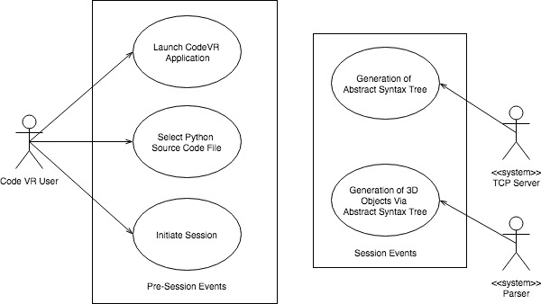

**Sequence Diagram:**

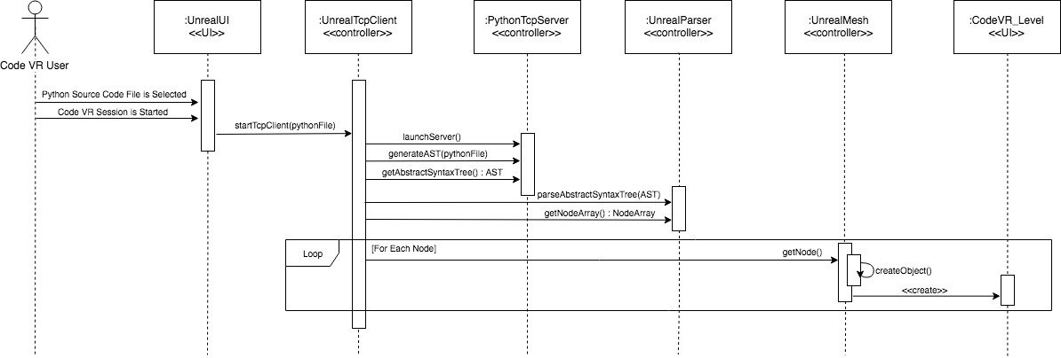

**Class Diagram:**

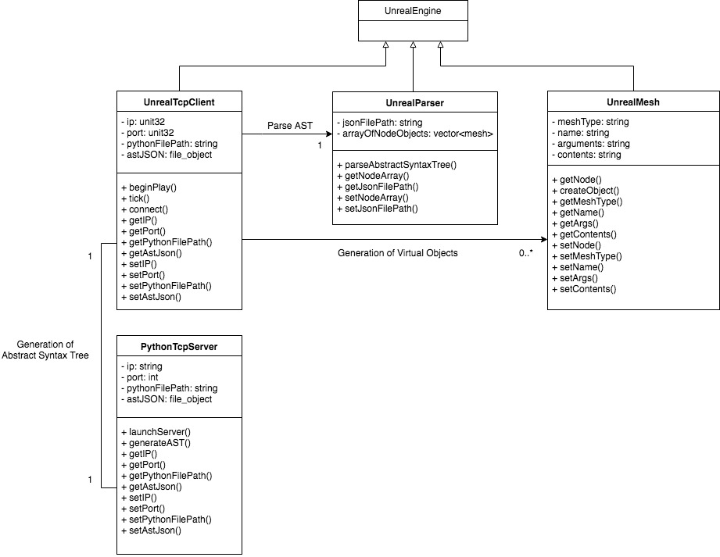

**Visual User Guide**

**Figure 1: Python source code with variable declaration**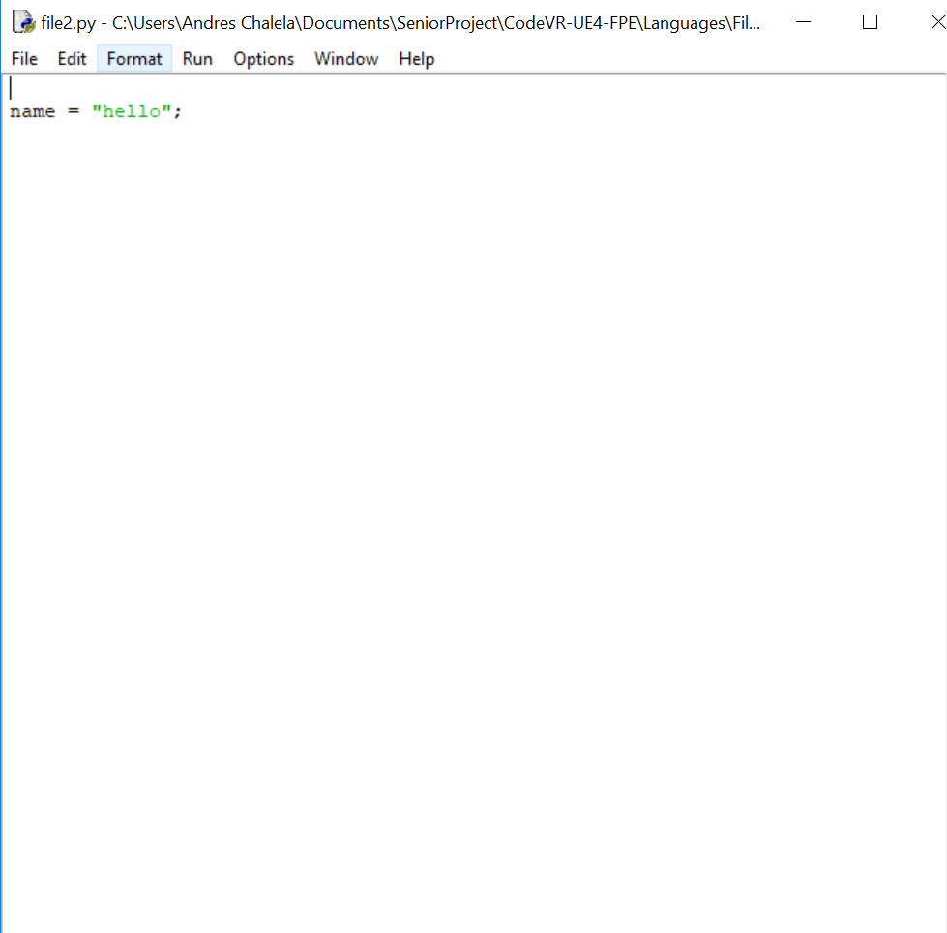

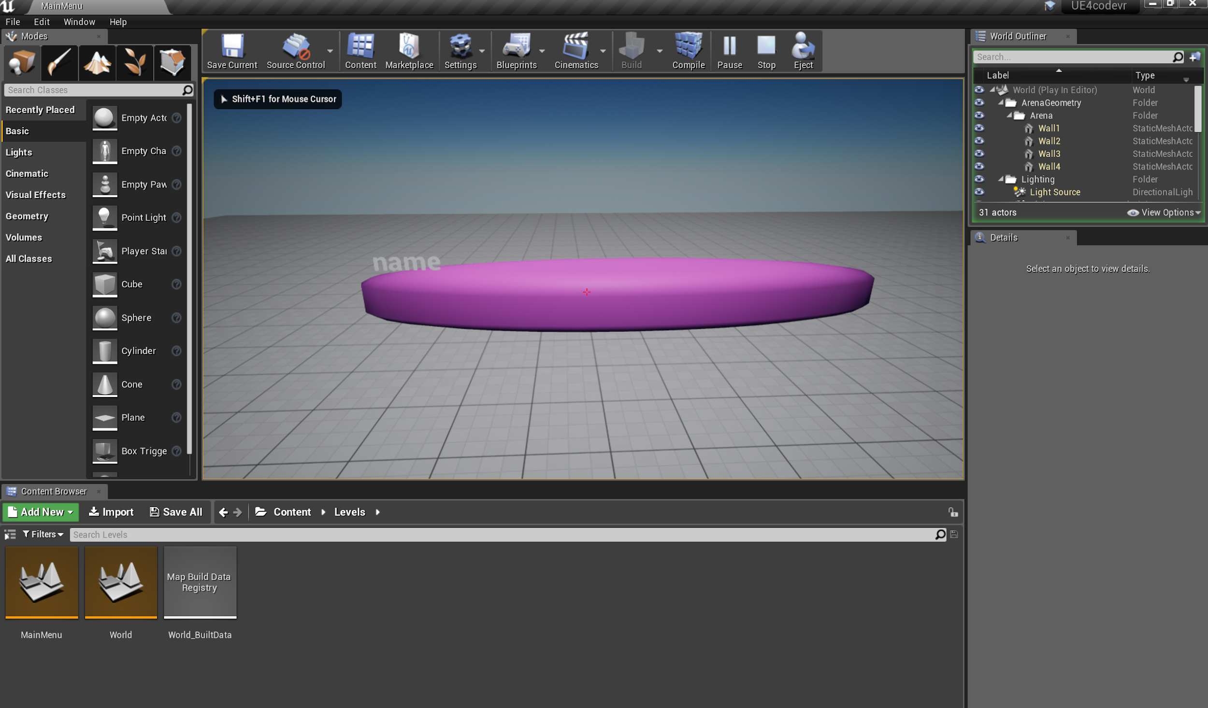

**Figure 2: Generated Variable 3D Object from parsing Abstract Syntax Tree**

**User Story ID:** #666 Embedded Python Server Execution

**Description:** As a User I would like to be able to parse AST with Python without the need of a system script, so that I may run the software on any operating system.

**Acceptance Criteria:**

* Removal of system call to execute python.

**Use Case:**

* Name: System use case
* Actor: Python server
* Preconditions:
  + Python Server running and working as expected
  + User have python file to upload
  + User have VR controller
  + Parser working as expected
  + CodeVR application working as expected
  + Device running CodeVR is connected to the internet
* Description :
  + The server is continuously running
  + The user lunch CodeVR application
  + CodeVR application successfully connect to the server
  + CodeVR application display server file upload option
  + User choose (the option) and successfully upload a python file
  + The server’s parser parse the code and generate a json tree

which the server return to the CodeVR application

* + The CodeVR application map the json tree information to 3D

objects representing coding elements.

* + The user can use the VR controller to pick up those 3D objects
  + The user can use the VR controller to drop those 3D objects

**Use Case Diagram :** Server use case diagram

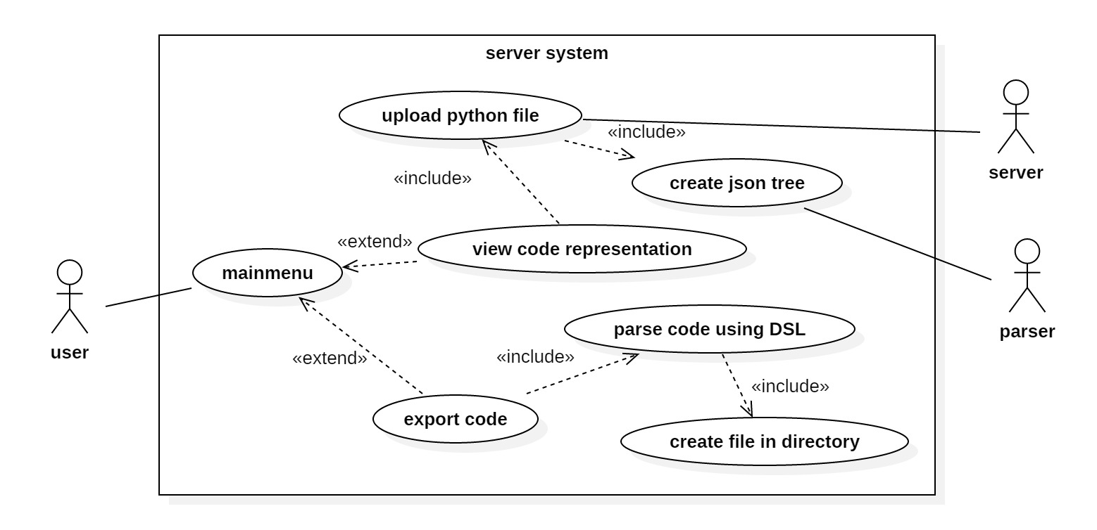

**Sequence Diagram** : server sequence diagram

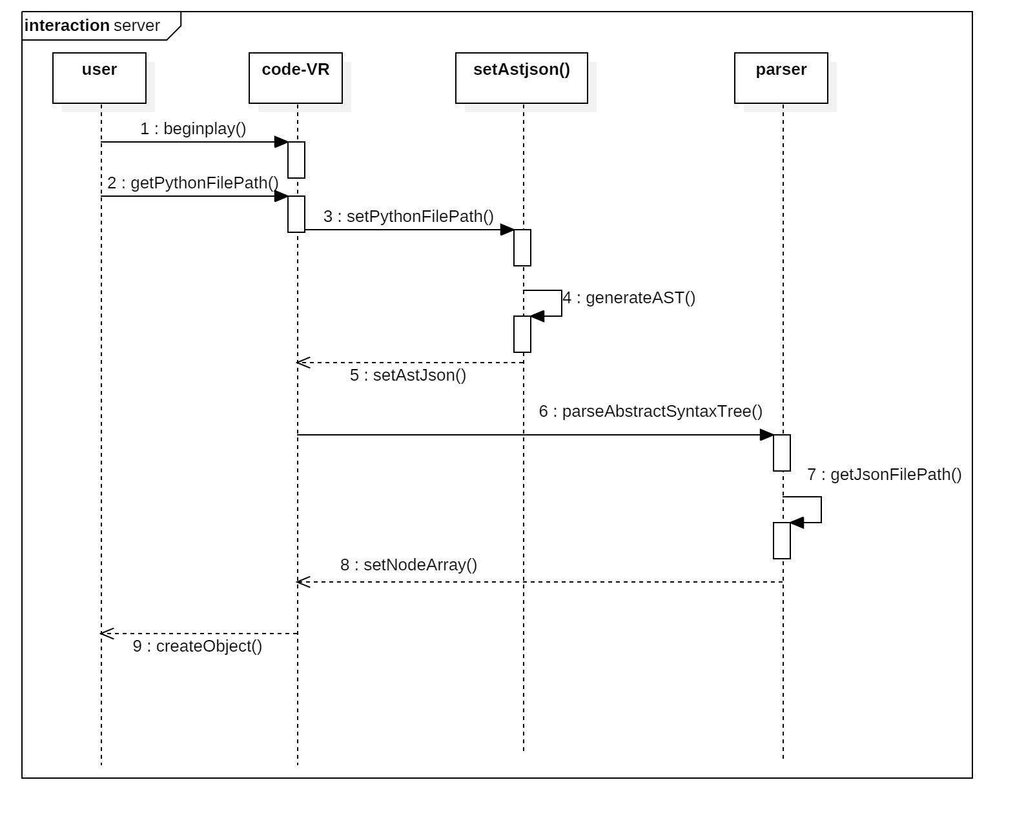

**Class Diagram :** server conceptual class diagram

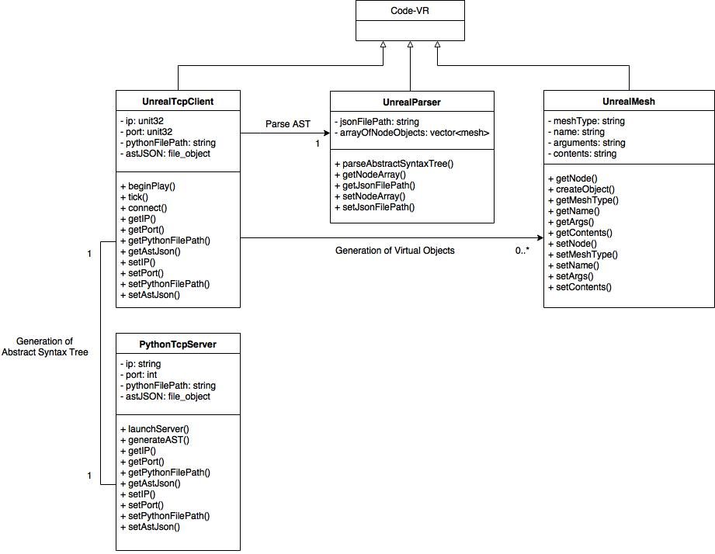

**Visual User Guide**

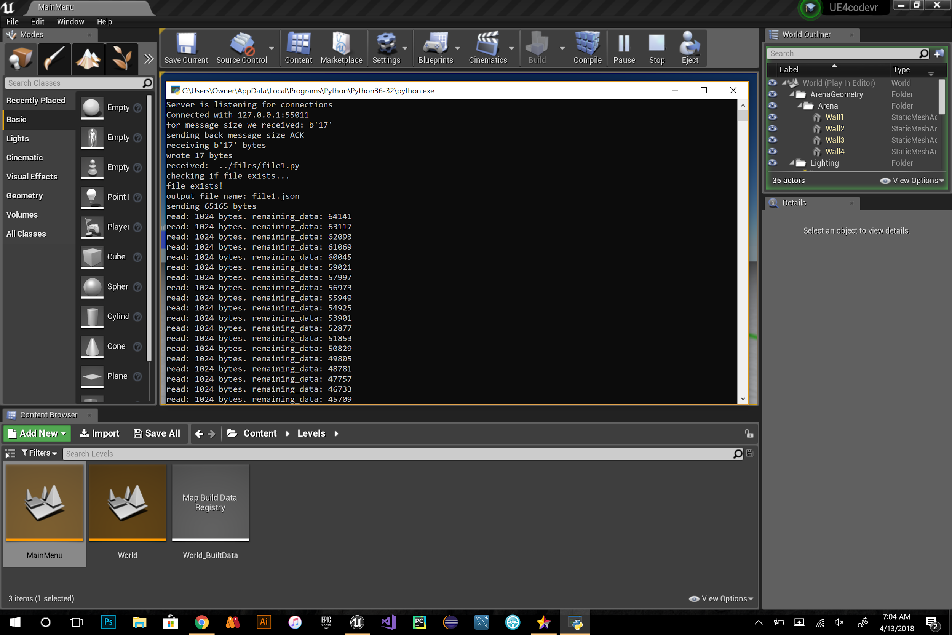

**Fig 1:** server execution

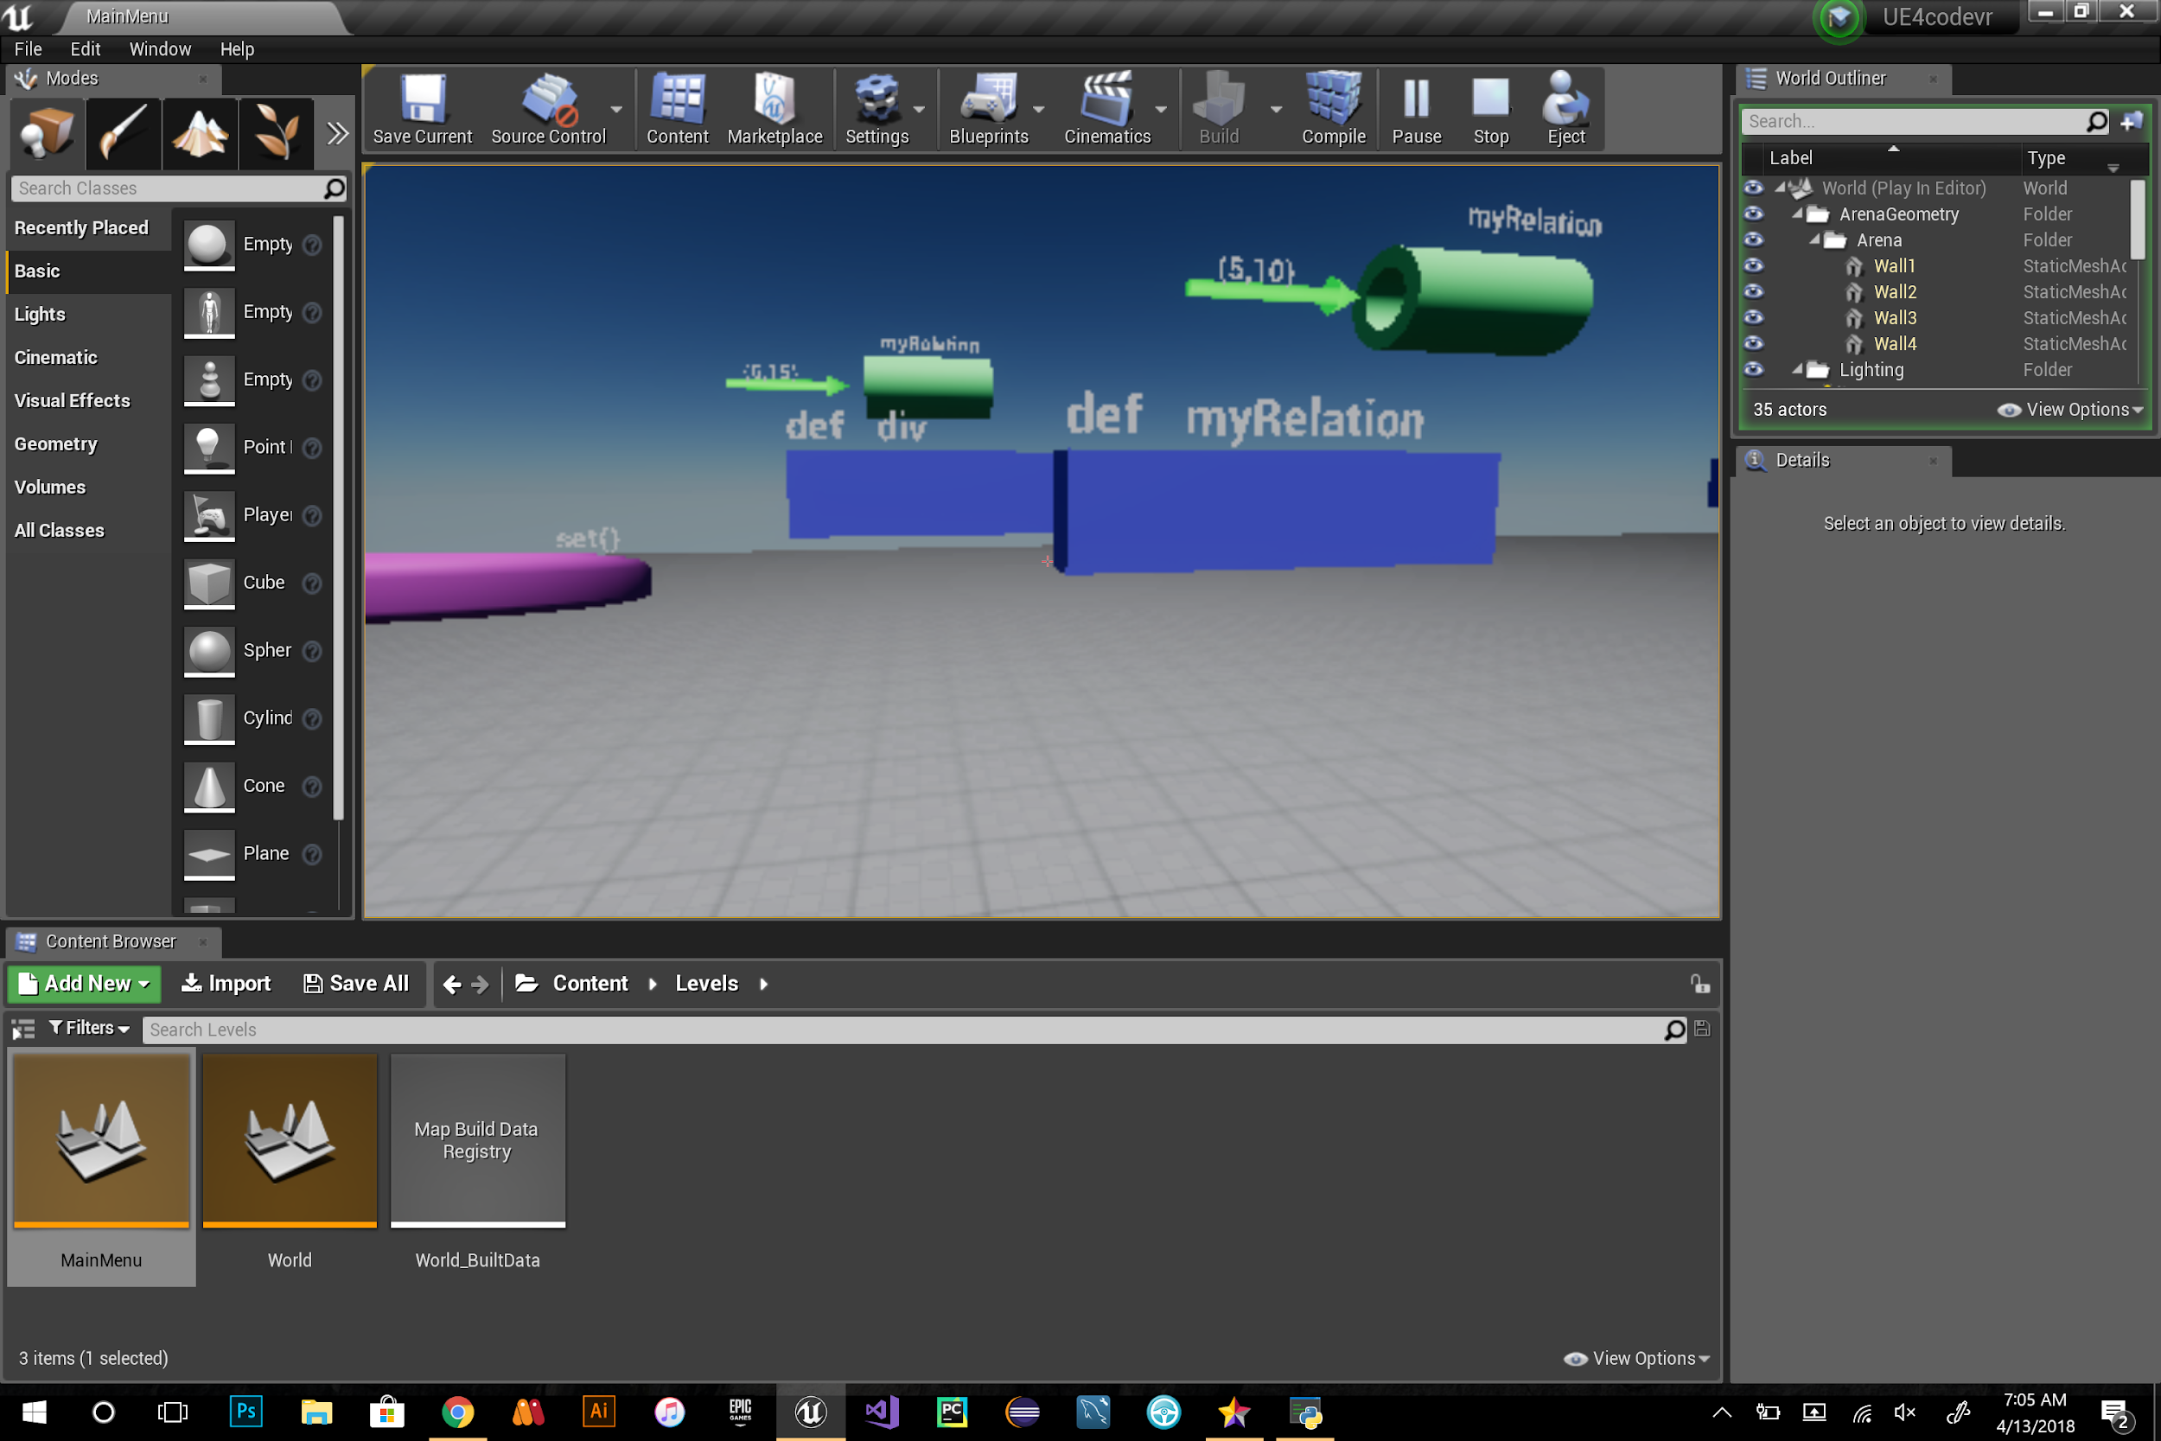

**Fig 2:** 3D element generated to represent the uploaded code

**User Story ID:** #667 VR Controller Menu (Research & Implementation)

**Description:** As a user, I would like to have access to a VR in-game menu, so that I have the option to either pause, resume, or end the current game session.

**Acceptance Criteria:**

* Have a prototype implementation of the controller menu
* Be able to pause and resume the game
* Be able to end the game and go back to the main menu

**Use Case:**

* Name: User Controls State of Game with Menu
* Actor: Student
* Preconditions: User has headset on and CodeVR is running
* Description: After the user has headsets set up together with controllers, user can point to menu options such as start/pause to freeze and unfreeze the visuals components of VR environment of level 0 or quit to end the game session

**Use Case Diagram:**

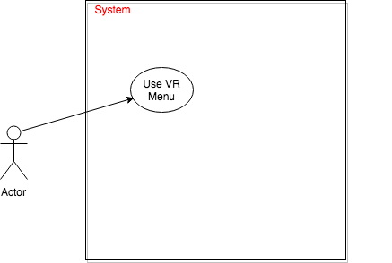

**VR - Menu Controller**

**Sequence Diagram:**

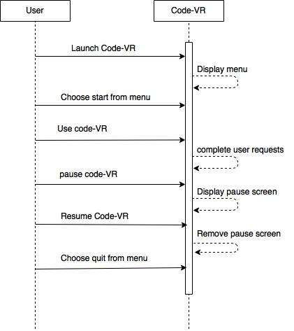

**Class Diagram:**



**Integration Test:**

* VR Menu Controller integrates independently of any previous functionality.

**User Story ID:** #668 Implementation of Different Shapes

**Description:** As a User I would like to see different shapes for different programming elements/components, so that I can better understand what each programming element does and represents.

**Acceptance Criteria:**

* Implementation of shapes for different elements.

**Use Case:**

* Name: Display shapes use case
* Actor: CodeVR application
* Preconditions:
  + Python Server running and working as expected
  + User have python file to upload
  + User upload python file
  + Parser working as expected
  + Device running CodeVR is connected to the internet
* Description:
  + 1- The server is continuously running
  + 2- The user lunch CodeVR application
  + 3- CodeVR application successfully connect to the server
  + 4- CodeVR application display server file upload option
  + 5- user choose (the option) and successfully upload a python file
  + 6- The server’s parser parse the code and generate a json tree

which the server return to the CodeVR application

* + 7- The CodeVR application map the json tree information to 3D

objects representing coding elements.

**Use Case Diagram :**

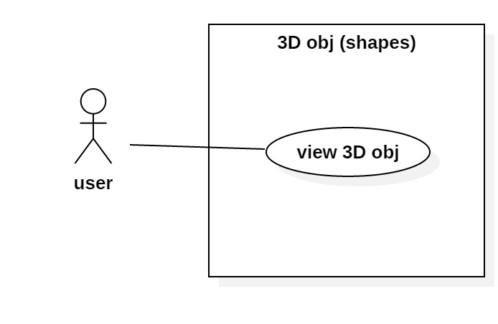

**Use Case - 3D Shapes**

**Sequence Diagram**:



**Server and Shape Sequence Diagram**

**Class Diagram:**



**Visual User Guide:**

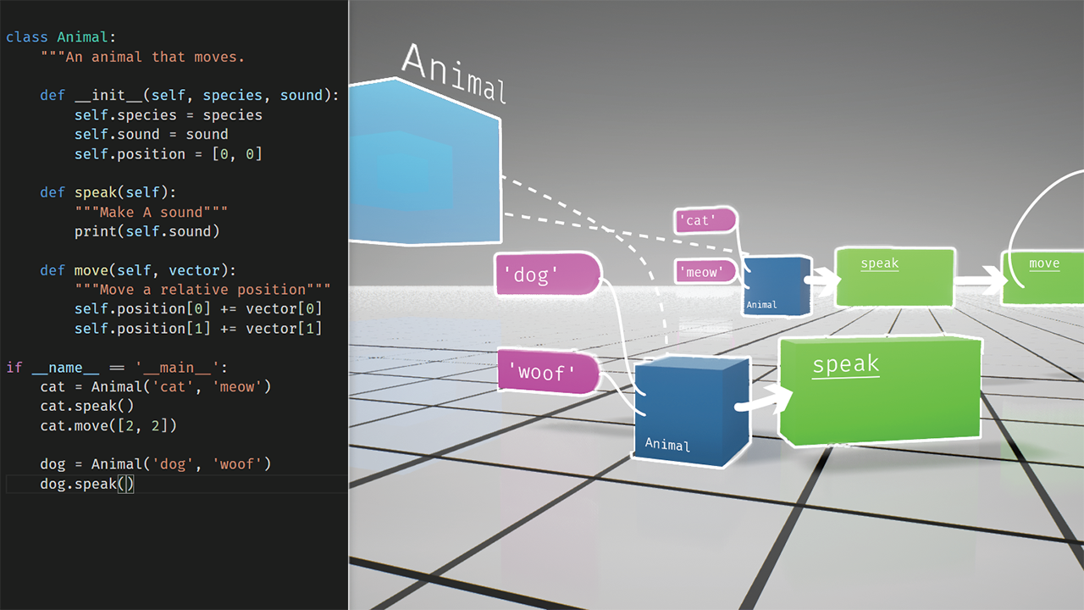

**Fig 1:** overall representation

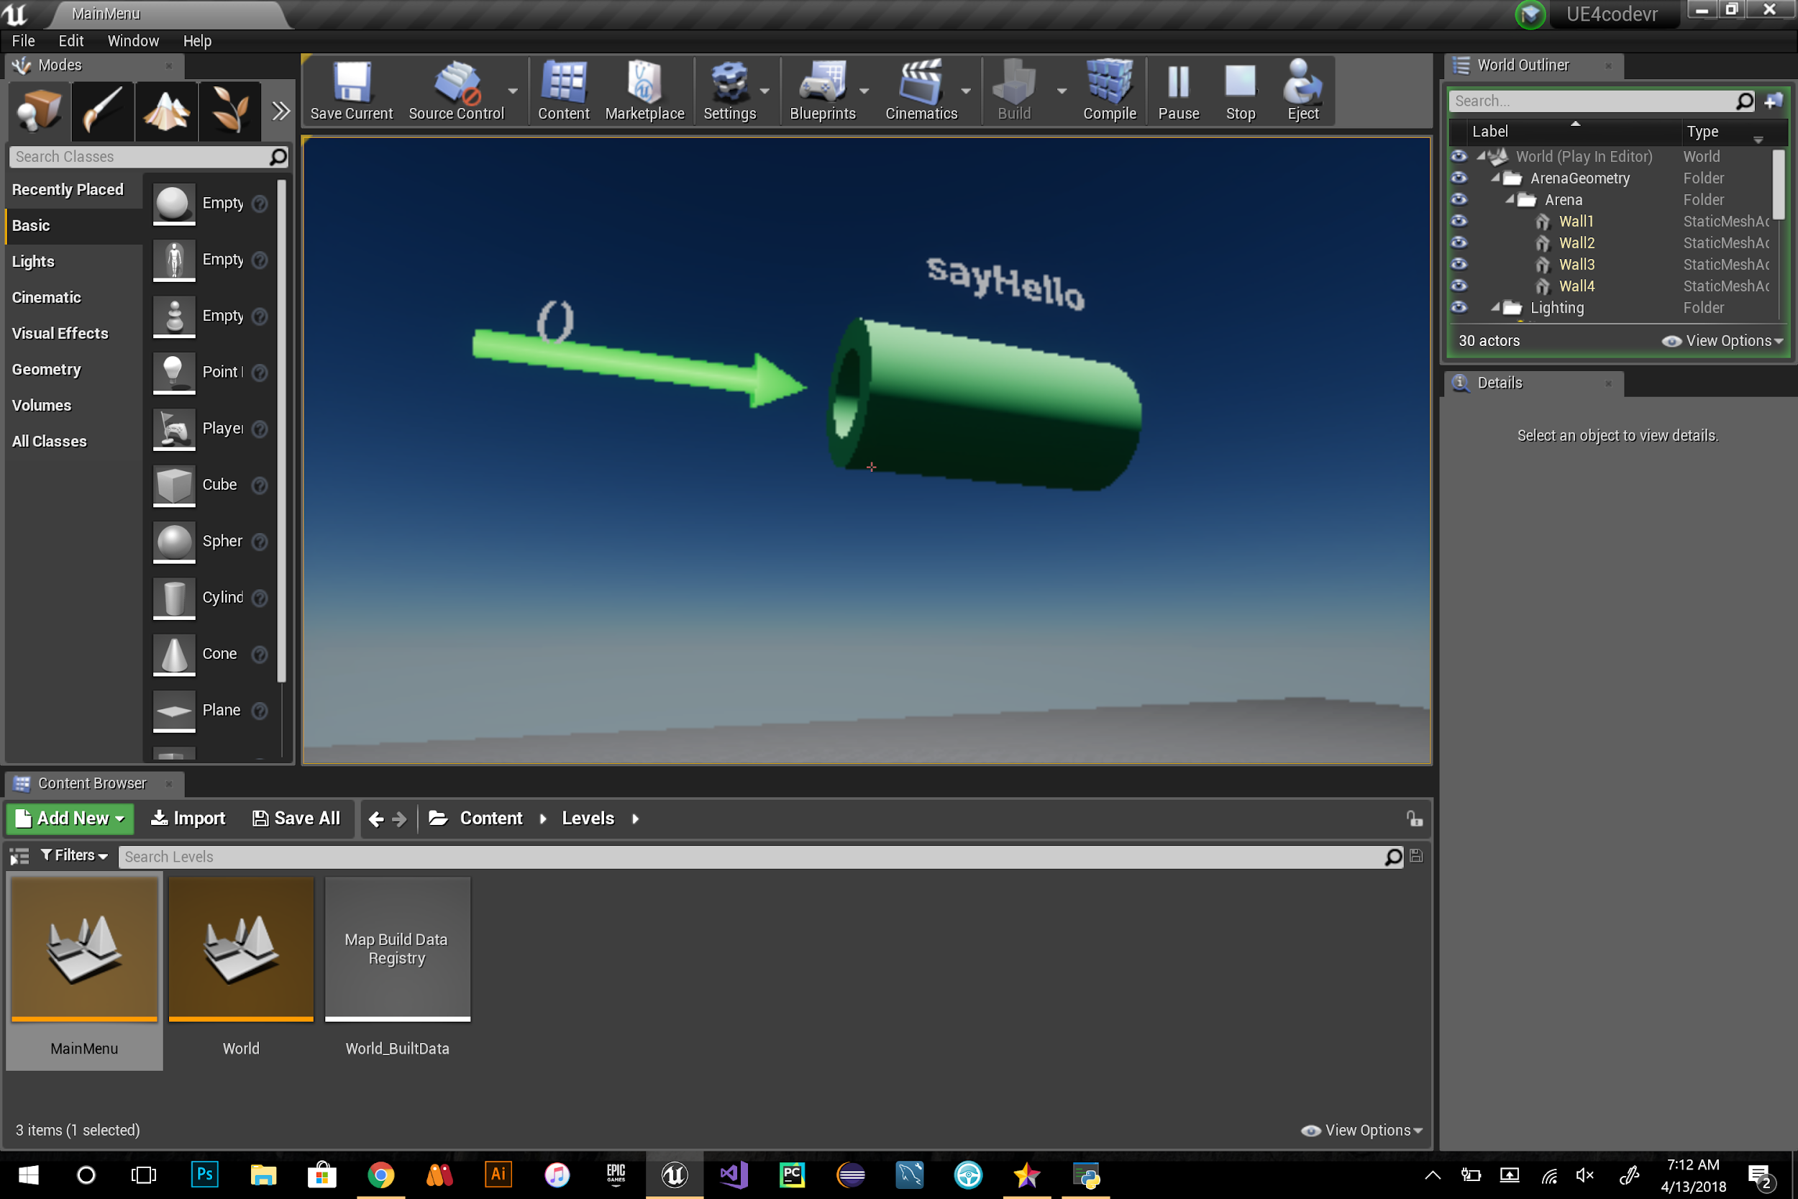

**Fig 2:** representation of sayhello() using cylinder

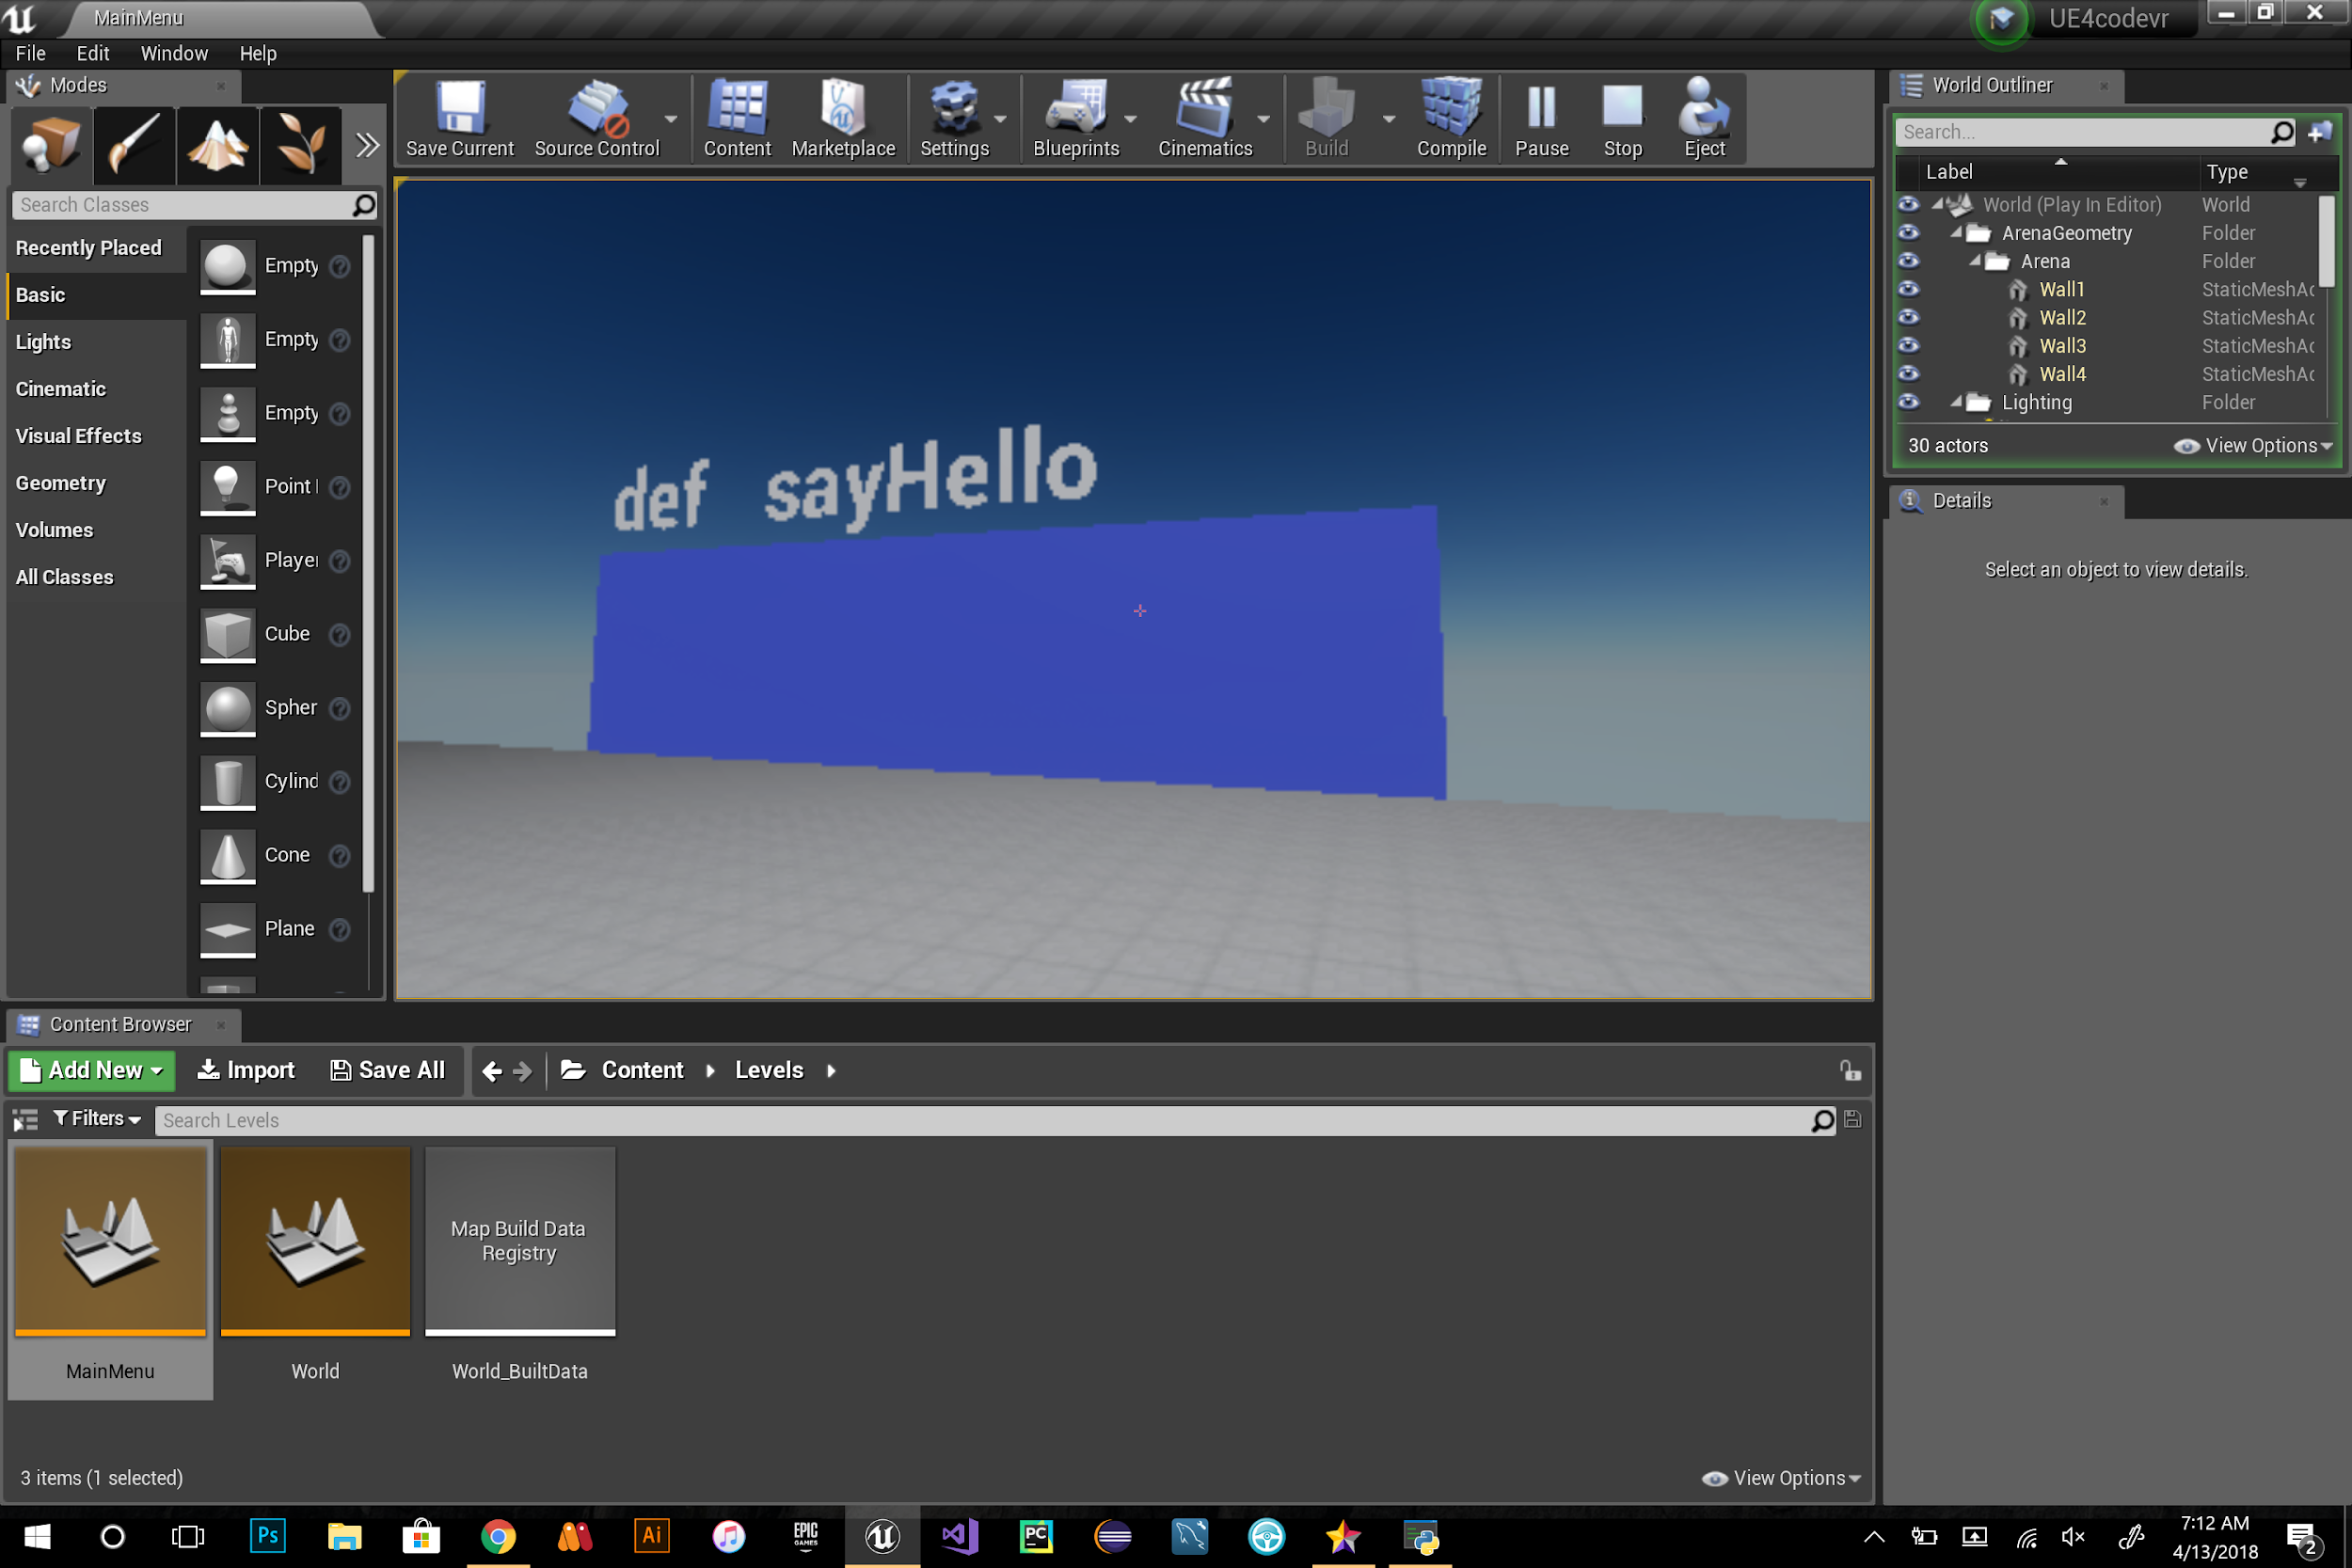

**Fig 3:** representation of sayHello() using rectangular shape

### SPRINT 3

**User Story ID:** [#694](https://fiu-scis-seniorproject.mingle.thoughtworks.com/projects/code_vr/cards/694) Update CodeVR Menu

**Description:** As a developer I would like to optimize the code-VR menu, so that the user have the option to pause, resume, end the current code-VR session.

**Acceptance Criteria:**

* Be able to pause the current code-VR session
* Be able to resume the current code-VR session
* Be able to quit the code-VR session

**Use Case:**

* Name: CodeVR_menu
* Actor: User, CodeVR system
* Preconditions:
  + System in ready state
  + User launch the CodeVR application
* Description :
  + System in ready state
  + User launch the CodeVR application
  + User use the CodeVR system
  + User use vr Controller to pause the CodeVR system
  + User use vr Controller to select resume option from menu
  + User use vr Controller to select quit option from menu

**Use Case Diagram :**

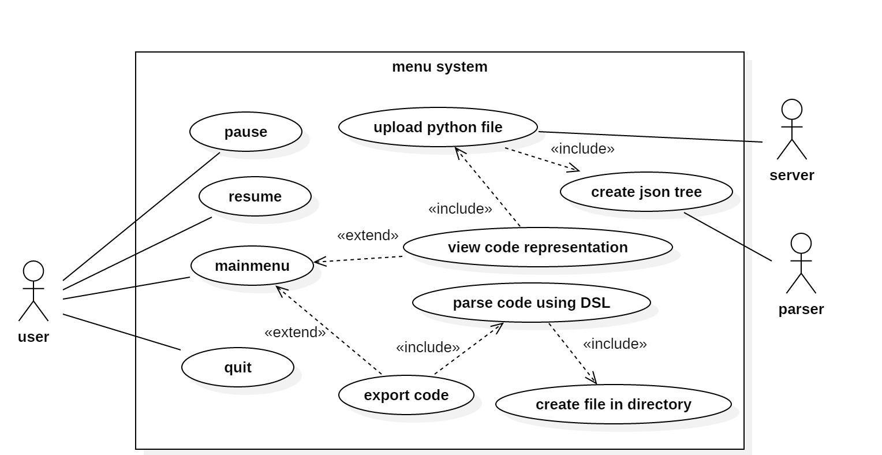

**Pause Use Case Diagram**

**Sequence Diagram**:

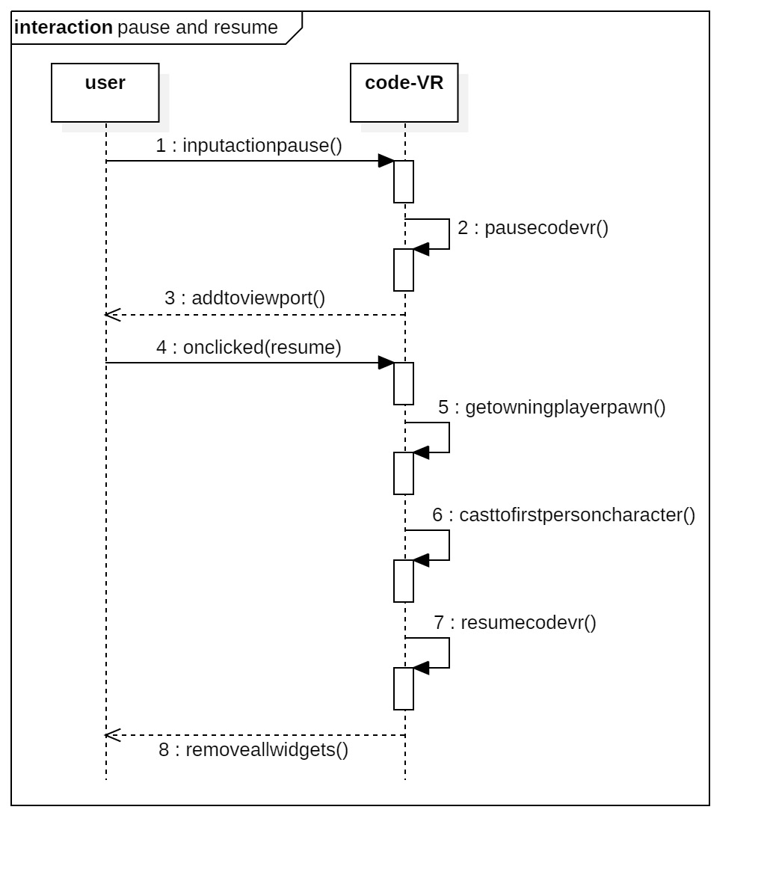

**Pause, Resume Sequence Diagram**

**Sequence Diagram**:

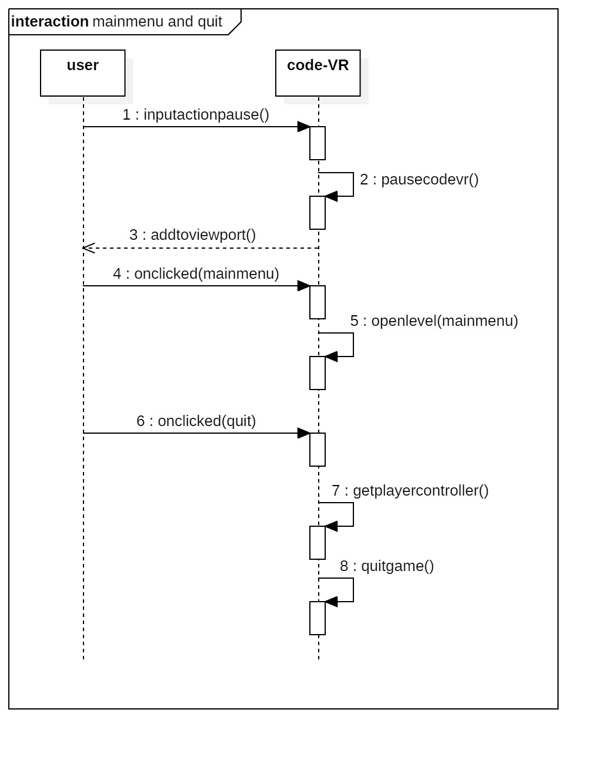

**Pause, Main Menu and Quit Sequence Diagram**

**Class Diagram :**

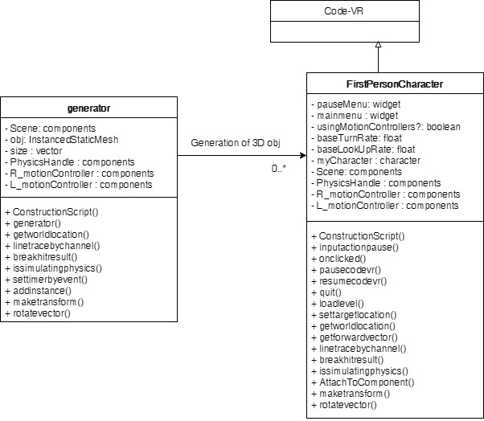

**Initial Conceptual Class Diagram**

**Visual User Guide:**

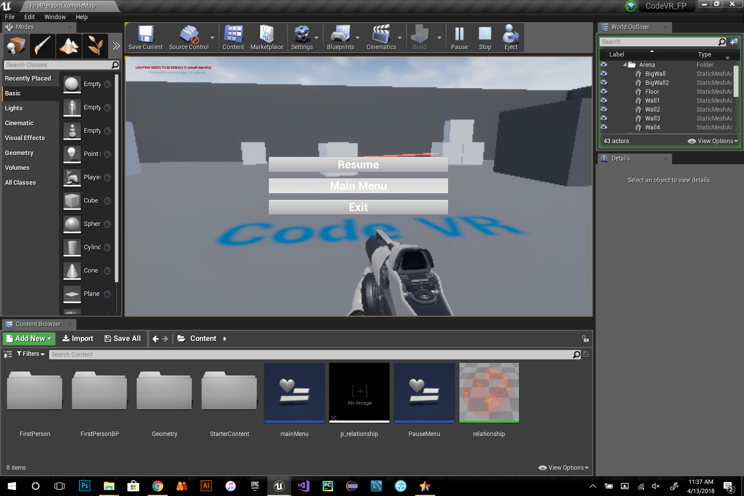

**Fig 1 :** pause menu triggered by pressing p from the keyboard

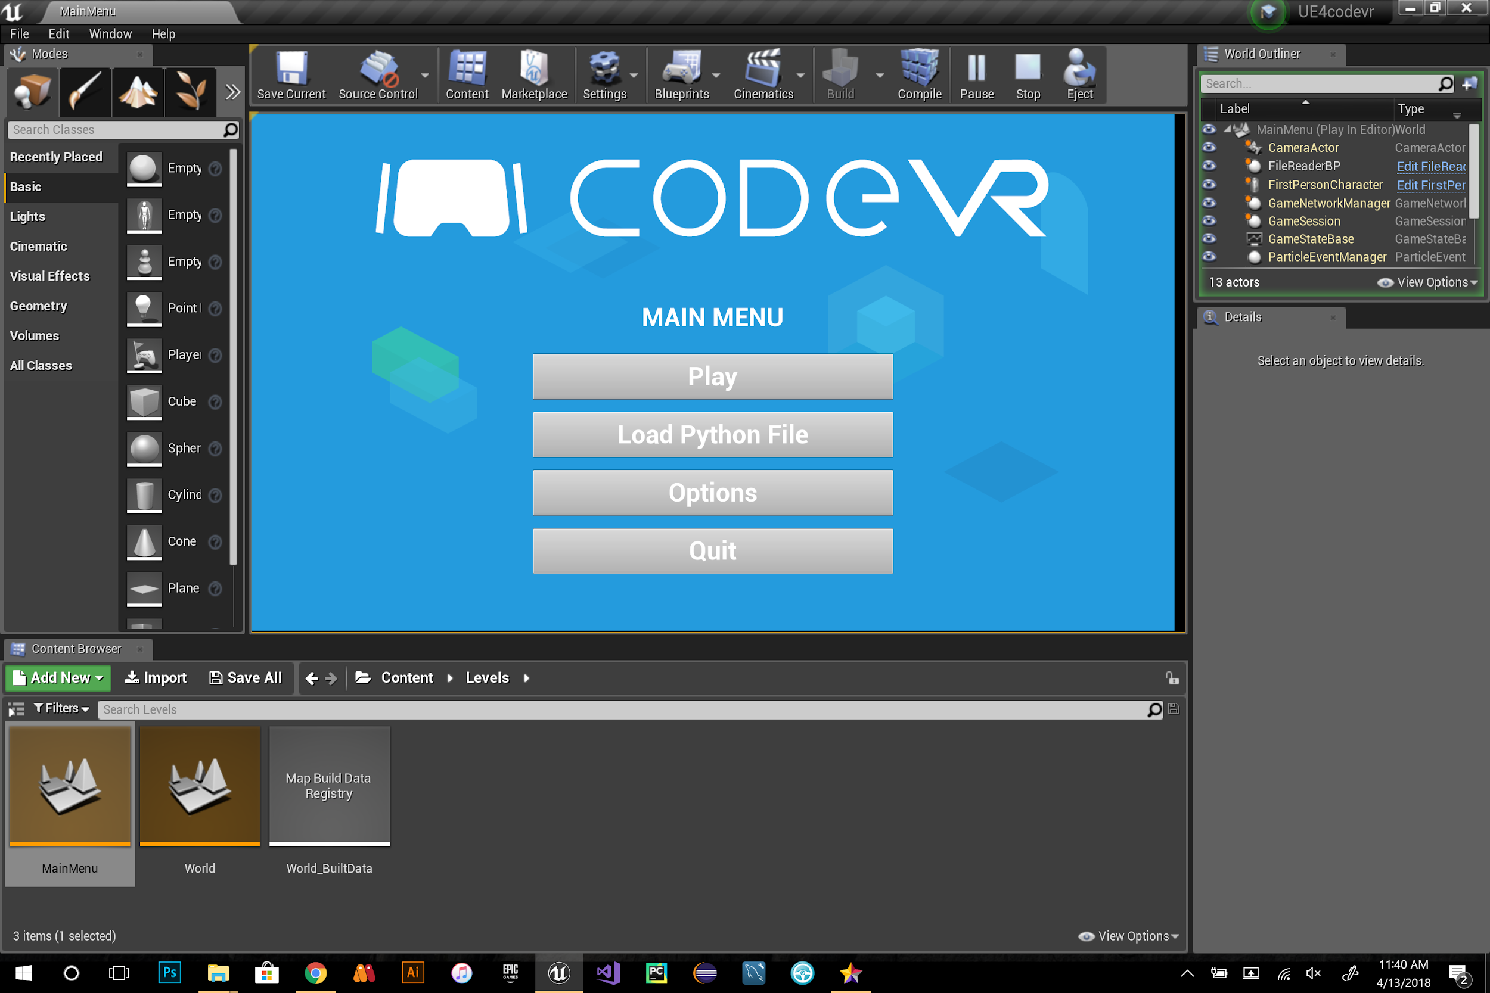

**Fig 2** : main menu

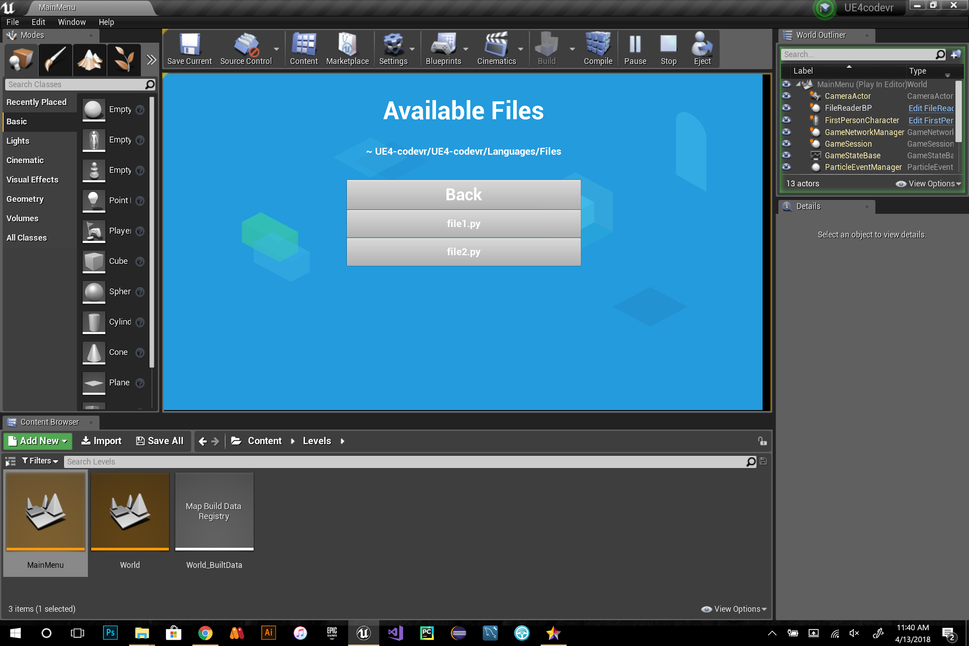

**Fig 3 :** upload file menu

**User Story ID:** #704 CodeVR Compiler Implementation (Lexer Phase)

**Description:** As a developer, I have to implement the Lexer module of the CodeVR compiler, so that the CodeVR language source code can be tokenized into a character stream for the Parser module.

**Acceptance Criteria:**

1. Lexer rules and tokens are properly defined.
2. The Lexer module can correctly tokenize the stream of CodeVR source code.

**Use Case:**

* Name: Lexical Analysis of CodeVR Language
* Actors: CodeVR Lexer
* Preconditions: CodeVR source code file has been generated and ready to be given as input to the Lexer module of the CodeVR Compiler.
* Description <Flow of events>:

1. CodeVR Lexer receives source code
2. CodeVR Lexer tokenizes the provided input
3. CodeVR Lexer passes token stream to Parser

**Use Case Diagram:**

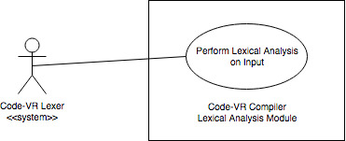

**Use Case - Execution of Lexical Analysis**

**Sequence Diagram:**

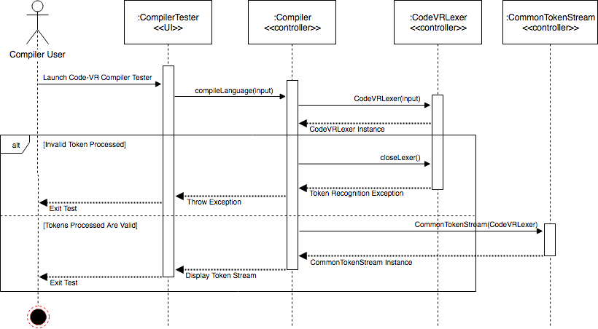

**CodeVR Compiler Lexical Analysis**

**Class Diagram:**

**CodeVR Compiler Class Diagram (Lexer Module)**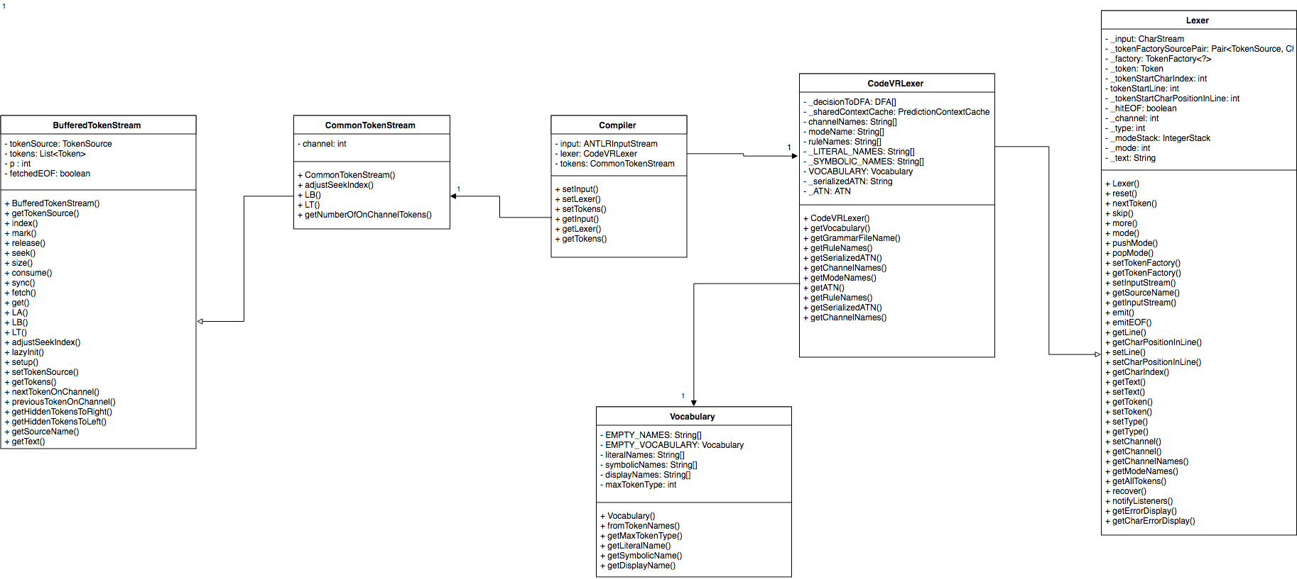

**Visual User Guide:**

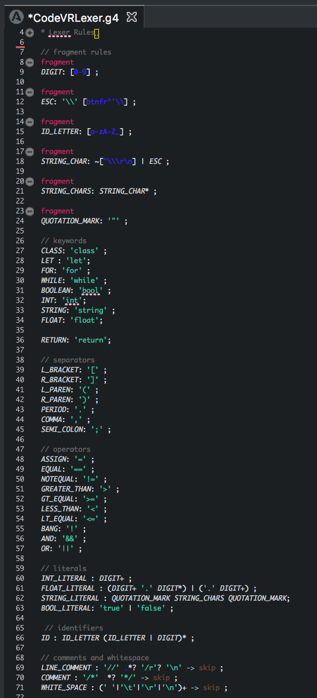

**Figure 1: CodeVR Lexer Grammar Rules & Definitions**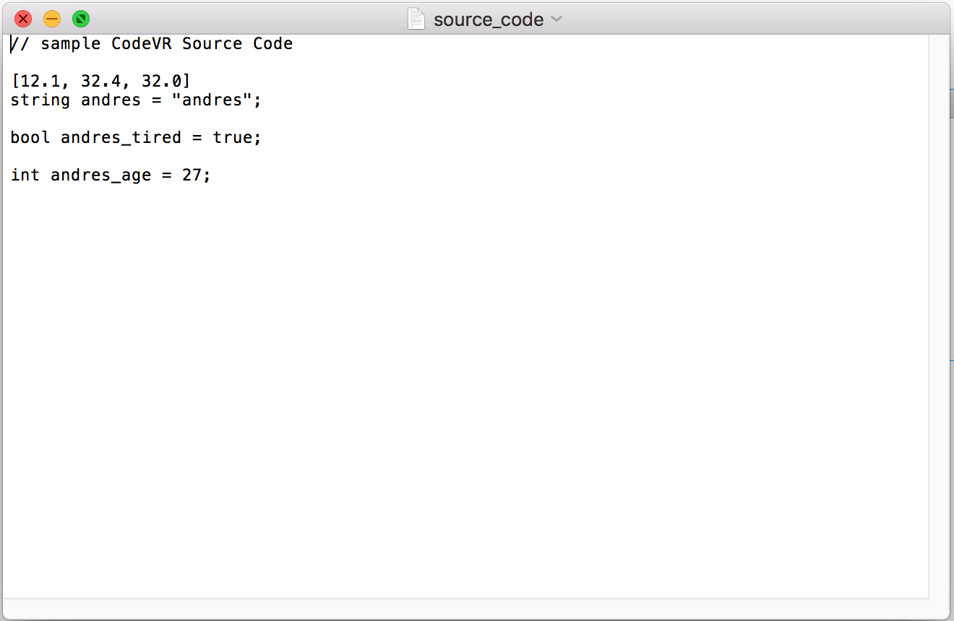

**Figure 2: CodeVR source code**

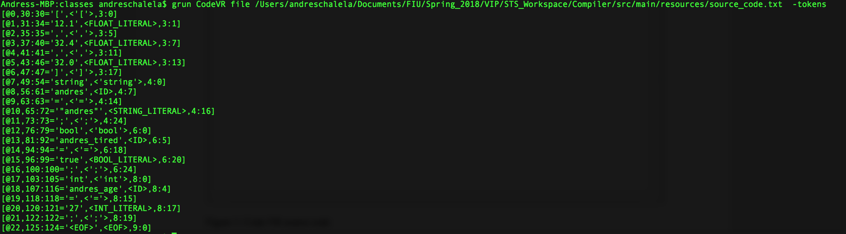

**Figure 3: Results of Lexical Analysis**

**User Story ID:** #691 3D Shape Generator Functionality

**Description:** As a developer, I would like to implement a predefined 3D shape generator UI tool, so that users can create predefined 3D objects that represent coding elements.

**Acceptance Criteria:**

* Able to generate new 3D object representing function
* Able to generate new 3D object representing a class
* Able to generate new 3D object representing a variable

**Use Case:**

* Name: generate 3D obj
* Actor: User, CodeVR system
* Preconditions:
  + System in ready state
  + User launch the CodeVR application
  + User have a vr controller
* Description :
  + System in ready state
  + User launch the code-VR application
  + User select from a list of shapes the one to be generated

**Use Case Diagram :**

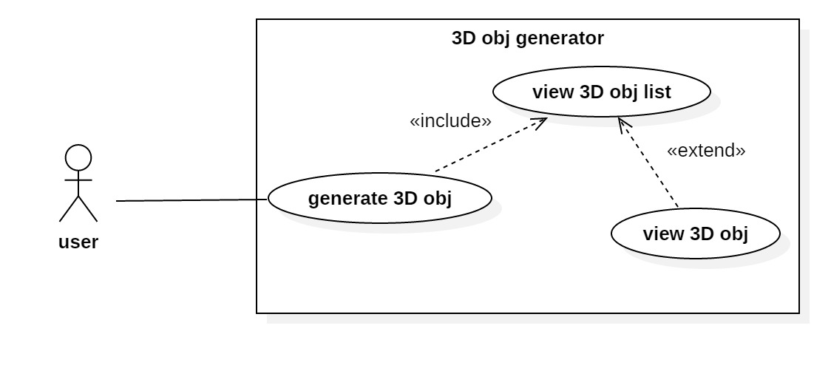

**Use Case - Generate 3D Object**

**Sequence Diagram** :

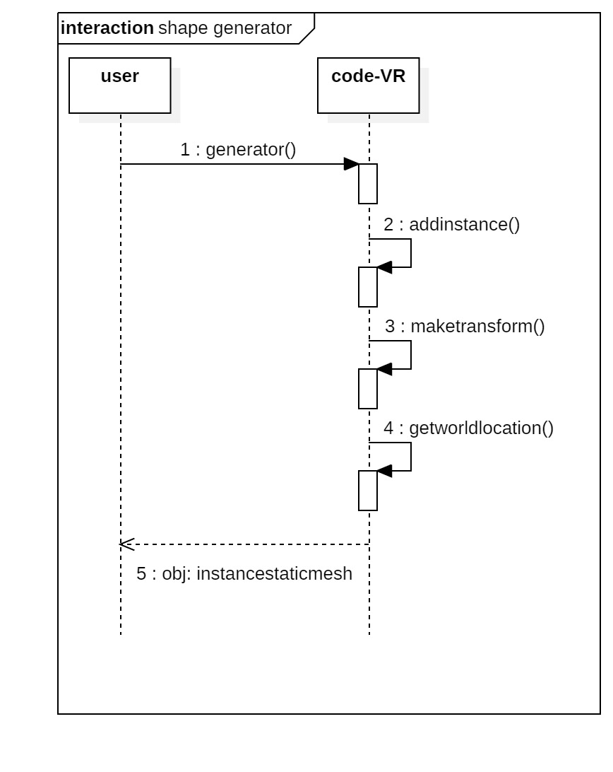

**Service-Level Sequence Diagram**

**Class Diagram :**

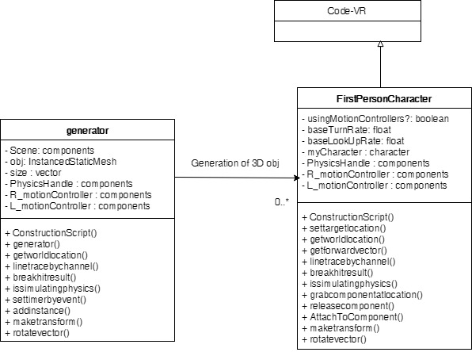

**Shape Generator Class Diagram**

**Visual User Guide:**

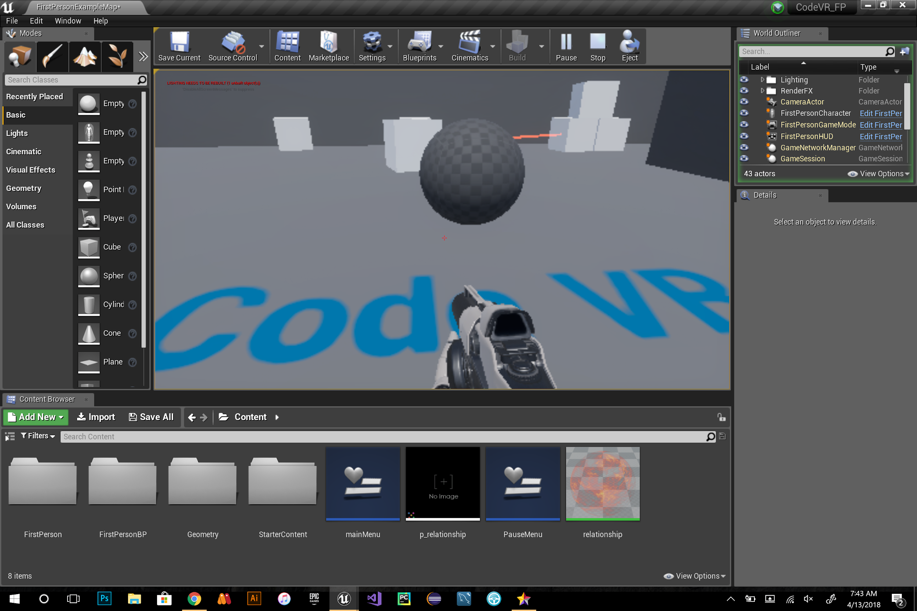

Fig1: sphere shape

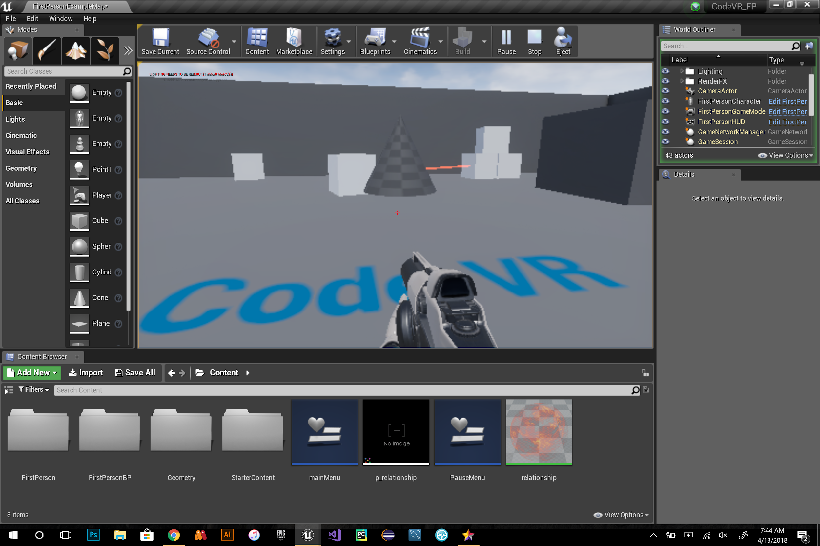

Fig 2: cone shape

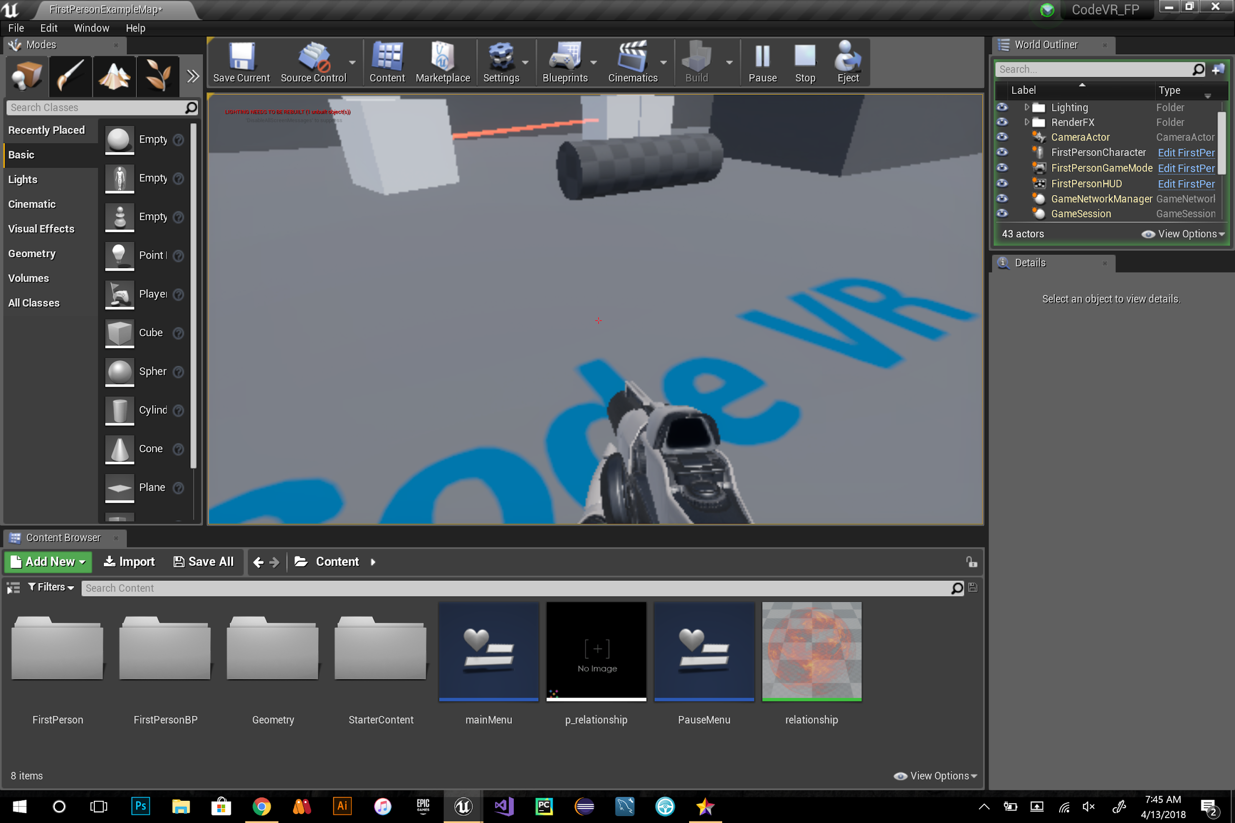

Fig 3: cylinder shape

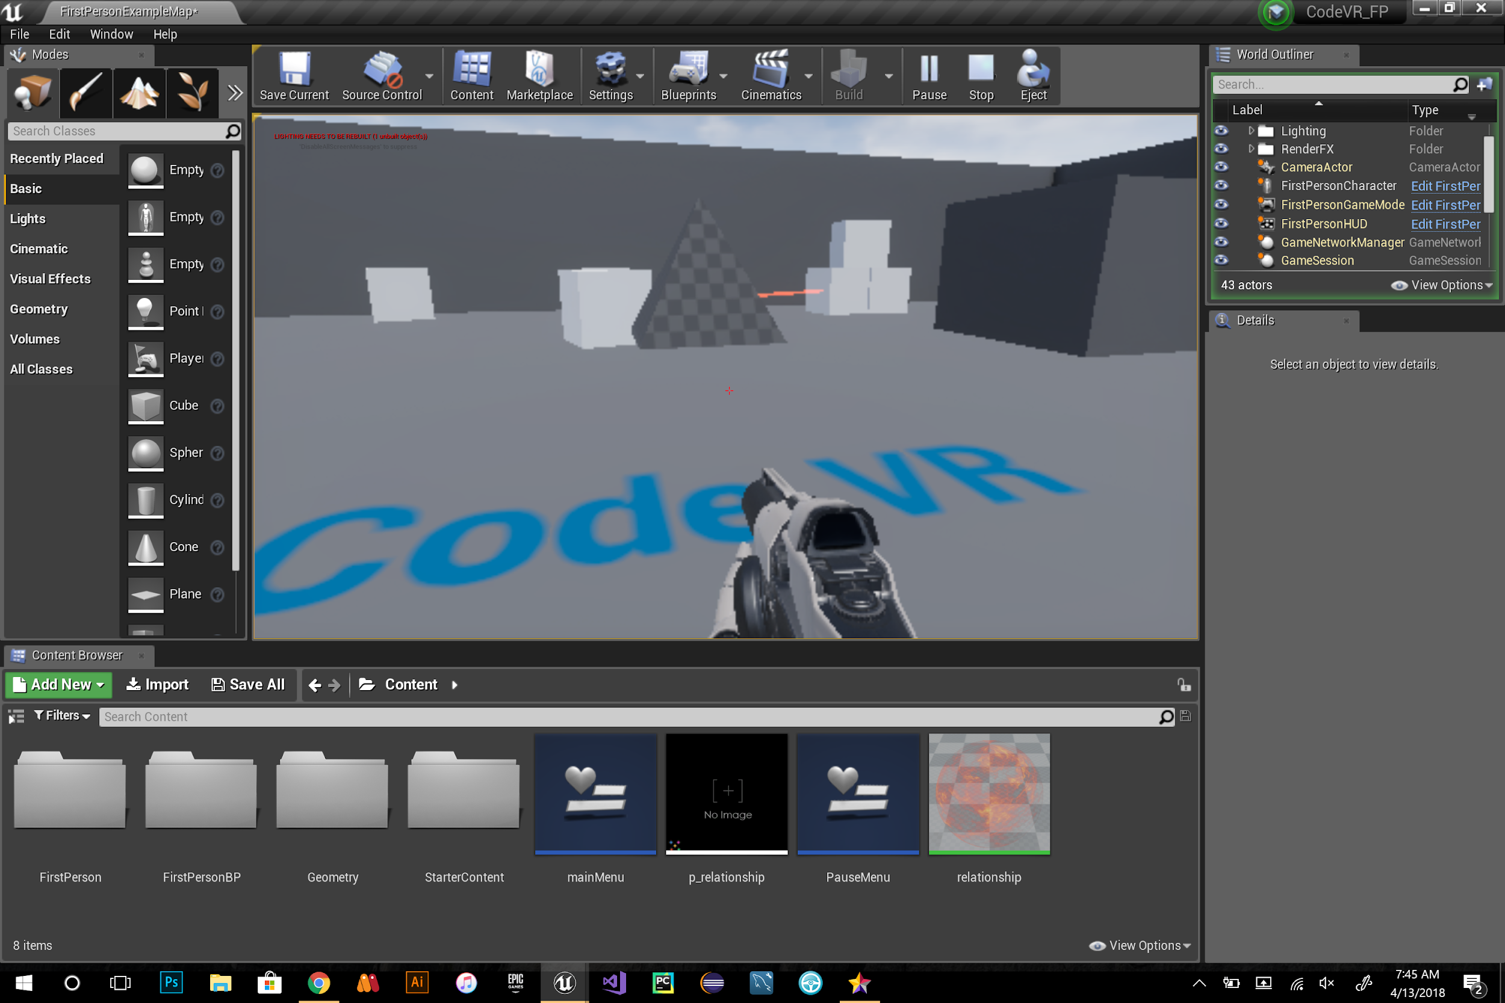

Fig 4: triangle shape

**User Story ID:** #690 3D Shapes Animation(Behavior)

**Description:** As a user I would like to experience 3D Objects in the shape of numbers so that I can experience the behavior of bubble sort.

**Acceptance Criteria:**

* Shapes should represent numbers
* When triggered, shapes should be in CodeVR environment.
* Shapes should allow for animation to start implementing bubble sort.

**Use Case:**

* Name: Shapes Creation for Animation of Bubble Sort
* Actor: User, Sample VR level
* Preconditions:
  + System is in ready state
  + User launch Sample VR level
* Description <Flow of events>:
  + System is in ready state
  + User launch Sample VR application
  + User can displace through the environment
  + User can see virtual 3D shapes as numbers
  + User can observe name of Sorting Algorithm “Bubble Sort”
  + User can continuously visualize 3D shapes as they become sorted

**Use Case Diagram:**

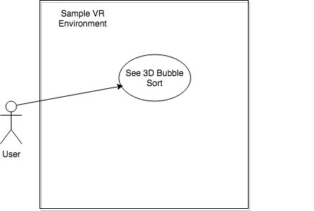

**Sequence Diagram:**

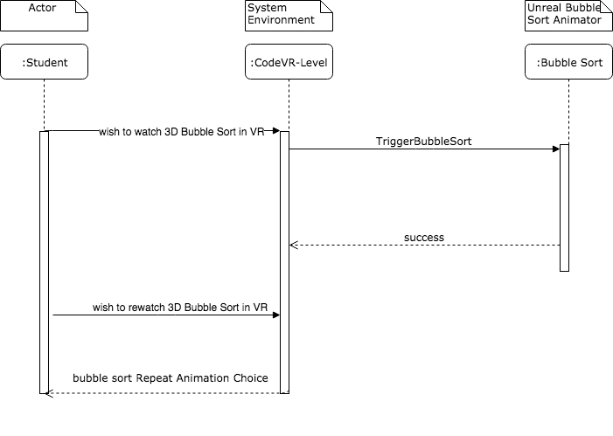

**Class Diagram:**

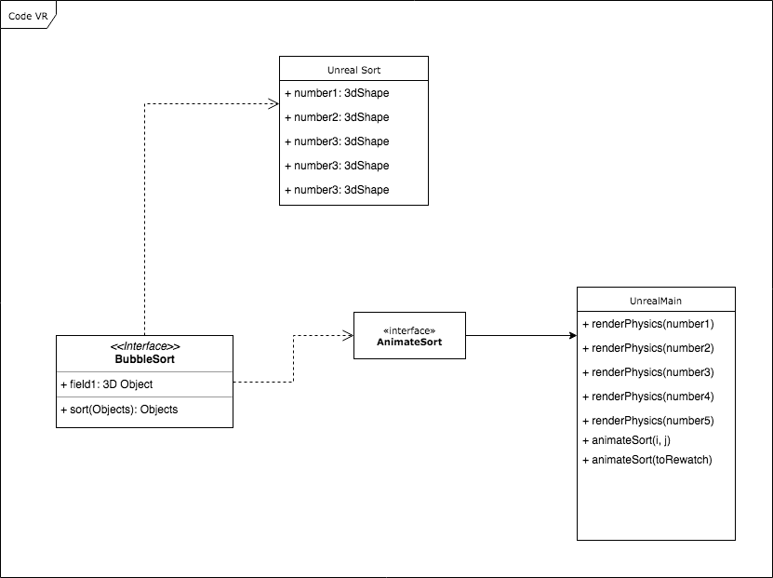

### SPRINT 4

**User Story ID:** [#688](https://fiu-scis-seniorproject.mingle.thoughtworks.com/projects/code_vr/cards/688) Grab and Drop Functionality

**Description:** As a User I would like to have a grab and drop functionality in the CodeVR virtual environment so that I can grab, move, and drop 3D objects.

**Acceptance Criteria:**

* Able to grab 3D objects
* Able to move 3D objects
* Able to drop 3D objects

**Use Case:**

* Name: grab
* Actor: User
* Preconditions: CodeVR system in ready state
* Description <Flow of events>:
  + User launch the code-VR application
  + User move close to the cube and press f from the keyboard
  + User grab a cube
  + User move the grabbed cube
  + User press f from the keyboard
  + User drop the cube

**Use Case Diagram :**

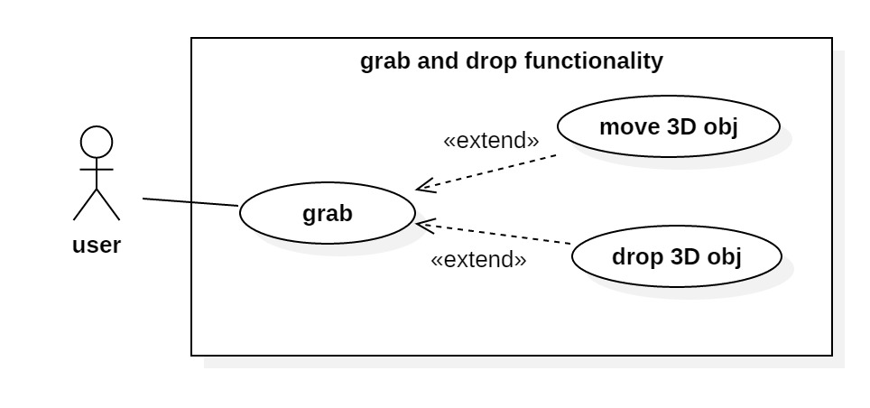

**Use Case - Grab & Drop**

**Sequence Diagram :**

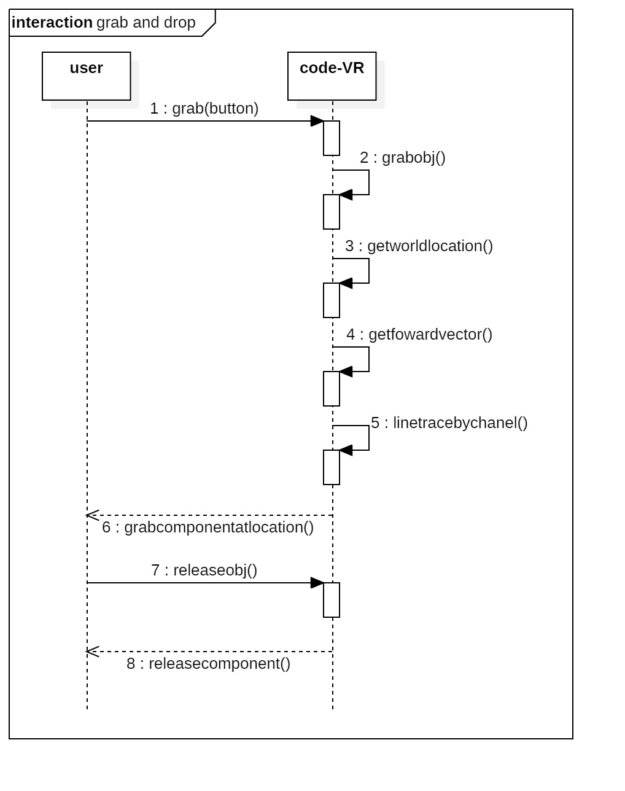

**Grab and Drop Functionality Sequence Diagram**

**Class Diagram:**

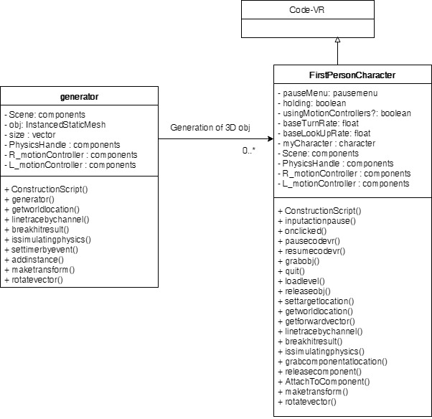

**Visual User Guide:**

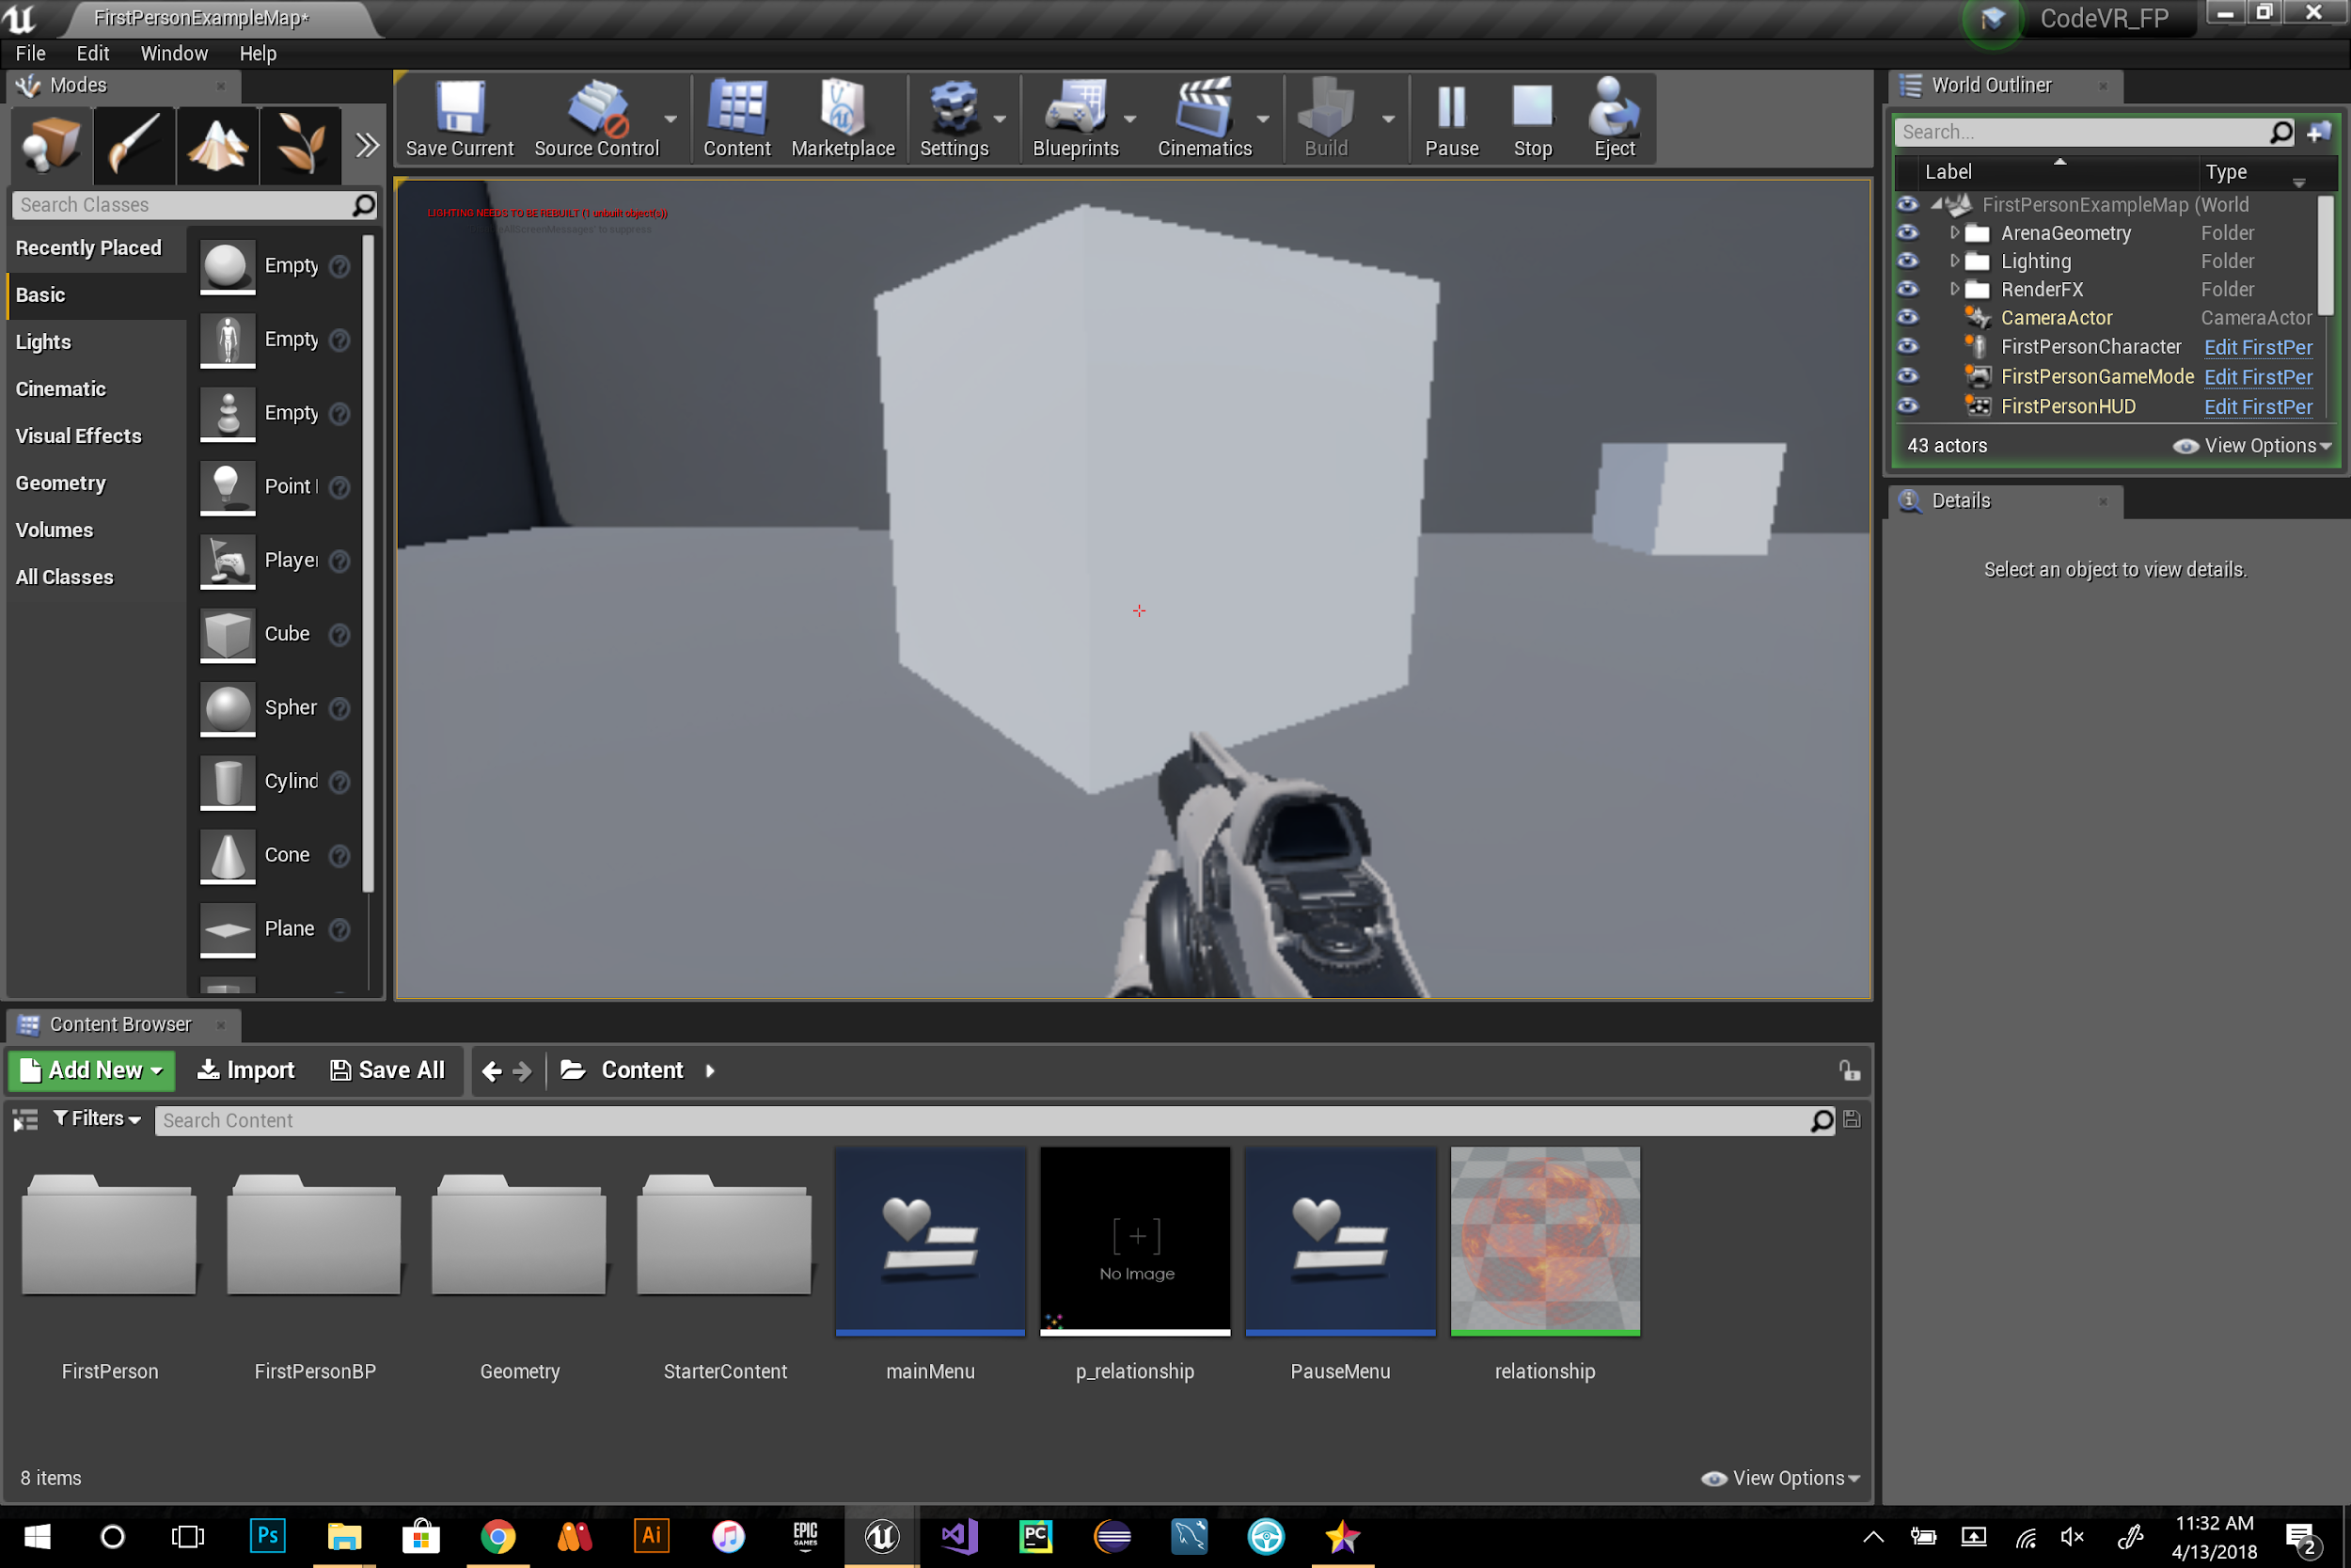

**Fig 1 :** before grabbing cube

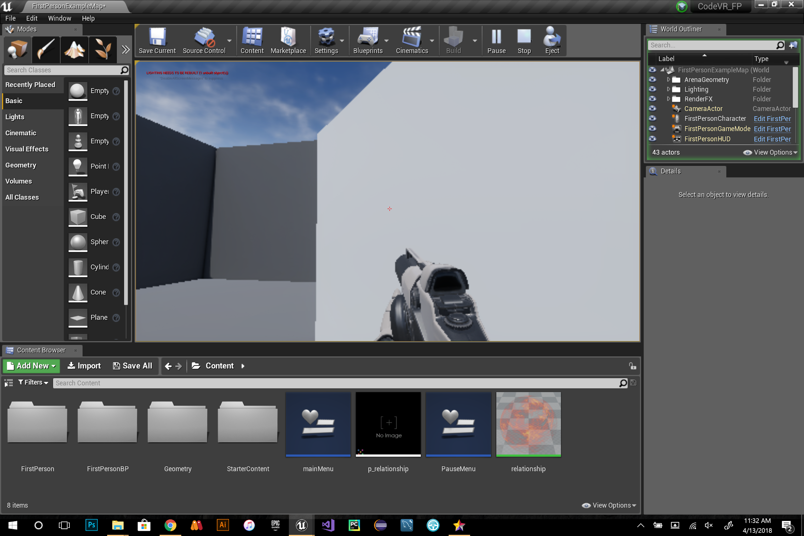

**Fig 2 :** cube is grabbed

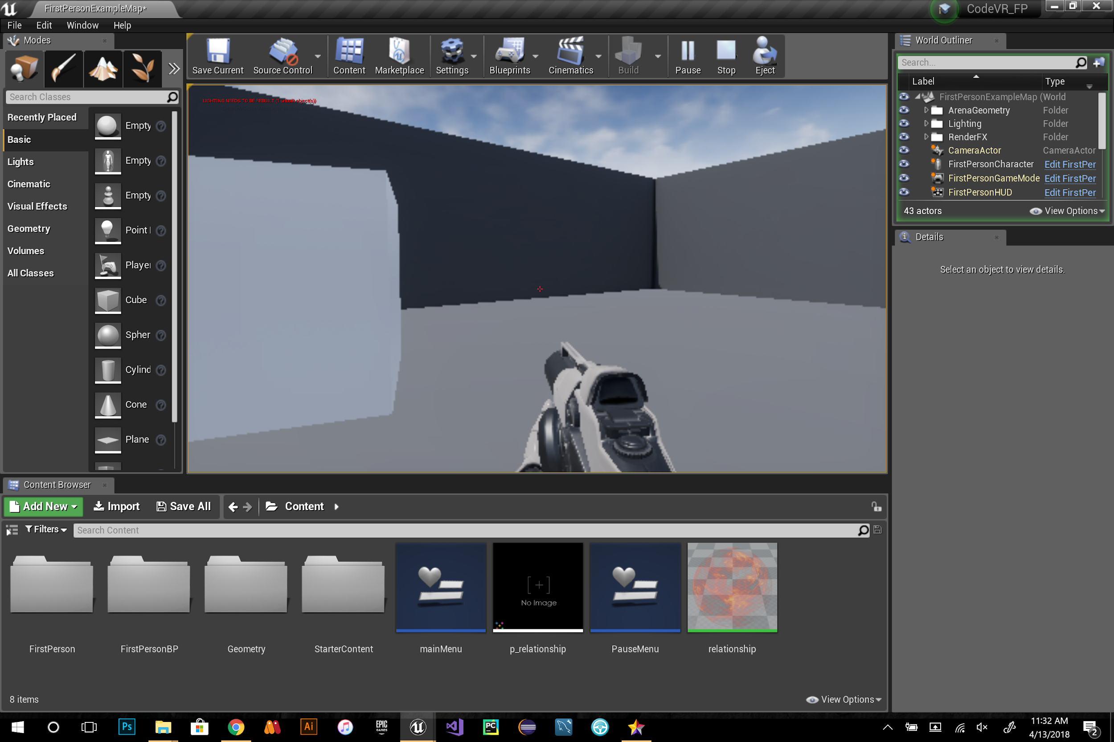

**Fig 3:** drop cube

**User Story ID:** #710 CodeVR Compiler Implementation (Parser Phase)

**Description:** As a developer, I have to implement the Parser module of the CodeVR compiler, so that an abstract syntax tree can be generated for our language application.

**Acceptance Criteria:**

1. Valid parse tree or abstract syntax tree is created from CodeVR source code.
2. CodeVR Language Grammar/Parser Rules must be defined for:
   1. Language 3D Coordinate Placement
   2. Function Declarations
   3. Function Calls
   4. Variable Declaration
   5. Variable Update

**Use Case:**

* Name: Generation of Parse Tree
* Actors: CodeVR Compiler User
* Preconditions: CodeVR source code file has been generated and lexical analysis has successfully generated token stream
* Description <Flow of events>:

1. CodeVR Compiler receives source code
2. CodeVR Compiler performs lexical analysis and passes tokens to parser
3. CodeVR Compiler parses the tokens and generates parse tree via grammar rules

**Use Case Diagram:**

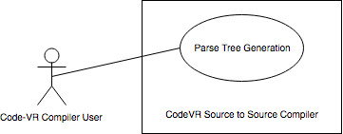

**Figure 1. Use Case Diagram - Parse Tree Generation**

**Sequence Diagram:**

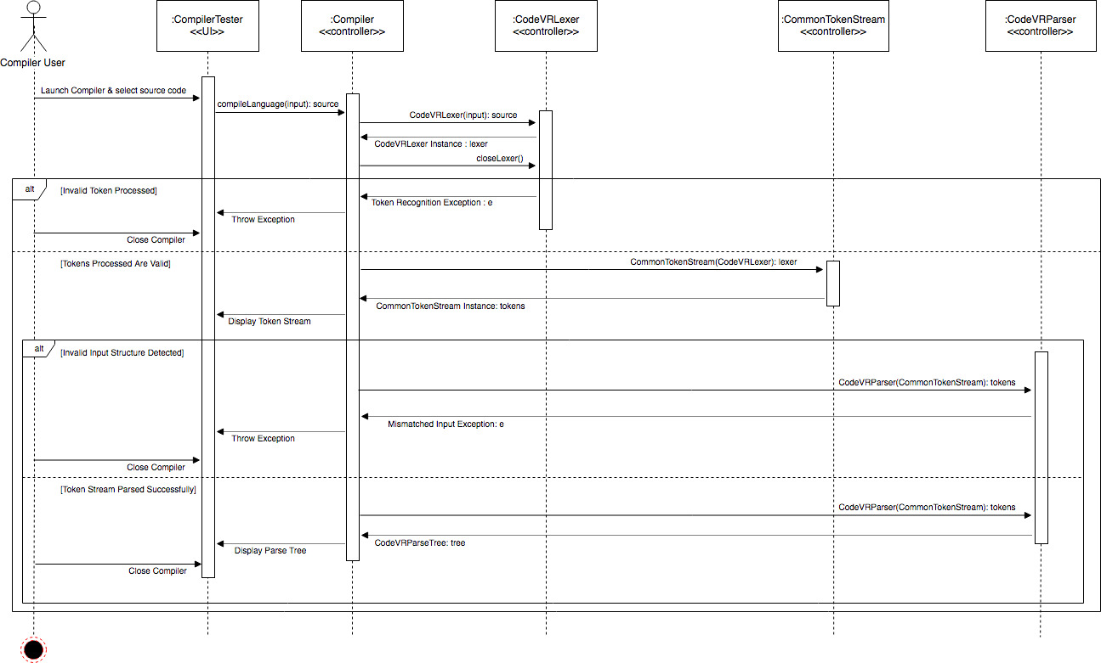

**Figure 2. Sequence Diagram - Parsing Language Input & Generation of**

**CodeVR Parse Tree**

**Class Diagram:**

**Figure 3. Class Diagram - Object Design**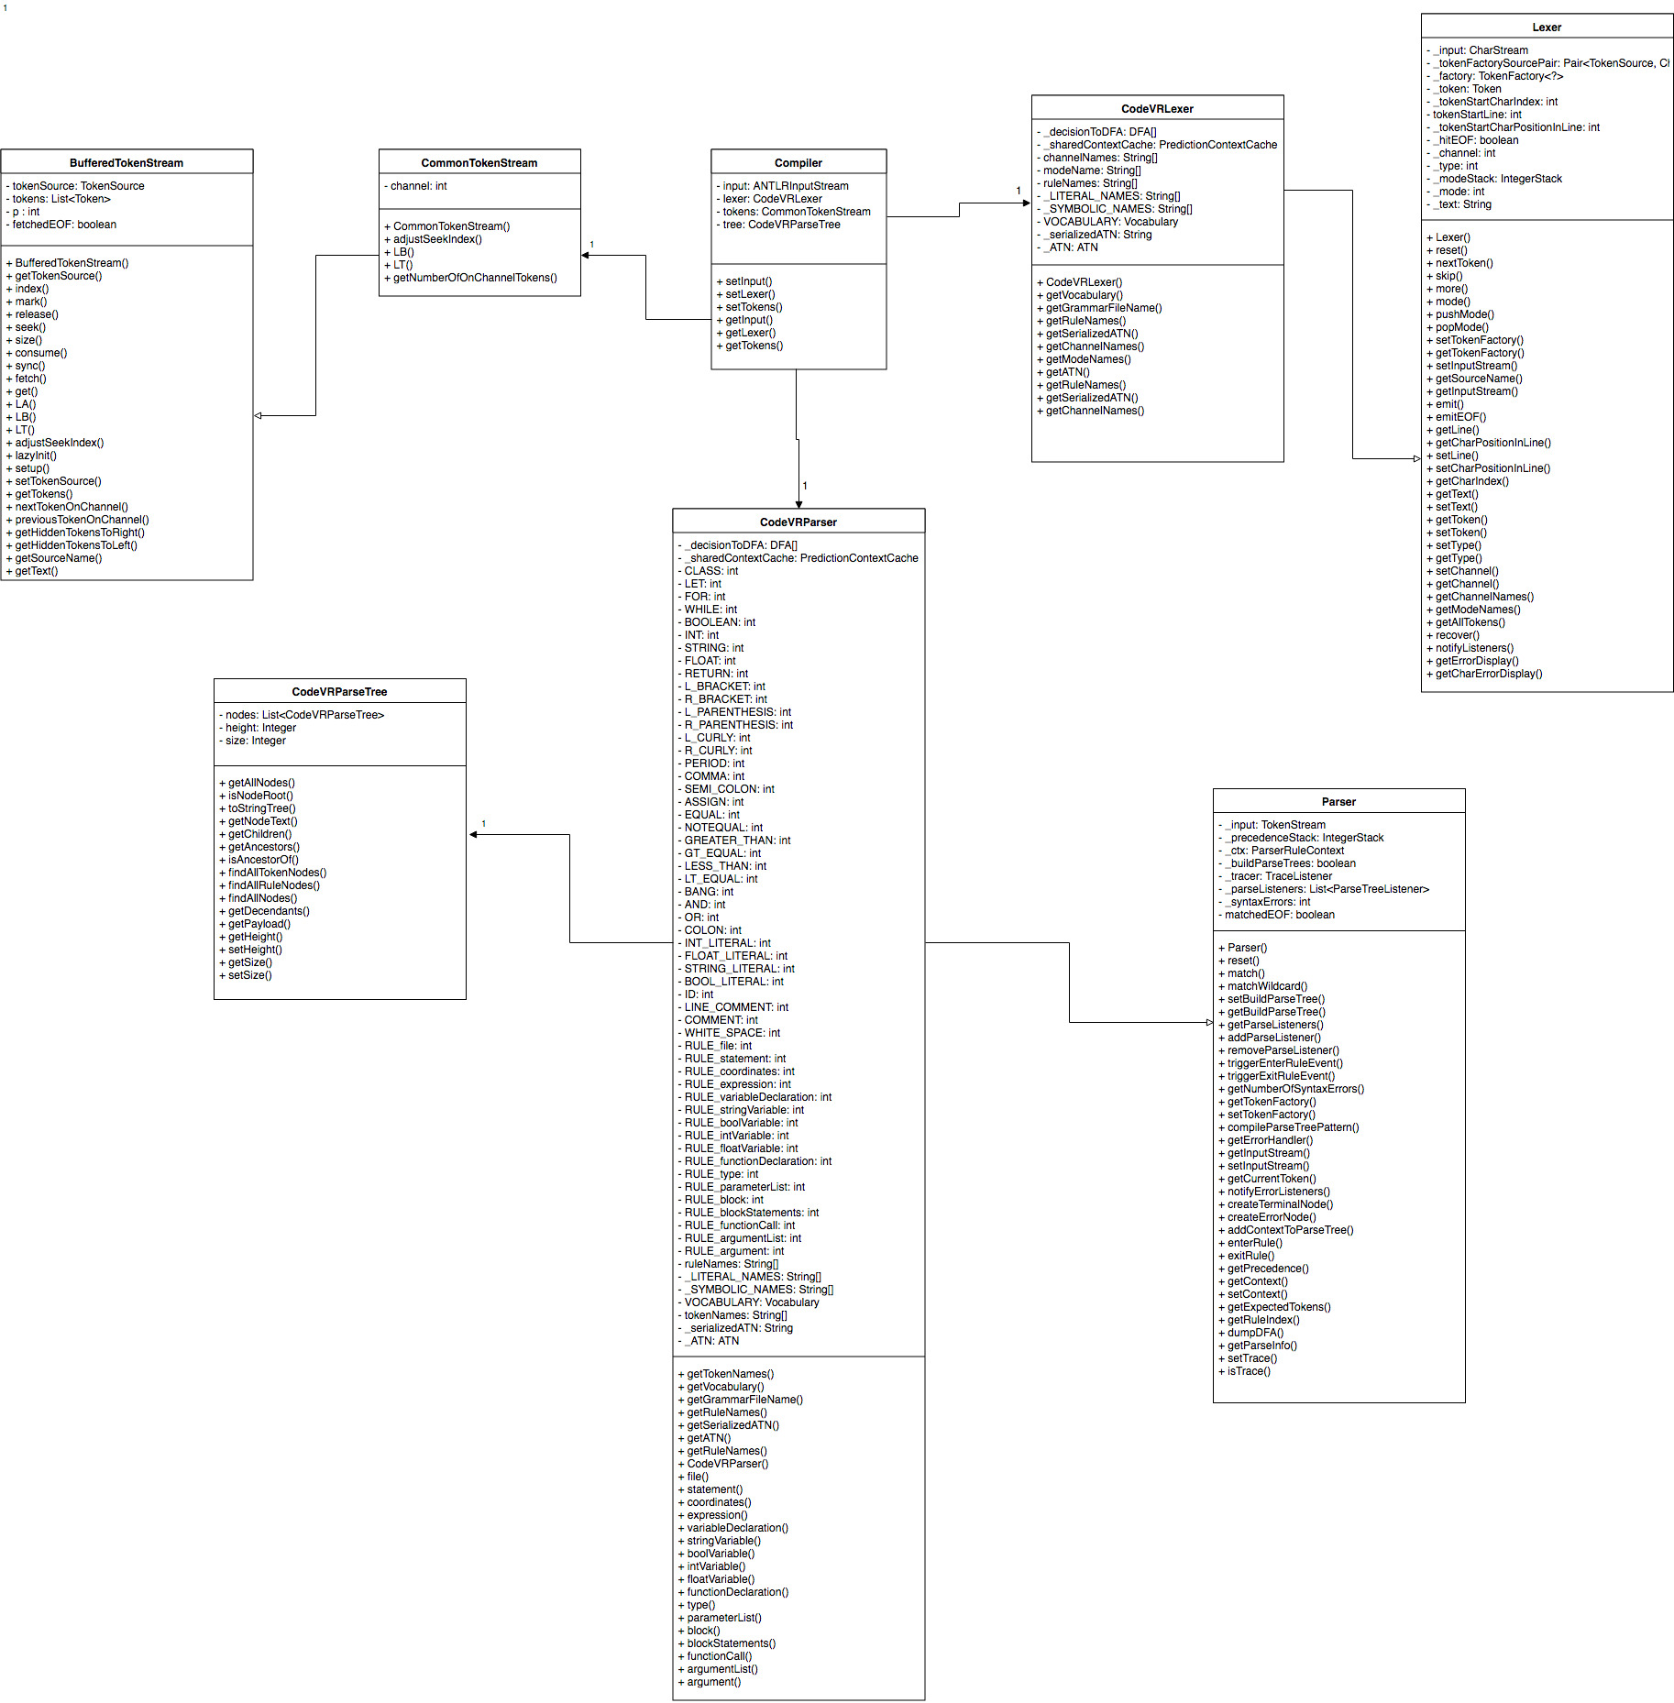

**Visual User Guide:**

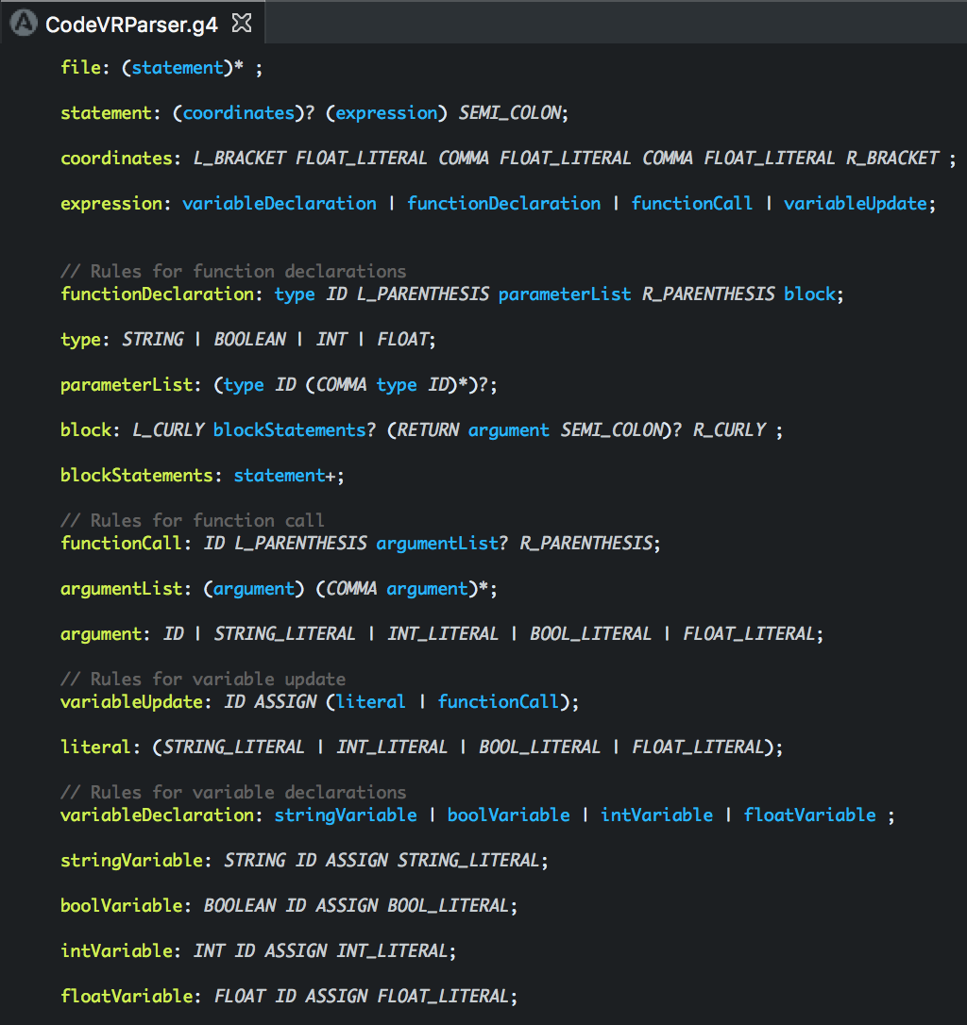

**Figure 4. CodeVR Parser Grammar Rules & Definitions**

**Figure 5. CodeVR Language Source Code**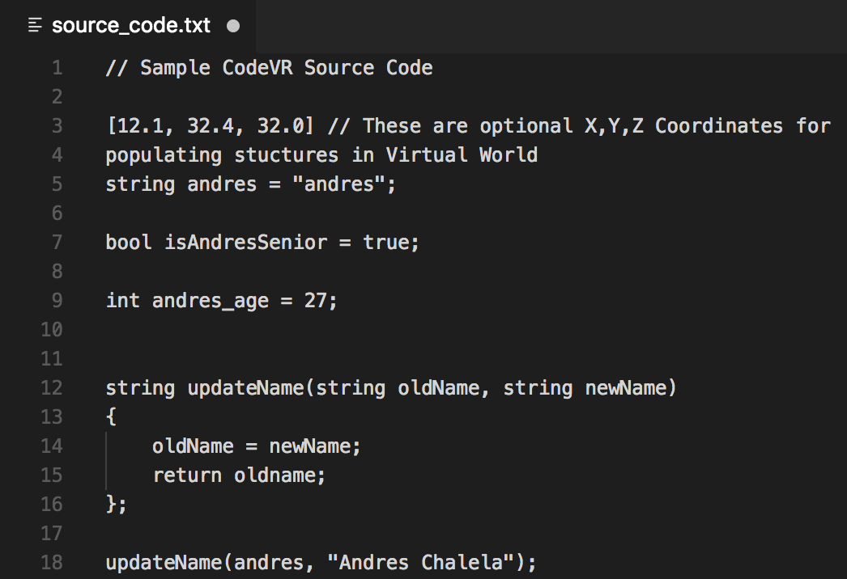

**Figure 6: GUI Representation of Generated CodeVR Parse Tree**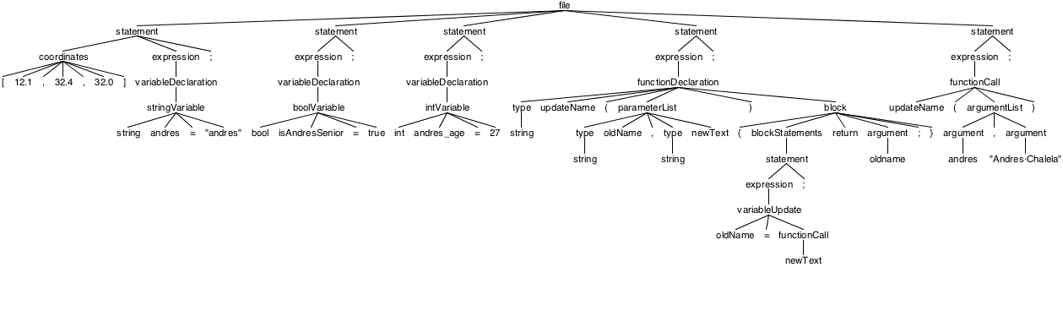

**User Story ID:** #711 3D Algorithm Animation (Physics)

**Description:** As a user, I want to experience 3D Cubes with integer numbers on them so that I can observe the flow of execution of **quick sort** in the CodeVR environment

**Acceptance Criteria:**

* The initial position of the boxes is unsorted
* The final position of the boxes is sorted

**Use Case:**

* Name: Shapes Physics for Animation of Quick Sort
* Actor: User, Sample CodeVR level
* Preconditions:
  + System is in ready state
  + User launch Sample VR level
* Description <Flow of events>:
  + System is in ready state
  + User launch Sample VR application
  + User can displace through the environment
  + User can see virtual 3D shapes as numbers moving
  + User can observe name of Sorting Algorithm “Quick Sort”
  + User can continuously visualize 3D shapes as they move
  + User can see boxes back to initial position

**Use Case Diagram:**

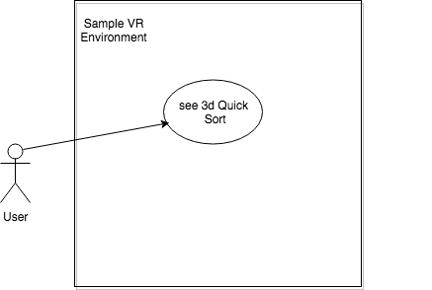

**Sequence Diagram:**

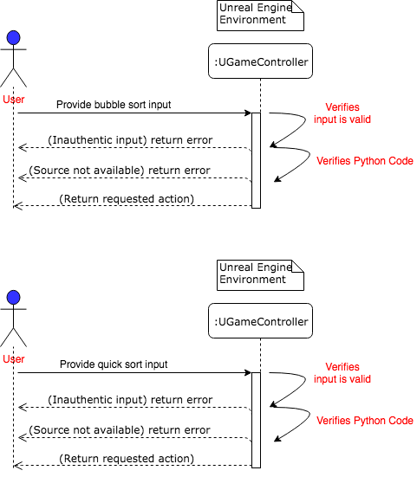

**Class Diagram:**

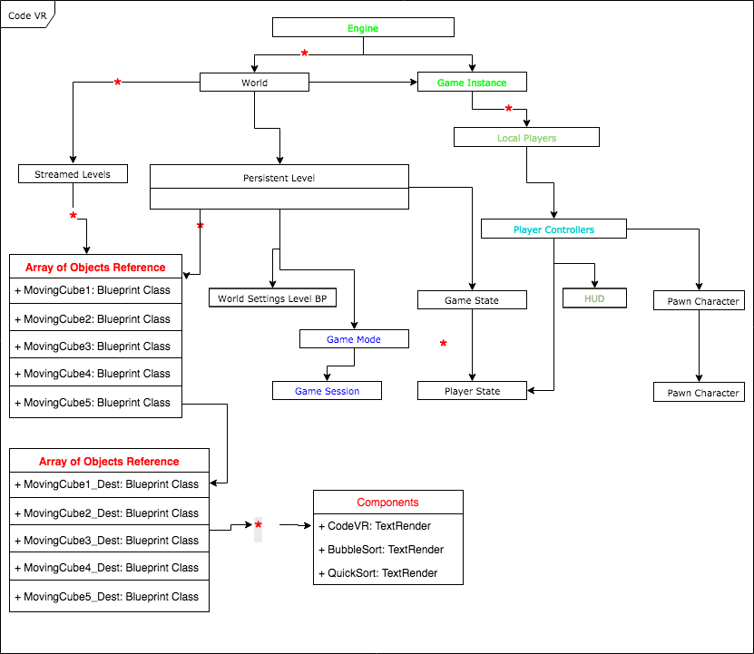

### SPRINT 5

**User Story ID:** #719 3D Cube Actors Flow Synchronization (Phase 1)

**Description:** As a user, I want to experience bubble sort flow of execution in VR so that I can understand how elements of an array data structure behave during the sorting process

**Acceptance Criteria:**

* The initial position of the boxes is unsorted
* The final position of the boxes is sorted

**Use Case:**

* Name: Displacement Optimization 3D memory cells (Represented as Cubes)
* Actor: User, Sample VR level
* Preconditions:
  + System is in ready state
  + User launch Sample VR level
* Description <Flow of events>:
  + System is in ready state
  + User launch Sample VR application
  + User can displace through the environment
  + User can see virtual 3D shapes as numbers
  + User can observe name of Sorting Algorithm “bubble sort”
  + User can continuously visualize 3D shapes as they become sorted

**Use Case Diagram:**



**Sequence Diagram:**



**Class Diagram:**



**User Story ID:** #724 CodeVR Language Application (Phase 1)

**Description**: As a developer, I have to implement a source to source CodeVR language application, so that the exported CodeVR language source code can be translated into Python source code

**Acceptance Criteria:**

1. Understand the purpose of CodeVR listener/visitor
2. Be able to implement a CodeVR Parse Tree listener/visitor
3. Be able to use listener/visitor to traverse the CodeVR Parse Tree nodes
4. Be able to transform the CodeVR source code for variable declarations to Python source code via the use of a listener/visitor.

**Use Case:**

* Name: Translation of variable declaration
* Actors: CodeVR Compiler User
* Preconditions:

1. CodeVR parse tree has been generated via the CodeVR source code input.
2. CodeVR source code input has at least 1 variable declaration

* Description <Flow of events>:
* CodeVR Compiler receives source code
* CodeVR Compiler performs lexical analysis and passes tokens to parser
* CodeVR Compiler parses the tokens and generates parse tree via grammar rules
* CodeVR Compiler traverses the parse tree variable declaration nodes and generates the respective Python Code

**Use Case Diagram:**

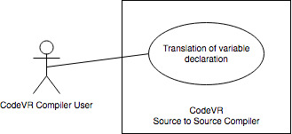

**Figure 1. Use Case Diagram - CodeVR Variable Declaration Translation to Python**

**Sequence Diagram:**

**Figure 2. Sequence Diagram - Execution Flow of** 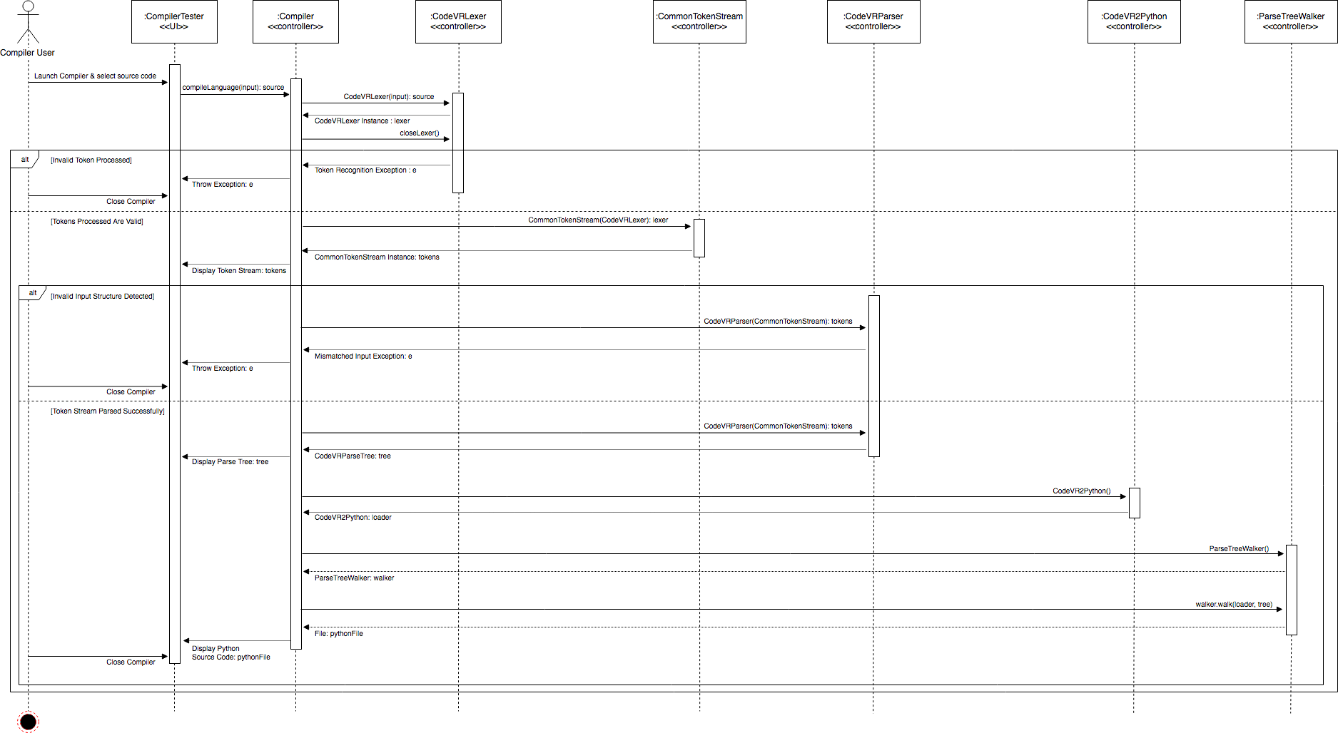

**CodeVR Source to Source Compiler**

**Class Diagram:**

**Figure 3. Class Diagram - Object Design**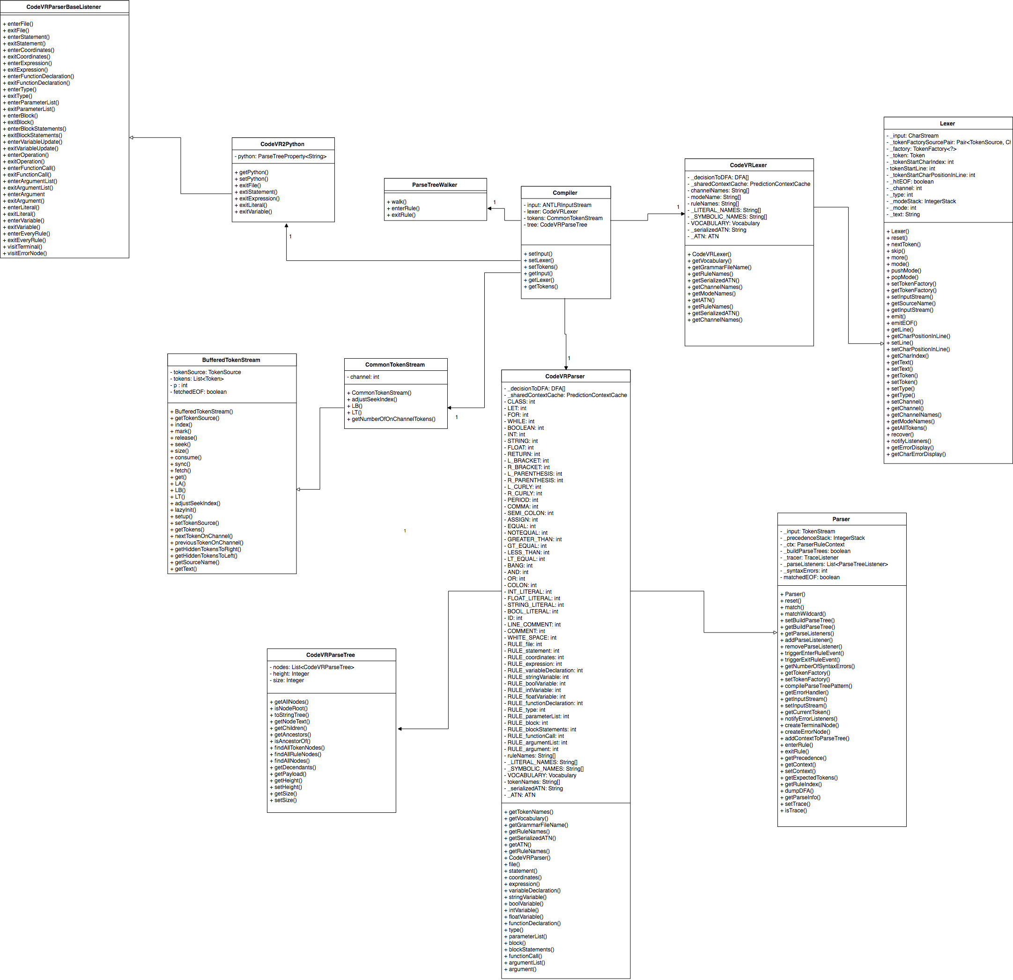

**Visual User Guide:**

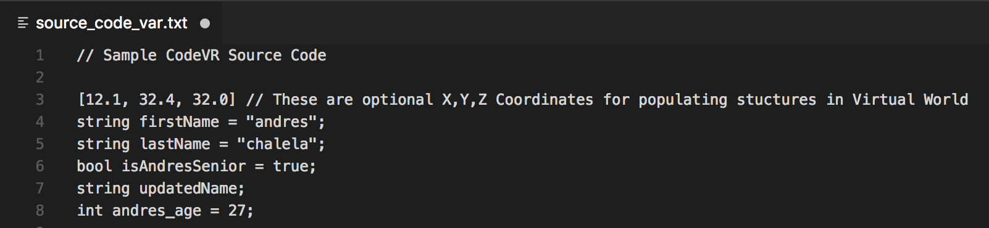

**Figure 4. CodeVR Input Source Code with Variable Declarations**

**Figure 5: GUI Representation of Generated CodeVR Parse Tree**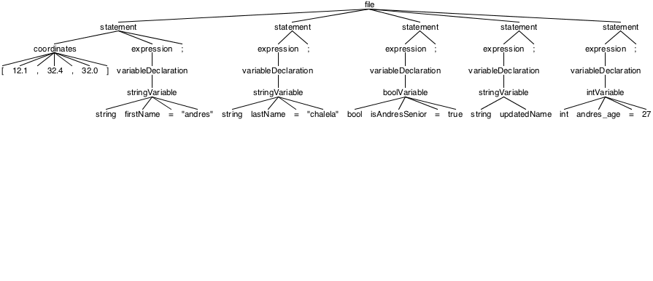

**Figure 6. CodeVR2Python Application Output**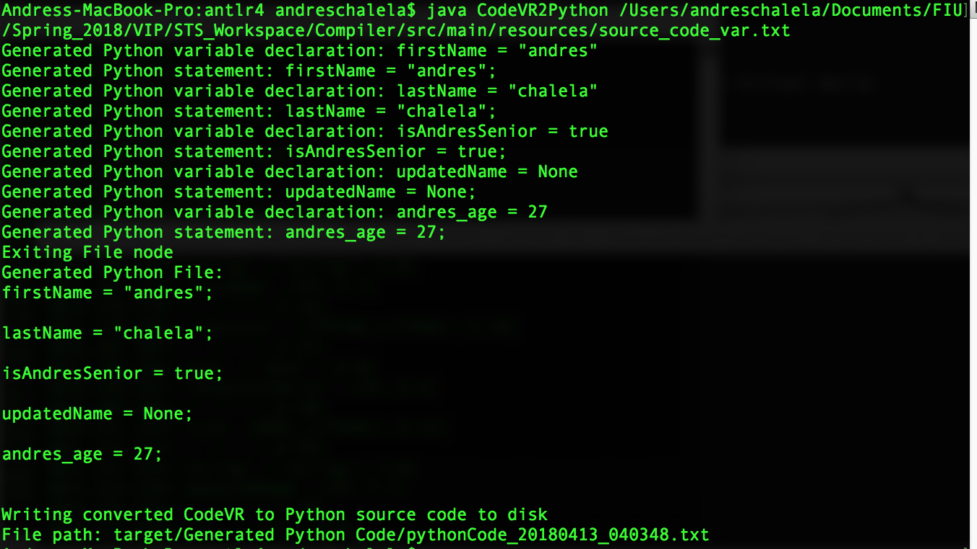

**User Story ID:** [#692](https://fiu-scis-seniorproject.mingle.thoughtworks.com/projects/code_vr/cards/692) Relationship Functionality

**Description:** As a User I would like to have relationship functionality, so that I can visualize, relationship between 3D objects inside of the code-VR environment.

**Acceptance Criteria:**

* visualise relationship between 3D objects
* Add relationship between 3D objects
* Drop relationship between 3D objects

**Use Case:**

* Name: view relationship
* Actor: user
* Preconditions:
  + System in ready state
  + User launch the code-VR application
  + User have a vr controller or working mousepad
* Description <Flow of events>:
  + System in ready state
  + User launch the code-VR application
  + User choose start in the menu
  + User choose a cube for the relationship source
  + User choose a cube for the relationship target
  + relationship of the two cubes are spawn
  + User see a beam going from one box to the other representing a simple relationship

**Use Case Diagram :**

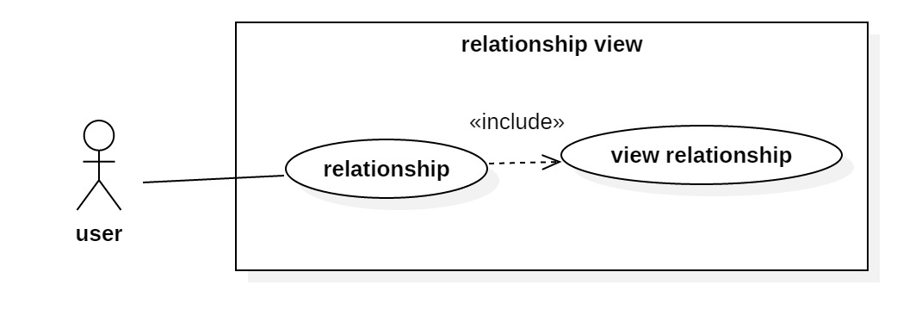

**Use Case - Relationship View**

**Sequence Diagram** :

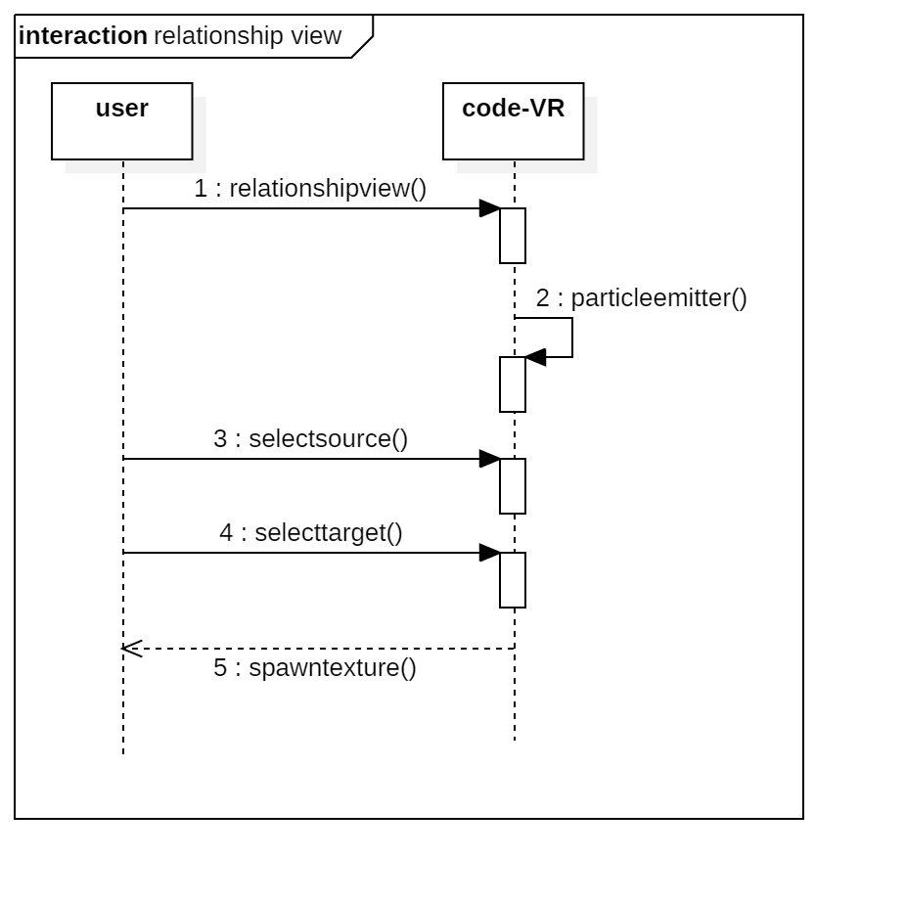

**Relationship View Sequence Diagram**

**Class Diagram**

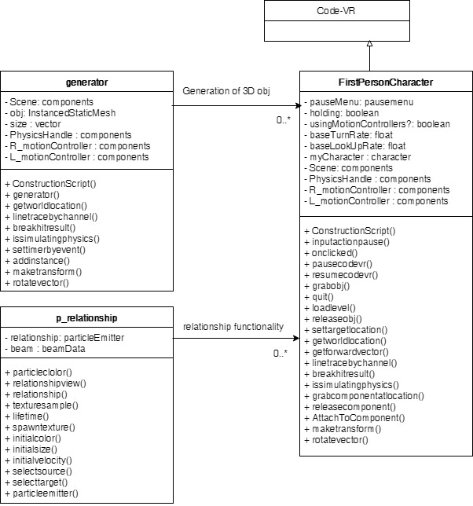

**Visual User Guide:**

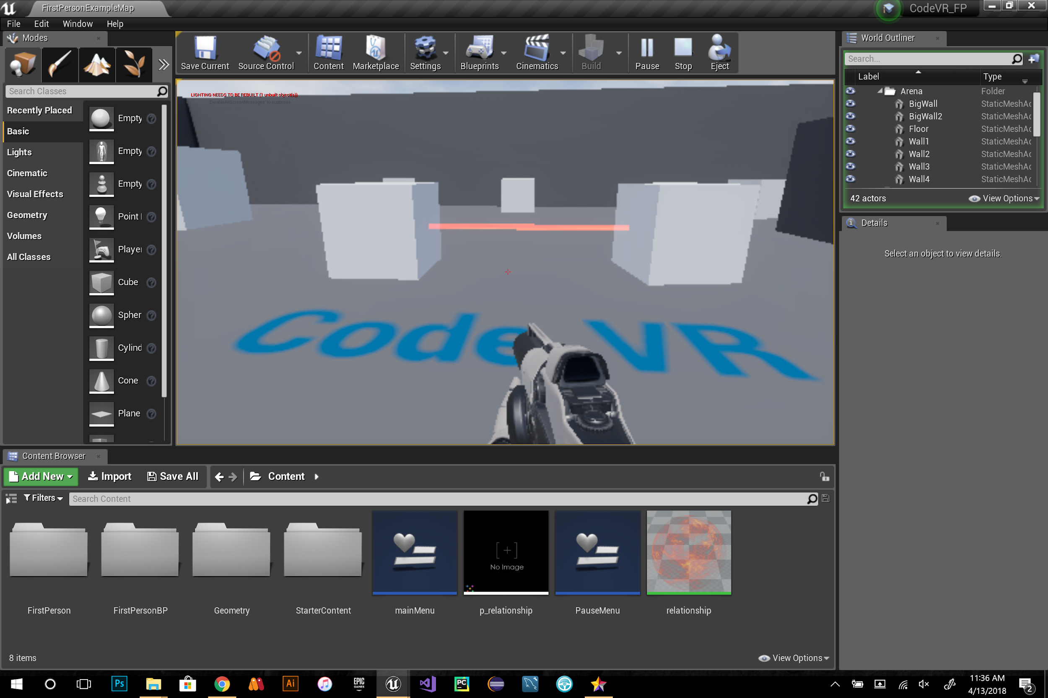

**Fig 1 :** relationship view

### SPRINT 6

**User Story ID:** 3D Cube Actors Flow Synchronization (Phase 2)

**Description:** As a user I want to be able to select bubble sort or quicksort so that I can compare differences and similarities between two different sorting algorithms

**Acceptance Criteria:**

* The initial position of boxes in unsorted
* The user can select between animations

**Use Case:**

* Name: Flow Synchronization Optimization (3D memory cells Represented as Cubes)
* Actor: User, Sample VR level
* Preconditions:
  + System is in ready state
  + User launch Sample VR level
* Description <Flow of events>:
  + System is in ready state
  + User launch Sample VR application
  + User can displace through the environment
  + User can see virtual 3D shapes as numbers
  + User can observe name of Algorithm “bubble sort” and “quicksort”
  + User can continuously visualize 3D shapes as they become sorted
  + User can decide when to stop or continue

**Use Case Diagram:**

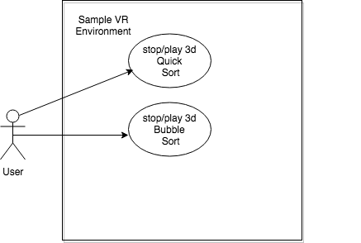

**Sequence Diagram:**



**Class Diagram:**



**User Story ID:** #744 CodeVR Language Application (Phase 2)

**Description:** As a developer, I have to implement a source to source CodeVR language application, so that the exported CodeVR language source code can be translated into Python source code

**Acceptance Criteria:**

1. Implement functionality for translation of CodeVR function declarations
2. Implement functionality for translation of CodeVR function calls
3. Implement functionality for translation of CodeVR variable update statements
4. Implement functionality for exportation of translated Python source code to text file

**US#744 - Use Case 1:**

* Name: Translation of function declaration
* Actors: CodeVR Compiler User
* Preconditions:

1. CodeVR parse tree has been generated via the CodeVR source code input.
2. CodeVR source code input has at least 1 function declaration

* Description <Flow of events>:

1. CodeVR Compiler receives source code
2. CodeVR Compiler performs lexical analysis and passes tokens to parser
3. CodeVR Compiler parses the tokens and generates parse tree via grammar rules
4. CodeVR Compiler traverses the parse tree variable declaration nodes and generates the respective Python Code

**US#744 - Use Case 2:**

* Name: Translation of function call
* Actors: CodeVR Compiler User
* Preconditions:

1. CodeVR parse tree has been generated via the CodeVR source code input.
2. CodeVR source code input has at least 1 function call

* Description <Flow of events>:

1. CodeVR Compiler receives source code
2. CodeVR Compiler performs lexical analysis and passes tokens to parser
3. CodeVR Compiler parses the tokens and generates parse tree via grammar rules
4. CodeVR Compiler traverses the parse tree variable declaration nodes and generates the respective Python Code

**US#744 - Use Case 3:**

* Name: Translation of variable update statement
* Actors: CodeVR Compiler User
* Preconditions:

1. CodeVR parse tree has been generated via the CodeVR source code input.
2. CodeVR source code input has at least 1 variable update statement

* Description <Flow of events>:

1. CodeVR Compiler receives source code
2. CodeVR Compiler performs lexical analysis and passes tokens to parser
3. CodeVR Compiler parses the tokens and generates parse tree via grammar rules
4. CodeVR Compiler traverses the parse tree variable declaration nodes and generates the respective Python Code

**US#744 - Use Case 4:**

* Name: Exportation of Python Code to text file
* Actors: CodeVR Compiler User
* Preconditions:

1. CodeVR Compiler has successfully traversed the parse tree and generated correct Python source code

* Description <Flow of events>:

1. CodeVR Compiler receives source code
2. CodeVR Compiler performs lexical analysis and passes tokens to parser
3. CodeVR Compiler parses the tokens and generates parse tree via grammar rules
4. CodeVR Compiler traverses the parse tree variable declaration nodes and generates the respective Python Code
5. Python code is exported and written to disk in respective file directory

**Use Case Diagram:**

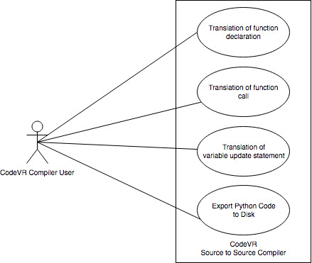

**Figure 1. Use Case Diagram - Translation to Python and Export to Disk**

**Sequence Diagram:**

**Figure 2. Sequence Diagram - Execution of CodeVR Source to Source Compiler**

**Class Diagram:**

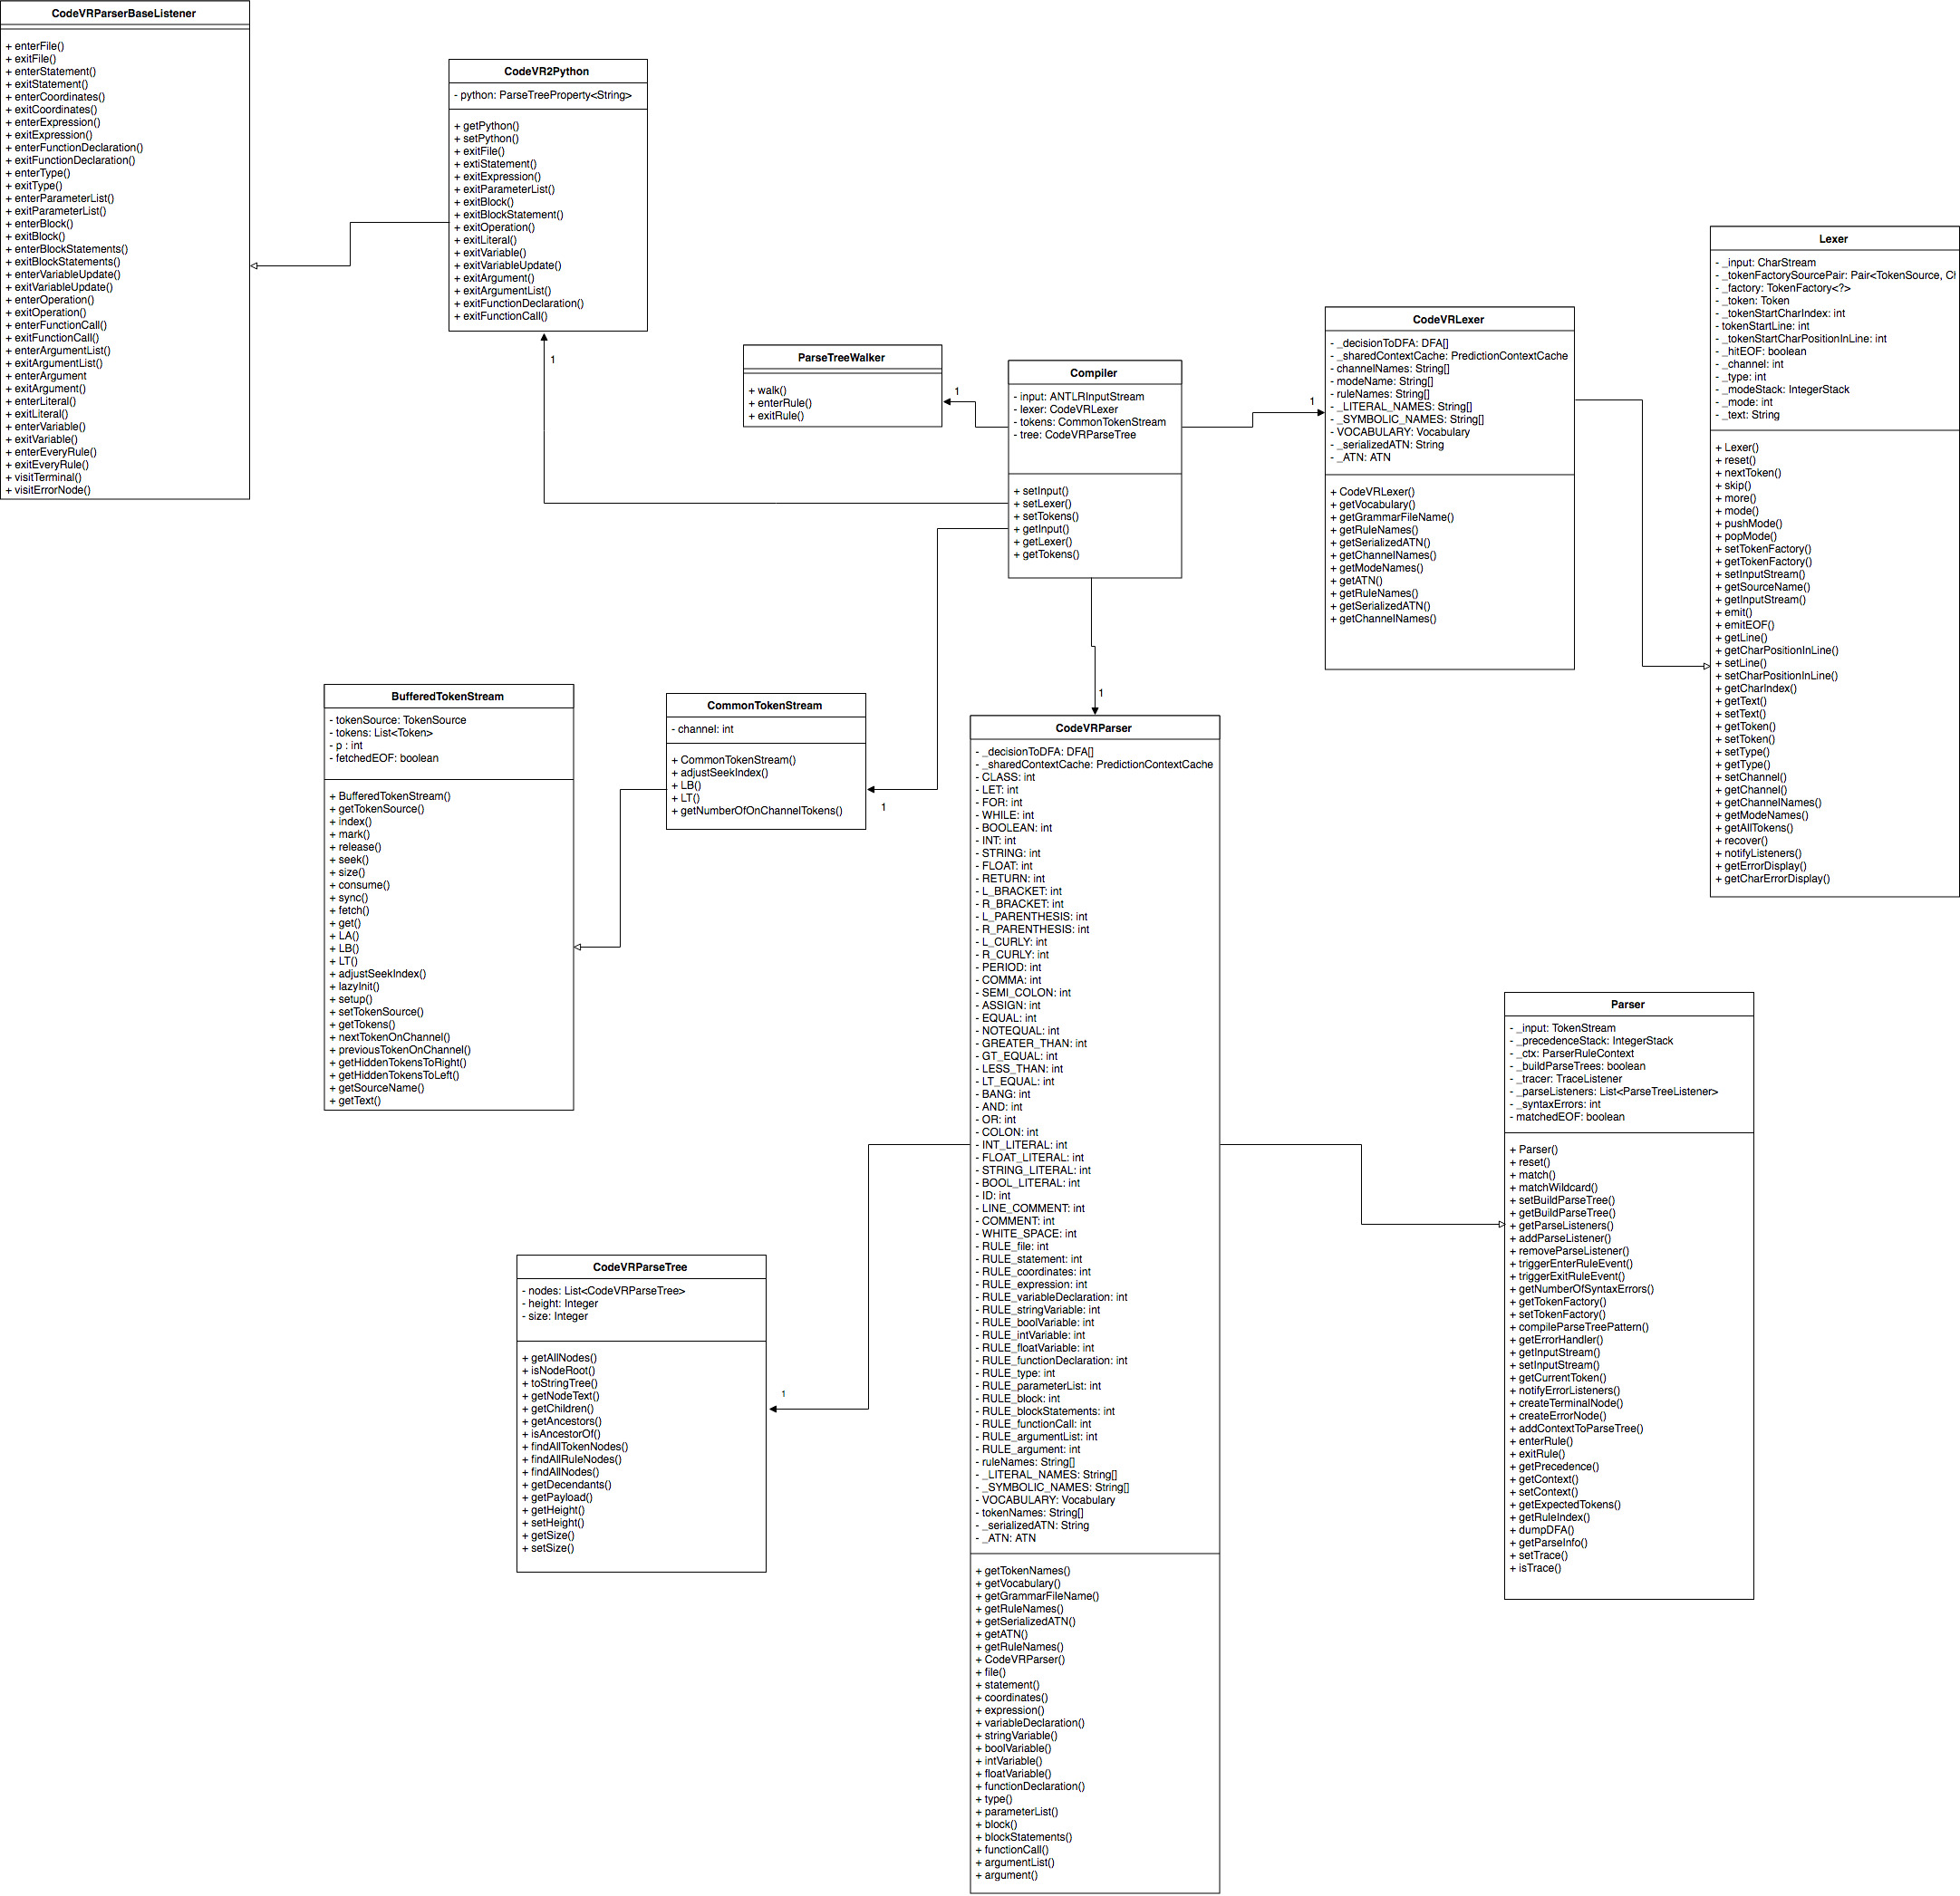

**Figure 3. Class Diagram - Object Design**

**Visual User Guide:**

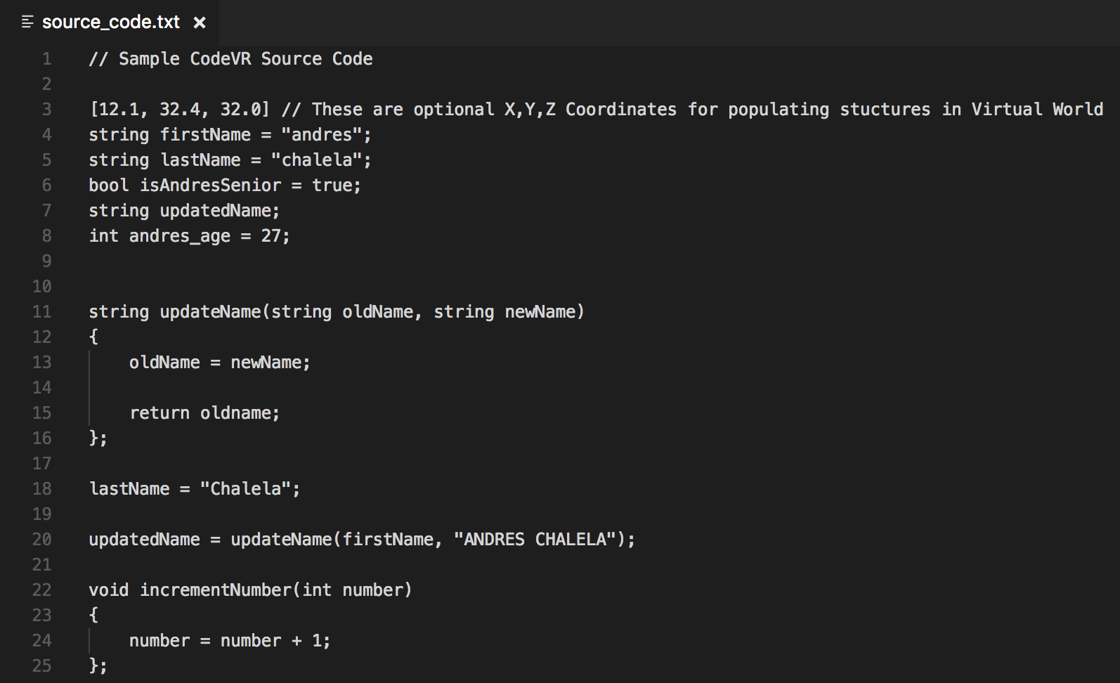

**Figure 4. CodeVR Input Source Code**

**Figure 5: GUI Representation of Generated CodeVR Parse Tree**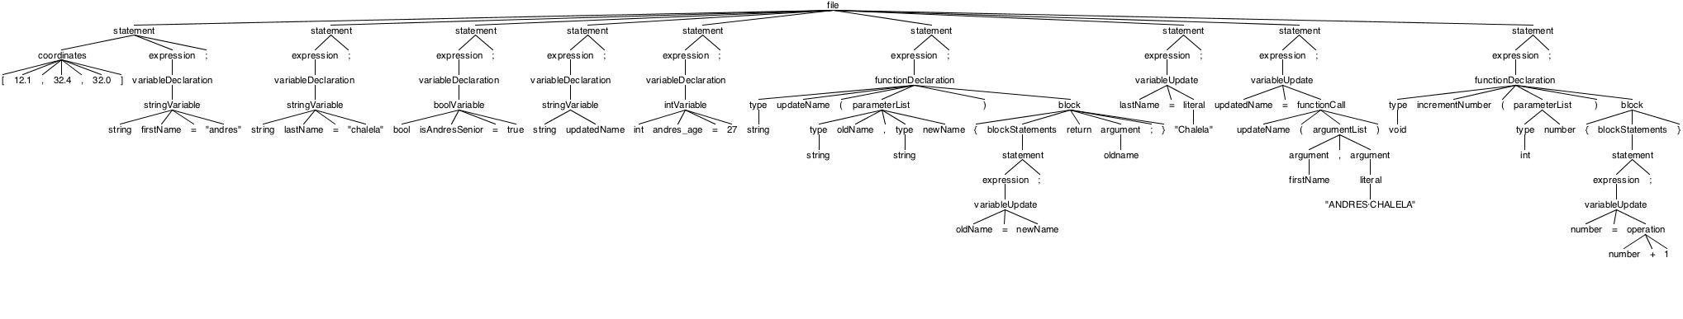

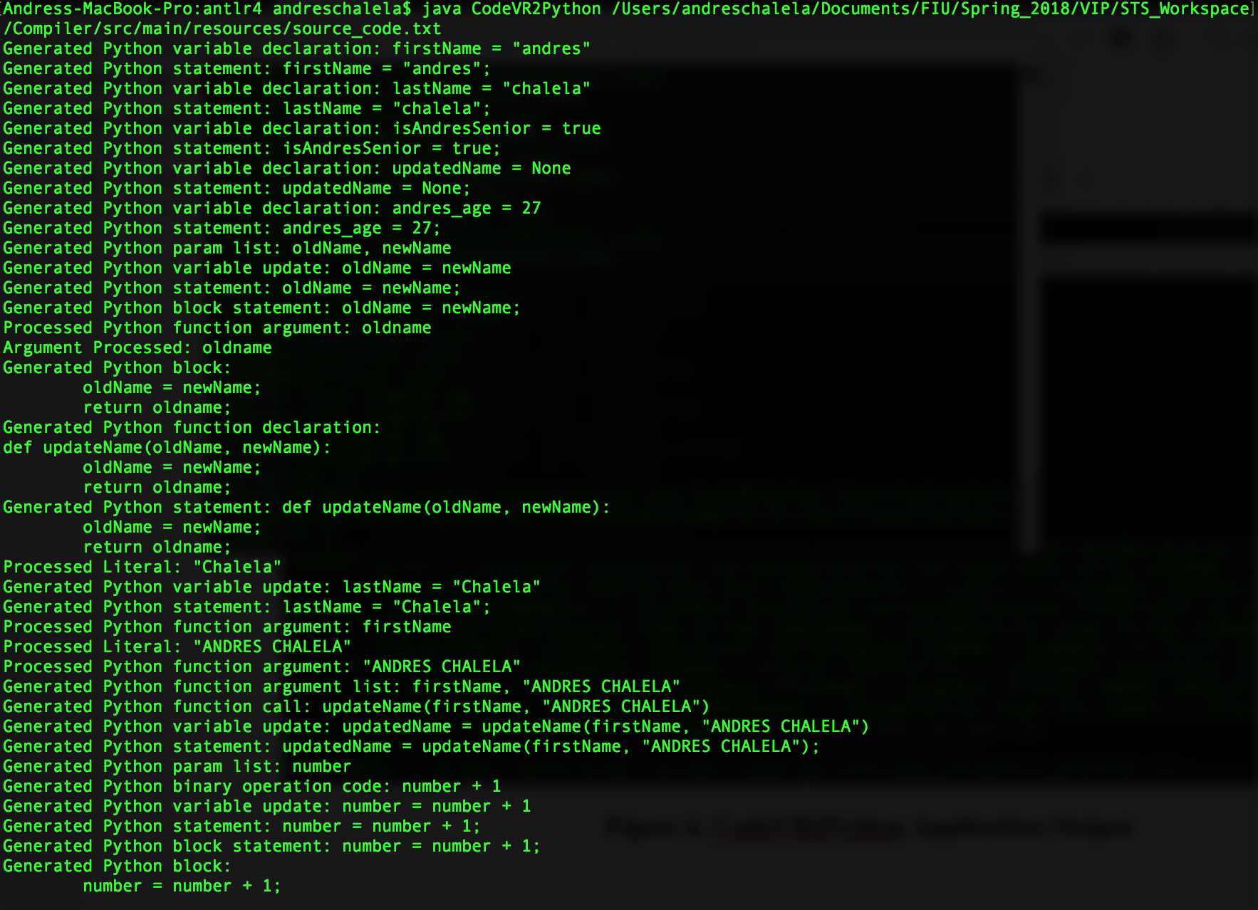

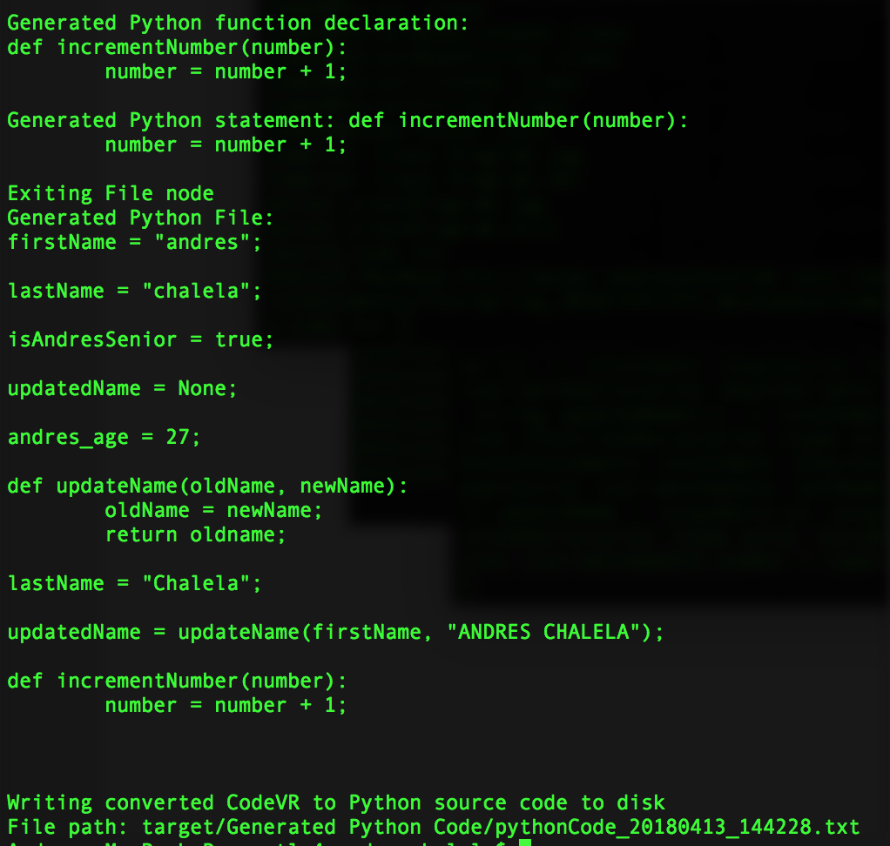

**Figure 6. CodeVR2Python Application Output**

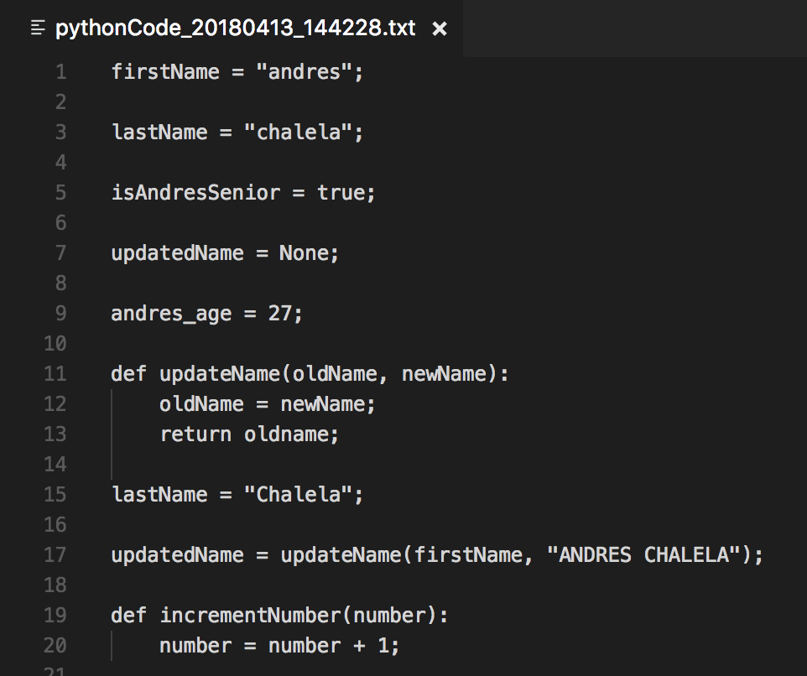

**Figure 7. Exported Python Source Code**

## 

**User Story ID:** #739 Relationship Functionality (Phase 2)

**Description:** As a User I would like to have relationship functionality, so that I can modify relationship between 3D objects inside of code-VR environment.

**Acceptance Criteria:**

* Able to modify relationship between 3D objects.

**Use Case:**

* Name: edit relationship
* Actor: user
* Preconditions:
  + System in ready state
  + User launch the code-VR application
  + User have a vr controller or working mousepad
  + User can see an existent relationship
* Description <Flow of events>:
  + User can see an existent relationship
  + User choose a different cube for the relationship source
  + User choose a different cube for the relationship target
  + relationship of the previously selected cubes is no more,
  + The newly selected two cubes are showing the relationship now
  + User see a beam going from one box to the other representing a simple relationship

**Use Case Diagram :**

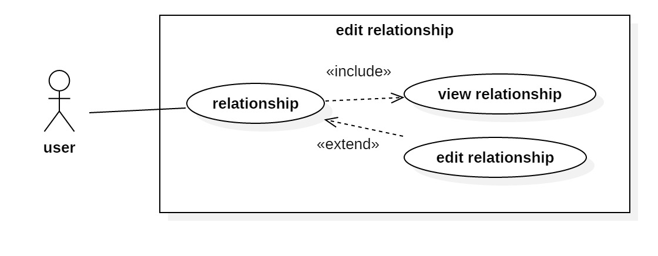

**Use Case - Edit Relationship**

**Sequence Diagram:**

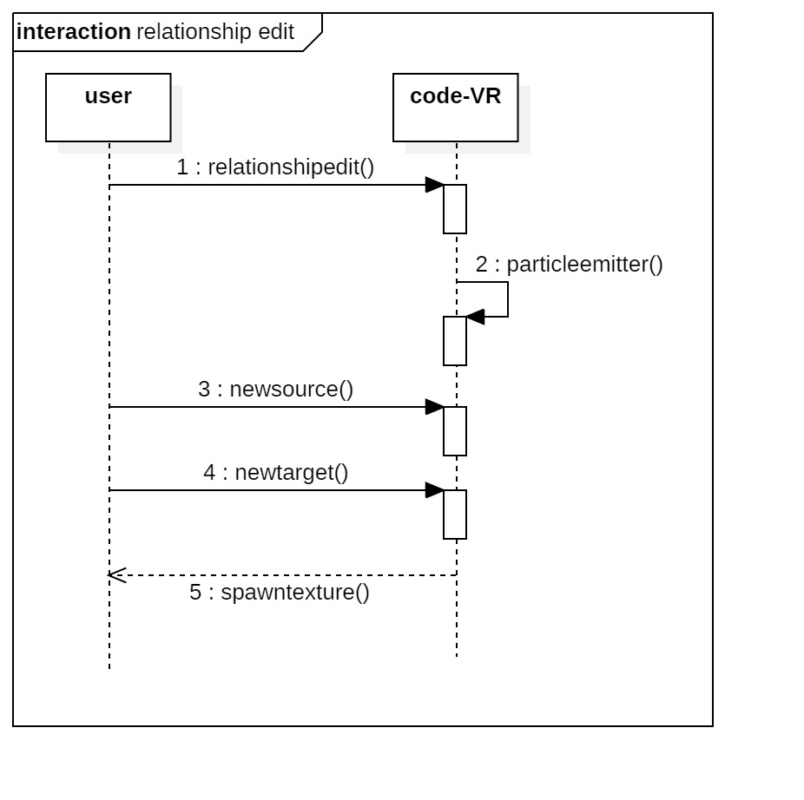

**Edit Relationship Sequence Diagram**

**Class Diagram**

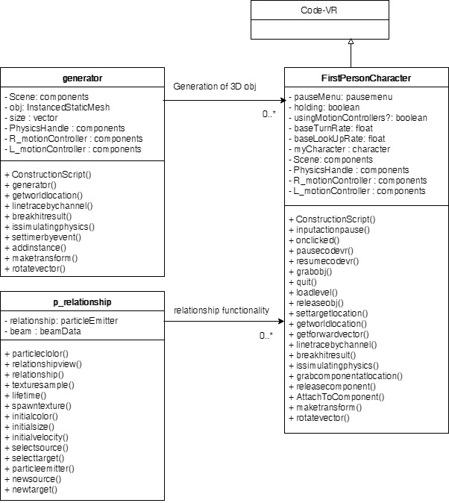

**Visual User Guide:**



**Fig 1 :** relationship view

## Pending User Stories

The following table contains the pending user stories for the CodeVR project.

|  |
| --- |
| Pending User Stories |
| * **Expansion of CodeVR Domain Specific Language**   + **Description:** As a developer, I need to expand the CodeVR grammar, so that users can have a more in-depth programming experience when exporting their generated code.   + **Acceptance Criteria:**     1. Add grammar rules that allow CodeVR to support if-statements     2. Add grammar rules that allow CodeVR to support for-loops     3. Add grammar rules that allow CodeVR to support classes * **Integration of CodeVR Compiler with Virtual Reality Application**   + **Description:** As a developer, I need to integrate the CodeVR Compiler with the VR application, so that users can export their generated code and translate it to a supported language of their choosing.   + **Acceptance Criteria:**     1. Be able to generate CodeVR source code from 3D objects in virtual environment     2. Be able to export generated code and pass it as input to the CodeVR compiler * **Expand Supported Languages for CodeVR Compiler**   + **Description:** As a developer, I need to add support for other programming languages to the CodeVR Compiler, so that users have the option to select to view their generated CodeVR code in a programming language of their choosing.   + **Acceptance Criteria:**     1. Be able to translate CodeVR source code to another language, such as C++, Java, JavaScript, etc…      * **Importation of CodeVR Source Code into Virtual Environment**   + **Description:** As a developer, I need to add support for importation of CodeVR source code, so that users have the option of manipulating and interacting with their pre-made code in the virtual environment.   + **Acceptance Criteria:**     1. Be able to import pre-made CodeVR source code into the virtual environment     2. Imported code is displayed as virtual objects that can be manipulated by a user |

# 

# Project Plan

This section describes the planning that went into the realization of this project. This project incorporated the agile development techniques and as such required the sprints to be planned. These sprint plannings are detailed in the section. This section also describes the components, both software and hardware, chosen for this project.

## Hardware and Software Resources

The following is a list of all hardware and software resources that were used in this project:

**Hardware**

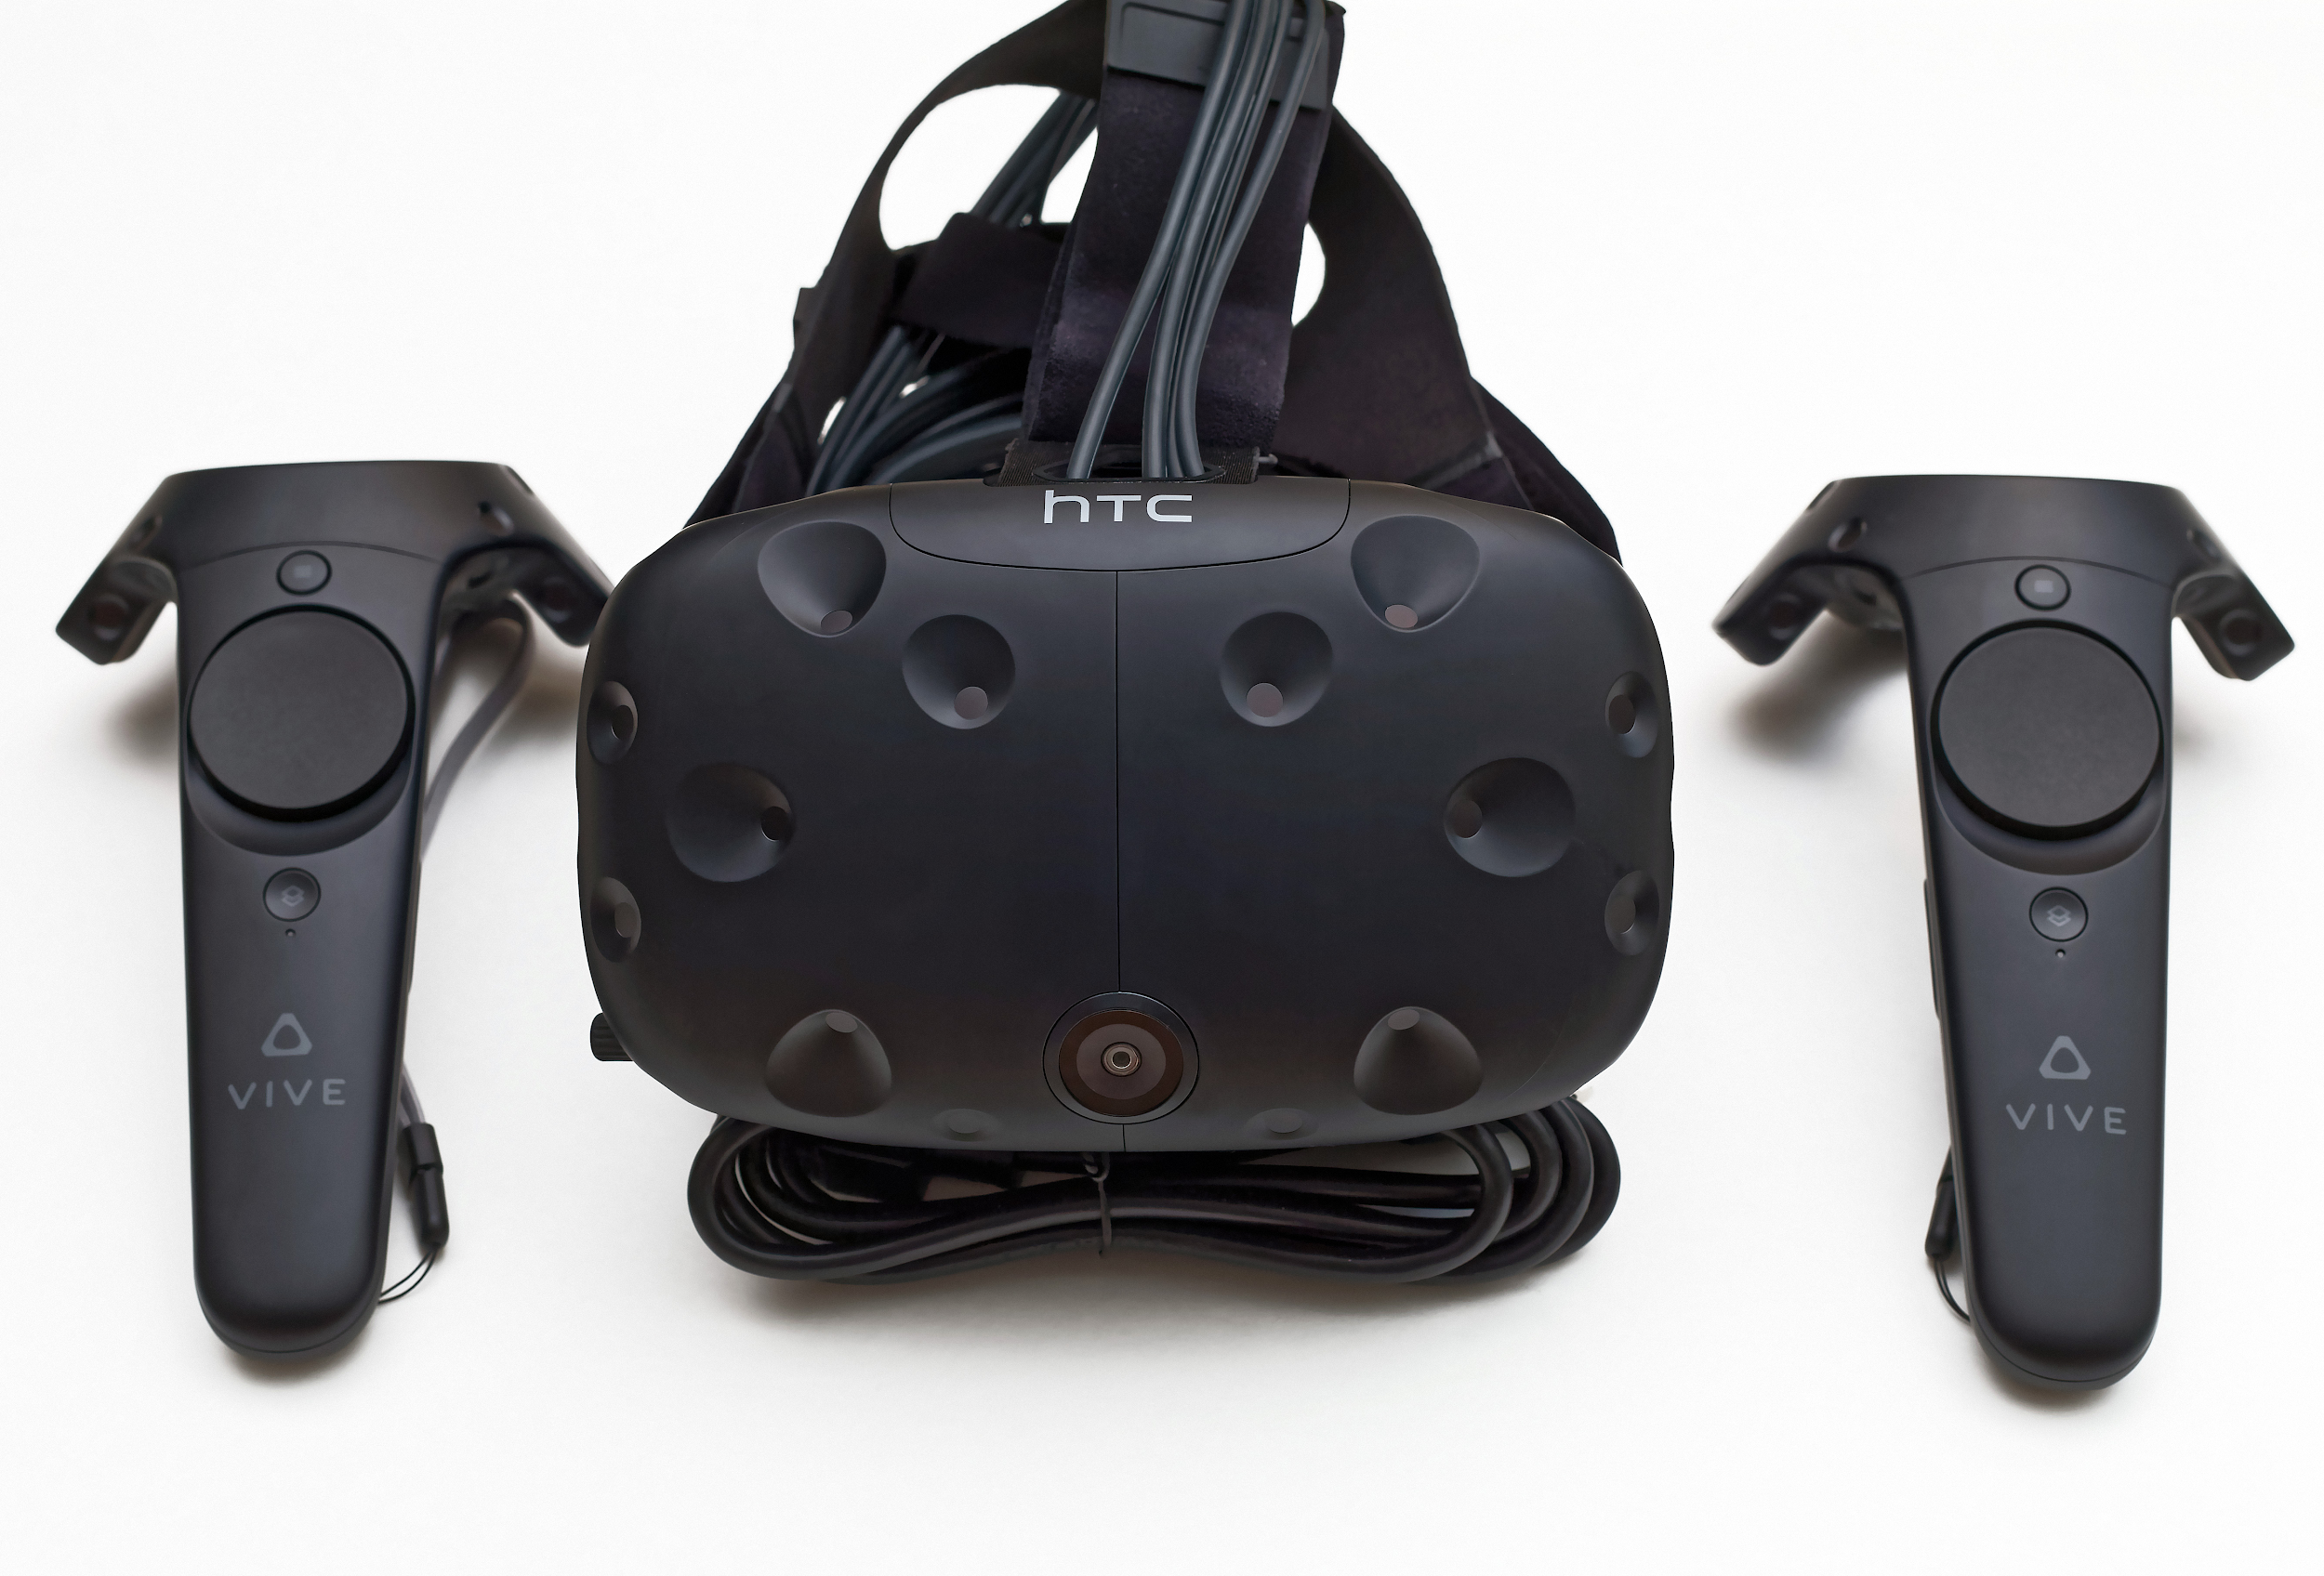

1. HTC Vive - Virtual Reality Headset
   1. Display Resolution : 2160 x 1200
   2. Base Station x 2
   3. Vive Controllers x 2

**Software**

1. Unreal Engine 4 - Virtual Application Development
2. Microsoft Visual Studio Professional 2017 - Implementation of 3D object functionalities
3. ANTLR4 Framework - CodeVR Language & Compiler Development
4. Spring Tool Suite - CodeVR Language & Compiler Development

## Sprint Planning

### 

### Sprint 2

Attendees: Andres Chalela, Miguel Jardines, Rolf Kinder Gilet, Francisco Ortega

Start time: 10:30am

End time: 11:30am

After discussion, the velocity of the team was estimated to be 120 hrs/Sprint.

The product owner chose the following user stories to be done during the next sprint. They are ordered based on their priority.

* User Story#670 Complete Parser Implementation (Phase 1)
* User Story#666 Embedded Python Server Execution
* User Story#667 VR Controller Menu (Research & Implementation)
* User Story#668 Implementation of Different Shapes

The team members indicated their willingness to work on the following user stories.

* Andres Chalela
* User Story#670 Complete Parser Implementation (Phase 1)
* Rolf Kinder Gilet
* User Story#666 Embedded Python Server Execution
* User Story#668 Implementation of Different Shapes
* Miguel Jardines
* User Story#667 VR Controller Menu (Research & Implementation)

### 

### Sprint 3

Attendees: Andres Chalela, Miguel Jardines, Rolf Kinder Gilet, Francisco Ortega

Start time: 10:30am

End time: 11:30am

After discussion, the velocity of the team was estimated to be 120 hrs/Sprint.

The product owner chose the following user stories to be done during the next sprint. They are ordered based on their priority.

* User Story #704 CodeVR Compiler Implementation (Lexer Phase)
* User Story #694 Update Menu
* User Story #691 3D Shape Generator functionality
* User Story #690 3D Shapes Animation(Behavior)

The team members indicated their willingness to work on the following user stories.

* Andres Chalela
* User Story #704 CodeVR Compiler Implementation (Lexer Phase)
* Rolf Kinder Gilet
* User Story #694 Update Menu
* User Story #691 3D Shape Generator functionality
* Miguel Jardines
* User Story #690 3D Shapes Animation(Behavior)

### 

### Sprint 4

Attendees: Andres Chalela, Miguel Jardines, Rolf Kinder Gilet, Francisco Ortega

Start time: 10:30am

End time: 11:30am

After discussion, the velocity of the team was estimated to be 120 hrs/Sprint.

The product owner chose the following user stories to be done during the next sprint. They are ordered based on their priority.

* User Story #710 CodeVR Compiler Implementation (Parser Phase)
* User Story #688 Grab and Drop Functionality
* User Story #711 3D Algorithm Animation (Physics)

The team members indicated their willingness to work on the following user stories.

* Andres Chalela
* User Story #710 CodeVR Compiler Implementation (Parser Phase)
* Rolf Kinder Gilet
* User Story #688 Grab and Drop Functionality
* Miguel Jardines
* User Story #711 3D Algorithm Animation (Physics)

### 

### Sprint 5

Attendees: Andres Chalela, Miguel Jardines, Rolf Kinder Gilet, Francisco Ortega

Start time: 10:30am

End time: 11:30am

After discussion, the velocity of the team was estimated to be 120 hrs/Sprint.

The product owner chose the following user stories to be done during the next sprint. They are ordered based on their priority.

* User Story #692 Relationship Functionality
* User Story #724 CodeVR Language Application (Phase 1)
* User Story #719 3D Cube Actors Flow Synchronization (Phase 1)

The team members indicated their willingness to work on the following user stories.

* Andres Chalela
* User Story #724 CodeVR Language Application (Phase 1)
* Rolf Kinder Gilet
* User Story #692 Relationship Functionality
* Miguel Jardines
* User Story #719 3D Cube Actors Flow Synchronization (Phase 1)

### Sprint 6

Attendees: Andres Chalela, Miguel Jardines, Rolf Kinder Gilet, Francisco Ortega

Start time: 10:30am

End time: 11:30am

After discussion, the velocity of the team was estimated to be 120 hrs/Sprint.

The product owner chose the following user stories to be done during the next sprint. They are ordered based on their priority.

* User Story #739 Relationship Functionality (Phase 2)
* User Story #744 CodeVR Language Application (Phase 2)
* User Story #743 3D Cube Actors Flow Synchronization (Phase 2)

The team members indicated their willingness to work on the following user stories.

* Andres Chalela
* User Story #744 CodeVR Language Application (Phase 2)
* Rolf Kinder Gilet
* User Story #739 Relationship Functionality (Phase 2)
* Miguel Jardines
* User Story #743 3D Cube Actors Flow Synchronization (Phase 2)

### Sprint 7

Attendees: Andres Chalela, Miguel Jardines, Rolf Kinder Gilet, Francisco Ortega

Start time: 10:30am

End time: 11:30am

After discussion, the velocity of the team was estimated to be 120 hrs/Sprint.

The product owner chose the following user stories to be done during the next sprint. They are ordered based on their priority.

* No User Stories were made for this sprint. Team members met up and collaborated to finalize documents, videos, and demos.

# 

# 

# System Design

This section contains information on the design decisions that went into this project. The architecture patterns are outlined and explained. The entire system is shown in a package diagram and the subsystems are explained. Finally, the design patterns used in the project are discussed.

## Architectural Patterns

The CodeVR 1.0 project is divided into two separate sections, a front-end and a back-end. The front-end is developed using Unreal Engine 4 to create the 3D objects and 3D tools that the user can use to interact with the CodeVR virtual reality environment. The back-end is implemented using Unreal Blueprint Scripting and Microsoft Visual Studio 2017 with C++ at is core. The current design allows for continuous integrationand refactoring of components as user requirements change. Animations of sorting algorithms in the VR environment are aimed to be simulated in the presence of their respective Python source code. CodeVR takes advantage of the code modularity, real world naming conventions and the connection between 3D objects offered by Object Oriented Design with Unreal Engine 4/C++. Actors and animations, such as the 3D cubes and Bubble Sort, are independent modules in the CodeVR system that prevent runtime overhead and maintain connection between all objects in the system. Additionally, the CodeVR Source to Source Compiler is a separate back-end application implemented with the Java programming language and the ANTLR4 framework.

## 

## System and Subsystem Decomposition

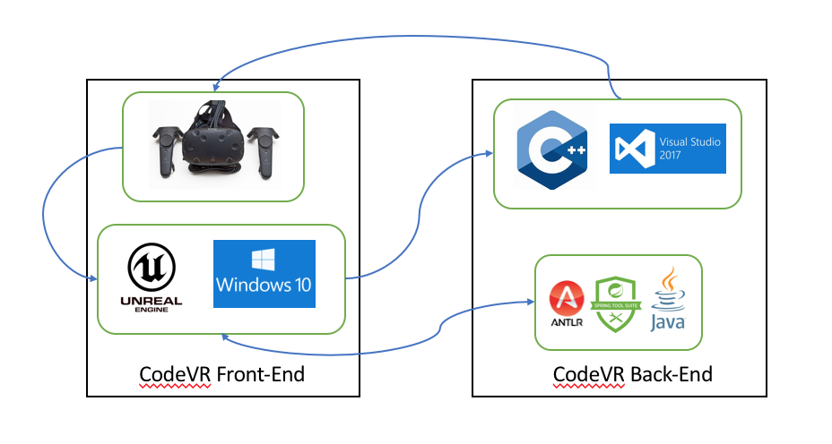

The back-end of the CodeVR virtual application is composed of Unreal Blueprints, scripts and C++ source code to generate predefined object functionality and functionality for the implemented user interface tools. The CodeVR Compiler is a modular back-end application that is decoupled from the virtual side of the project and is composed of the required ANTLR4 grammar files and Java classes.

The front-end is composed of a set of predefined 3D objects created within the Unreal platform, that represent the coding elements of our virtual language. The implemented CodeVR tools are also 3D objects that the user can use and interact with to generate predefined 3D Objects, perform move grab and drop operations, create relationships between objects, and execute functions.

## Deployment Diagram

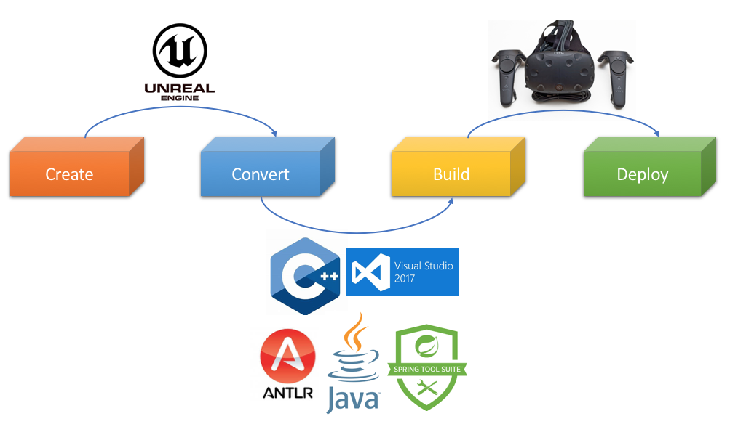

Developing and deploying the CodeVR 1.0 application requires four key steps: Creation, Conversion, Building, and Deployment. The Create step deals with the production of the virtual world that a user would be placed in, the generation of the 3D objects that represent the programming concepts, and the development of the functionality for the generated objects. The development is done via the Unreal Engine 4 platform which offers all the needed tools for the creation of a virtual reality application. Additionally, C++ and Visual Studio are used for the implementation of the animations and functionalities that the objects have in the virtual environment. Since the CodeVR Compiler is decoupled from the Unreal Engine project, the development of the language application is done via the Spring Tool Suite IDE and relies on the ANTLR4 framework. The Convert step generates the needed project files from the Unreal platform, which can be opened in Virtual Studio for further customization through direct code manipulation. In respect to the CodeVR Compiler, the Convert step generates the required Java classes from the provided ANTLR4 lexer and parser grammar files. The implementation of the source to source language application is done during the Convert step once the base Java classes are generated by ANTLR4. The Build step manages the compilation and creation of the Unreal application, and the compilation of the CodeVR Compiler classes required to launch the source to source language application. Once all the files have been compiled and built, the Unreal CodeVR application and source to source compiler can be deployed successfully.

## 

## Design Patterns

CodeVR 1.0 is built in the form of levels which represent the different environments that a user can interact with. The first level that a user sees is the initial main menu screen that provides the following options:

1. Selection of a premade Python source code file for importation
2. Launch the CodeVR 3D environment,
3. Exiting the CodeVR Unreal application.

The selection of the option for picking a premade Python source code file takes the user to another level, which populates and displays a list of available source code files that have been placed within the correct directory in the CodeVR project structure. The selection of the option which launches the CodeVR 3D environment places the user into a sandbox style virtual world in where they will see the 3D objects generated from the selected Python source code file. If a user does not select a premade Python source code file prior to launching the 3D level, they are placed in an empty world to start programming from scratch. Once in the 3D world, a user can interact with the implemented tools for the generation and manipulation of the 3D objects that represent programming concepts. Finally, if the user decides to select the last option of exiting the application, CodeVR closes its running processes and takes the user back to the window where the project was initially launched.

# 

# System Validation

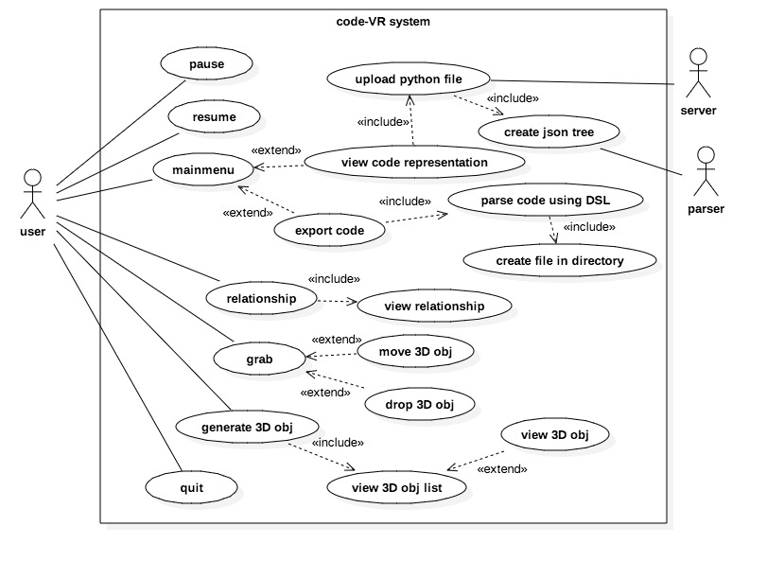

**High Level CodeVR System Use Case Diagram**

## 

The table below show the Unit tests used to verify and validate that the features of CodeVR 1.0 conform to the product owner’s requirements and intended usage.

|  |  |
| --- | --- |
| Test case ID | US670-1 |
| Description/Summary of Test | Variable is Parsed |
| Precondition: | Python source code is provided with a variable declaration & AST is created |
| Expected Results | Parser successfully generates a variable struct for 3D object generation |
| Actual Result | Variable is parsed and struct is generated |
| Status (Fail/Pass) | Pass |

# 

|  |  |
| --- | --- |
| Test case ID | CodeVR_Obj_Animation_001 |
| Description/Summary of Test | To test appearance of objects |
| Precondition: | User is wearing VR set, User is at specified position y, there exists a 3D VR set of objects who successfully appear in CodeVR environment |
| Expected Results | Object shows up. Message showing “Bubble Sort” and CodeVR system maintains objects rendered. |
| Actual Result | Objects shows up, Some objects disappear. |
| Status (Fail/Pass) | Fail |

# 

|  |  |
| --- | --- |
| Test case ID | US701-1 |
| Description/Summary of Test | Lexical Analysis of CodeVR Source Code |
| Precondition: | File containing CodeVR source code as input |
| Expected Results | Lexer successfully tokenizes the source code input |
| Actual Result | Lexical Analysis successfully performed |
| Status (Fail/Pass) | Pass |

|  |  |
| --- | --- |
| Test case ID | CodeVR_Obj_Selection_002 |
| Description/Summary of Test | To test appearance of objects |
| Precondition: | User is wearing VR set, User is at specified position y, there exists a 3D VR set of objects who successfully appear in CodeVR environment |
| Expected Results | Objects show up. Message showing “Bubble Sort” and CodeVR system maintains objects rendered. |
| Actual Result | Popup is displayed, all objects show up. |
| Status (Fail/Pass) | Pass |

|  |  |
| --- | --- |
| Test case ID | US710-1 |
| Description/Summary of Test | Generation of CodeVR Parse Tree |
| Precondition: | File containing CodeVR source code as input & successful generation of token stream |
| Expected Results | Parser generates CodeVR Parse Tree |
| Actual Result | Parse Tree is Generated |
| Status (Fail/Pass) | Pass |

# 

# 

|  |  |
| --- | --- |
| Test case ID | 3D_objtest_001 |
| Description/Summary of Test | To check if CodeVR generate predefined 3D shapes for a given coding element. |
| Precondition: | * Server running * User upload valid python file * Device connected to the internet |
| Expected Results | * 3D shapes generated.   + A gray cube is generated to represent a class   + A gray 3D rectangle is generated to represent a function |
| Actual Result | * A gray cube is generated to represent a class * A gray 3D rectangle is generated to represent a function |
| Status (Fail/Pass) | Pass |

# 

# 

|  |  |
| --- | --- |
| Test case ID | CodeVR_Sys_Menu_001 |
| Description/Summary of Test | To test the start/pause menu feature |
| Precondition: | * User is wearing VR set and Controllers * User is at specified position y * There exists a 3D VR menu who successfully starts and pause CodeVR environment |
| Expected Results | * “Loading...” popup is displayed and disappears after ~1-3 seconds. * Menu shows up. Message showing “Game paused” and CodeVR freezes after pointing start/pause button. * CodeVR resumes when start/pause button is pointed to again. |
| Actual Result | * Popup is displayed * Menu shows up * Game is paused then resumed |
| Status (Fail/Pass) | Pass |

# 

# 

|  |  |
| --- | --- |
| Test case ID | Server_systest_001 |
| Description/Summary of Test | To check if the server start without using sys call |
| Precondition: | Server not running |
| Expected Results | Message “ server was successfully started” |
| Actual Result | Message “ server was successfully started” |
| Status (Fail/Pass) | Pass |

# 

|  |  |
| --- | --- |
| Test case ID | CodeVR_menu_001 |
| Description/Summary of Test | To check if code-VR system pause option from menu behave accordingly. |
| Precondition: | * System in ready state * user launch code-VR * User trigger pause |
| Expected Results | Display menu screen |
| Actual Result | Display menu screen |
| Status (Fail/Pass) | Pass |

# 

|  |  |
| --- | --- |
| Test case ID | CodeVR_menu_002 |
| Description/Summary of Test | To check if code-VR system resume option from menu behave accordingly. |
| Precondition: | * System in ready state * user launch code-VR * User trigger pause * User choose resume option from menu |
| Expected Results | Remove menu screen and user can use code-VR |
| Actual Result | Remove menu screen and user can use code-VR |
| Status (Fail/Pass) | Pass |

# 

|  |  |
| --- | --- |
| Test case ID | CodeVR_menu_003 |
| Description/Summary of Test | To check if code-VR system Quit option from menu behave accordingly. |
| Precondition: | * System in ready state * user launch code-VR * User trigger pause * code-VR display menu * User choose Quit from menu |
| Expected Results | code-VR system exit |
| Actual Result | code-VR system exit |
| Status (Fail/Pass) | Pass |

# 

# 

|  |  |
| --- | --- |
| Test case ID | Code-VR_3Dshape_generator_001 |
| Description/Summary of Test | To check if code-VR 3Dshape_generator Display list of 3D objs user can choose to create |
| Precondition: | * System in ready state * user launch code-VR * User trigger shape generator functionality |
| Expected Results | Display list of 3D objs user can choose to create |
| Actual Result | Display list of 3D objs user can choose to create |
| Status (Fail/Pass) | Pass |

# 

# 

|  |  |
| --- | --- |
| Test case ID | CodeVR_3Dshape_generator_002 |
| Description/Summary of Test | To check if CodeVR 3Dshape_generator generate obj chosen by user |
| Precondition: | * System in ready state * user launch code-VR * User trigger shape generator functionality * User choose 3D obj to be generated |
| Expected Results | CodeVR generate the 3D obj the user chose |
| Actual Result | CodeVR generate the 3D obj the user chose |
| Status (Fail/Pass) | Pass |

# 

# 

|  |  |
| --- | --- |
| Test case ID | grab_001 |
| Description/Summary of Test | check if using the grab, the actor Bob can grab a cube |
| Precondition: | * The code-VR application is in ready state * Bob trigger the grab functionality in range of a 3D obj * Number of 3D objects generated is > 0 |
| Expected Results | Bob grab a cube |
| Actual Result | Bob grab a cube |
| Status (Fail/Pass) | pass |

# 

# 

|  |  |
| --- | --- |
| Test case ID | grab_002 |
| Description/Summary of Test | check if using the grab, the actor Bob can move a previously |
| Precondition: | * The code-VR application is in ready state * Bob trigger the grab functionality in range of a 3D obj * Bob is holding a cylinder after performing the grab action |
| Expected Results | Bob move the cylinder up , down, right and left consecutively |
| Actual Result | Bob move the cylinder up , down, right and left consecutively |
| Status (Fail/Pass) | pass |

# 

|  |  |
| --- | --- |
| Test case ID | grab_003 |
| Description/Summary of Test | check if using the grab, the actor Bob can drop a previously |
| Precondition: | * The code-VR application is in ready state * Bob trigger the grab functionality in range of a 3D obj * Bob is holding a prisme after performing the gram action |
| Expected Results | Bob drop the previously grabbed prisme |
| Actual Result | Bob drop the previously grabbed prisme |
| Status (Fail/Pass) | pass |

# 

|  |  |
| --- | --- |
| Test case ID | relationshipview_001 |
| Description/Summary of Test | to see if user can visualise a simple relationship between two cubes. |
| Precondition: | * System in ready state * User launch the code-VR application * User have a vr controller or working mousepad |
| Expected Results | User see a beam going from one box to the other representing a simple relationship |
| Actual Result | User see a beam going from one box to the other representing a simple relationship |
| Status (Fail/Pass) | pass |

# 

|  |  |
| --- | --- |
| Test case ID | editrelationship_001 |
| Description/Summary of Test | to see if user can modify a simple relationship between two cubes by changing the simple relation source and the simple relation target. |
| Precondition: | * System in ready state * User launch the code-VR application * User have a vr controller or working mousepad * User can see an existent relationship |
| Expected Results | User see a beam going from one box to the other representing a simple relationship |
| Actual Result | User see a beam going from one box to the other representing a simple relationship |
| Status (Fail/Pass) | fail |

|  |  |
| --- | --- |
| Test case ID | CodeVR_Obj_Animation_001_QuickSort |
| Description/Summary of Test | To test appearance of objects and animation |
| Precondition: | User is wearing VR set, User is at specified position y, there exists a 3D VR set of objects who successfully appear in CodeVR environment under Quick Sort text |
| Expected Results | Object shows up. Message showing “Quick Sort” and CodeVR system maintains objects rendered and in animation |
| Actual Result | Objects shows up, Some objects display incorrectly. |
| Status (Fail/Pass) | Fail |

|  |  |
| --- | --- |
| Test case ID | CodeVR_Obj_Animation_002_QuickSort |
| Description/Summary of Test | To test appearance and animation of objects |
| Precondition: | User is wearing VR set, User is at specified position y, there exists a 3D VR set of objects who successfully appear in CodeVR environment |
| Expected Results | Objects show up. Message showing “Quick Sort” and CodeVR system maintains objects rendered and in animation |
| Actual Result | Complete set of objects is displayed, all objects show up. |
| Status (Fail/Pass) | Pass |

# 

|  |  |
| --- | --- |
| Test case ID | CodeVR_Obj_Animation_001_BubbleSort |
| Description/Summary of Test | To test appearance of objects and animation |
| Precondition: | User is wearing VR set, User is at specified position y, there exists a 3D VR set of objects who successfully appear in CodeVR environment under Bubble Sort text |
| Expected Results | Objects show up. Message showing “Bubble Sort”. User can see animation |
| Actual Result | Objects shows up, Some objects display incorrectly. |
| Status (Fail/Pass) | Fail |

|  |  |
| --- | --- |
| Test case ID | CodeVR_Obj_Animation_002_BubbleSort |
| Description/Summary of Test | To test appearance of objects and animation |
| Precondition: | User is wearing VR set, User is at specified position y, there exists a 3D VR set of objects who successfully appear in CodeVR environment |
| Expected Results | Objects show up. Message showing “Bubble Sort” and CodeVR system maintains objects rendered and in animation |
| Actual Result | Complete set of objects is displayed, all objects show up. |
| Status (Fail/Pass) | Pass |

# 

|  |  |
| --- | --- |
| Test case ID | US724-1 |
| Description/Summary of Test | Translation of CodeVR variable declaration to Python |
| Precondition: | Parse tree successfully generated |
| Expected Results | Source to source compiler successfully translates variable declaration to Python |
| Actual Result | Python source code file with variable declarations is successfully generated from CodeVR input |
| Status (Fail/Pass) | Pass |

|  |  |
| --- | --- |
| Test case ID | Synchronization_Bubble_Sort_ Stop_001 |
| Description/Summary of Test | To test appearance of objects and animation |
| Precondition: | User is wearing VR set, User is at specified position y, there exists a 3D VR set of objects who successfully appear in CodeVR environment under Bubble Sort text and under Quick Sort Text |
| Expected Results | Object shows up. Message showing both “Bubble Sort” and “Quick Sort” CodeVR system maintains objects rendered and animation happens |
| Actual Result | Objects shows up, Some objects display incorrectly. |
| Status (Fail/Pass) | Fail |

# 

|  |  |
| --- | --- |
| Test case ID | Synchronization_Quick_Sort_ Stop_002 |
| Description/Summary of Test | To test appearance of objects and animation |
| Precondition: | User is wearing VR set, User is at specified position y, there exists a 3D VR set of objects who successfully appear in CodeVR environment under Bubble Sort text and under Quick Sort Text |
| Expected Results | Object shows up. Message showing both “Bubble Sort” and “Quick Sort” CodeVR system maintains objects rendered and animation happens. User can stop either animation |
| Actual Result | Objects shows up, animation occurs |
| Status (Fail/Pass) | Pass |

|  |  |
| --- | --- |
| Test case ID | US744-1 |
| Description/Summary of Test | Translation of CodeVR function declaration to Python |
| Precondition: | Input has function declaration and parse tree successfully generated |
| Expected Results | Source to source compiler successfully translates function declaration to Python |
| Actual Result | Python source code file with function declarations is successfully generated from CodeVR input |
| Status (Fail/Pass) | Pass |

# 

|  |  |
| --- | --- |
| Test case ID | US744-2 |
| Description/Summary of Test | Translation of CodeVR function call to Python |
| Precondition: | Input has function call and parse tree successfully generated |
| Expected Results | Source to source compiler successfully translates function call to Python |
| Actual Result | Python source code file with function calls is successfully generated from CodeVR input |
| Status (Fail/Pass) | Pass |

# 

|  |  |
| --- | --- |
| Test case ID | US744-3 |
| Description/Summary of Test | Translation of CodeVR variable update statement to Python |
| Precondition: | Input has variable update statement and parse tree successfully generated |
| Expected Results | Source to source compiler successfully translates variable update statement to Python |
| Actual Result | Python source code file with variable update statements is successfully generated from CodeVR input |
| Status (Fail/Pass) | Pass |

# 

# 

|  |  |
| --- | --- |
| Test case ID | US744-4 |
| Description/Summary of Test | Export of Python Code |
| Precondition: | Python source code has been successfully generated from CodeVR parse tree |
| Expected Results | Generated Python source code has been written to disk as a text file |
| Actual Result | Python source code is successfully generated and written to disk as a text file |
| Status (Fail/Pass) | Pass |

# 

# Glossary

**ANTLR4** **(Another Tool For Language Recognition)** - is a parser generator that uses LL(*) for parsing.

**C++** – is a high-level programming language developed by Bjarne Stroustrup at Bell Labs, it adds object-oriented features to its predecessor, C.

**Java -** a general-purpose computer-programming language that is concurrent, class-based, object-oriented, and specifically designed to have as few implementation dependencies as possible.

**JSON** – JavaScript Object Notation; a document format used by certain database systems and networked applications.

**Source to Source Compiler -** A type of compiler that takes the source code of a program written in one programming language as its input and produces the equivalent source code in another programming language.

**Spring Tool Suite** - an Eclipse-based IDE. It provides a ready-to-use environment to implement, debug, run, and deploy applications.

**Unit testing** – is a software development process in which the smallest testable parts of an application, called **units**, are individually and independently scrutinized for proper operation.

**Unreal Engine 4** - A game engine developed by Unreal Games, designed for Microsoft Windows, macOS, Linux, SteamOS, HTML5, iOS, Android, Nintendo Switch, PlayStation 4, Xbox One, Magic Leap One, and virtual reality.

**UScript** – Unreal Engine'snative scripting language used for authoring game code and gameplay events before the release of Unreal Engine 4

**VR** – Virtual Reality is the use of computer technology to create a simulated environment

# Appendix

## Appendix A - UML Diagrams

**Use Case Diagrams**

































**Sequence Diagrams**

Fig 1 : Parsing Python Variable and Generating 3D Object



Fig 2: Python Server



Fig 3 : Pause, Resume Sequence Diagram



Fig 4 : Pause, Main Menu and Quit Sequence Diagram



Fig 5 : Shape Generator



Fig 6 : Grab and Drop Functionality



Fig 7 : Relationship View



Fig 8 : Edit Relationship



Fig 9: Flow of CodeVR Compiler Lexical Analysis



Fig 10: Parsing Language Input & Generation of CodeVR Parse Tree



Fig 11: Execution Flow of CodeVR Source to Source Compiler

Fig 12: Execution Flow of CodeVR Menu Controller



Fig 13: Spawning of Cubes



Fig 14: Spawning and simulation triggering for Quicksort

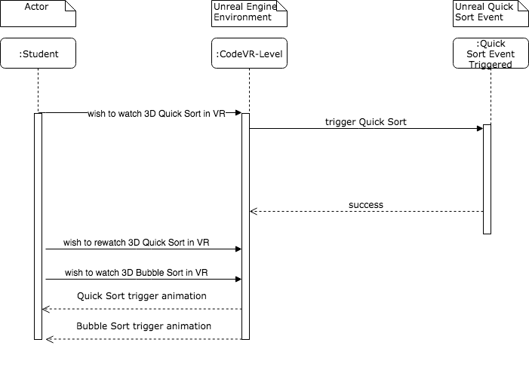

Fig 14: Spawning and simulation triggering for Bubble Sort

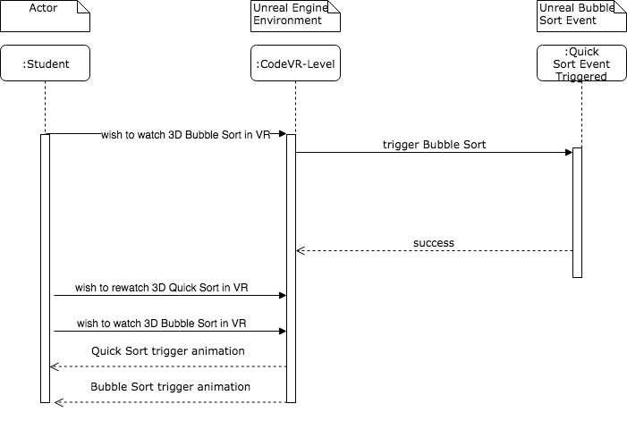

Fig 15: Comparison and simulation triggering for Bubble Sort and QuickSort



**Class Diagrams**



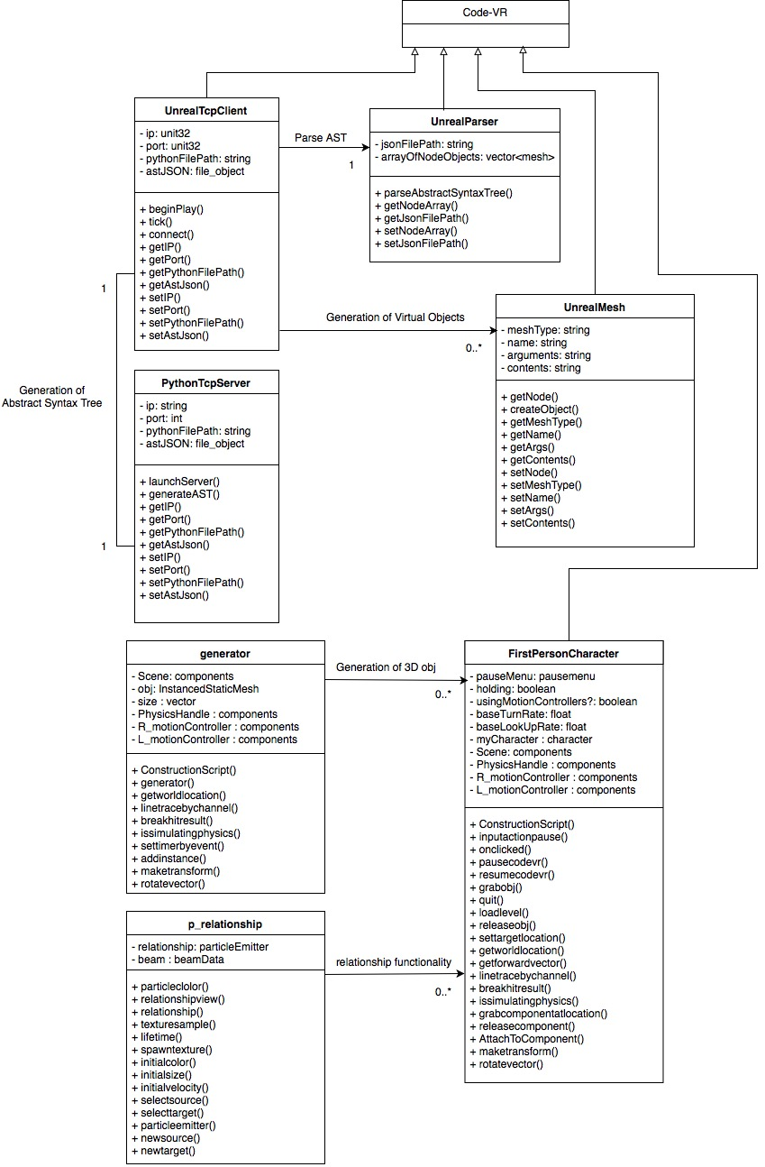





## 

**CodeVR Compiler Class Diagram (Lexer Module)**

**CodeVR Compiler Class Diagram (Parser Module)**

## 

**Complete CodeVR Compiler Class Diagram**

## 

## 

**Bubble Sort Class Diagram**

** VR Version Sort (Bubble and Quick + Compare both) Class Diagram**

## 

## 

## Appendix B - User Interface Design

Click load python file to Upload file



Select file1 or file2 than click back



Click play to automatically generate 3D code representation



Press p from keyboard to pause



After selection of source and target, relationship are shown automatically



Move towards a 3D



Press f from the keyboard to grab



User can move with the grabbed obj and press f from the keyboard to drop



## 

## 

## 

## 

## Appendix C - Sprint Review Reports

### Sprint 1 Retrospective Meeting Minutes

Attendees: Andres Chalela, Rolf Kinder Gilet, Miguel Jardines

Start time: 9:00am

End time: 9:30am

What went wrong?

* Did we do a good job estimating our team's velocity?
  + Yes, we dedicated the estimated 120 hrs/sprint
* Did we do a good job estimating the points (time required) for each user story?
  + No User Stories for Sprint 1
* Did each team member work as scheduled?
  + Every team member did their part in the ramp up process.

What went right?

* Every team member was able to get their development environment set up and get familiarized with the project.

How to address the issues in the next sprint?

* How to improve the process?
  + Communication between members and address problems with product owner early on to get feedback.
* How to improve the product?
  + Continue working with product owner regarding the implementation of the required parser and custom Code-VR language

### Sprint 2 Review Meeting Minutes

Attendees: Andres Chalela, Rolf Kinder Gilet, Miguel Jardines, Francisco Ortega

Start time: 11:00am

End time: 11:30am

After a show and tell presentation, the implementation of the following user stories were accepted by the product owners: All.

* User Story#670 Complete Parser Implementation (Phase 1)
* User Story#666 Embedded Python Server Execution
* User Story#667 VR Controller Menu (Research & Implementation)
* User Story#668 Implementation of Different Shapes

The following ones were rejected and moved back to the product backlog to be assigned to a future sprint at a future Sprint Planning meeting.

* None

### Sprint 2 Retrospective Meeting Minutes

Attendees: Andres Chalela, Rolf Kinder Gilet, Miguel Jardines

Start time: 9:00am

End time: 9:30am

What went wrong?

* Did we do a good job estimating our team's velocity?
  + Yes, we dedicated the estimated 120 hrs/sprint
* Did we do a good job estimating the points (time required) for each user story?
  + No, we underestimated the amount of time required for each User Story.
* Did each team member work as scheduled?
  + Every team member did their part as scheduled.

What went right?

* Every team member focused on their respective User Stories and made progress for the next sprint.

How to address the issues in the next sprint?

* How to improve the process?
  + Consistent communication between team members and provide more specific feedback during the daily SCRUM meetings.
* How to improve the product?
  + Look for available technologies and ideas that may help us with the development of the 3D objects and intermediary language. Get feedback for 3D object implementation via student surveys.

### 

### Sprint 3 Review Meeting Minutes

Attendees: Andres Chalela, Rolf Kinder Gilet, Miguel Jardines, Francisco Ortega

Start time: 11:00am

End time: 11:30am

After a show and tell presentation, the implementation of the following user stories were accepted by the product owners: All.

* User Story#690 3D Shapes Selection (Research of Semantics)
* User Story#694 Update Code-VR Menu
* User Story#691 3D Shape Generator functionality
* User Story#704 CodeVR Compiler Implementation (Lexer Phase)

The following ones were rejected and moved back to the product backlog to be assigned to a future sprint at a future Sprint Planning meeting.

* None

**Sprint 3 Retrospective Meeting Minutes**

Attendees: Andres Chalela, Rolf Kinder Gilet, Miguel Jardines

Start time: 9:00am

End time: 9:30am

What went wrong?

* Did we do a good job estimating our team's velocity?
  + Yes, we dedicated the estimated 120 hrs/sprint
* Did we do a good job estimating the points (time required) for each user story?
  + No, we underestimated the amount of time required for each User Story.
* Did each team member work as scheduled?
  + Every team member did their part as scheduled.

What went right?

* Every team member focused on their respective User Stories and made progress for continuing the product development in the next sprint.

How to address the issues in the next sprint?

* How to improve the process?
  + Continue to interact and communicate regarding progress and quickly address roadblocks.
* How to improve the product?
  + Get familiarized with the Leap Motion technology for 3D object manipulation and interactions. Get more feedback from team & product owner regarding CodeVR language design.

### 

### Sprint 4 Review Meeting Minutes

Attendees: Andres Chalela, Rolf Kinder Gilet, Miguel Jardines, Francisco Ortega

Start time: 11:00am

End time: 11:30am

After a show and tell presentation, the implementation of the following user stories were accepted by the product owners: All.

* User Story#688 Grab and Drop Functionality
* User Story **#710** Code-VR Compiler Implementation (Parser Phase)
* User Story **#711** 3D Algorithm Animation (Physics)

The following ones were rejected and moved back to the product backlog to be assigned to a future sprint at a future Sprint Planning meeting.

* None

### Sprint 4 Retrospective Meeting Minutes

Attendees: Andres Chalela, Rolf Kinder Gilet, Miguel Jardines

Start time: 9:00am

End time: 9:30am

What went wrong?

* Did we do a good job estimating our team's velocity?
  + Yes, we dedicated the estimated 120 hrs/sprint
* Did we do a good job estimating the points (time required) for each user story?
  + No, we underestimated the amount of time required for each User Story.
* Did each team member work as scheduled?
  + Every team member did their part as scheduled.

What went right?

* Every team member focused on their respective User Stories and made progress for continuing the product development in the next sprint.

How to address the issues in the next sprint?

* How to improve the process?
  + Continue to interact and communicate regarding progress and quickly address roadblocks.
* How to improve the product?
  + Continue to get familiarized with the Leap Motion technology and plan the architectural approach to CodeVR Language as a visual representation.

### 

### Sprint 5 Review Meeting Minutes

Attendees: Andres Chalela, Rolf Kinder Gilet, Miguel Jardines, Francisco Ortega

Start time: 11:00am

End time: 11:30am

After a show and tell presentation, the implementation of the following user stories were accepted by the product owners: All.

* User Story #692 Relationship Functionality
* User Story #719 3D Cube Actors Flow Synchronization (Phase 1)

The following ones were rejected and moved back to the product backlog to be assigned to a future sprint at a future Sprint Planning meeting.

* None

### Sprint 5 Retrospective Meeting Minutes

Attendees: Andres Chalela, Rolf Kinder Gilet, Miguel Jardines

Start time: 9:00am

End time: 9:30am

What went wrong?

* Did we do a good job estimating our team's velocity?
  + Yes, we dedicated the estimated 120 hrs/sprint
* Did we do a good job estimating the points (time required) for each user story?
  + Yes, we properly estimated the amount of time required for each User Story.
* Did each team member work as scheduled?
  + Every team member did their part as scheduled.

What went right?

* Every team member focused on their respective User Stories and made progress for continuing the product development in the next sprint.

How to address the issues in the next sprint?

* How to improve the process?
  + Continue to interact and communicate regarding progress and quickly address roadblocks.
* How to improve the product?
  + Continue to researching better implementation for dynamic features

### 

### Sprint 6 Review Meeting Minutes

Attendees: Andres Chalela, Rolf Kinder Gilet, Miguel Jardines, Francisco Ortega

Start time: 11:00am

End time: 11:30am

After a show and tell presentation, the implementation of the following user stories were accepted by the product owners: All.

* User Story #744 CodeVR Language Application (Phase 2)
* User Story #739 Relationship Functionality (Phase 2)
* User Story #743 3D Cube Actors Flow Synchronization (Phase 2)

The following ones were rejected and moved back to the product backlog to be assigned to a future sprint at a future Sprint Planning meeting.

* None

### Sprint 6 Retrospective Meeting Minutes

Attendees: Andres Chalela, Rolf Kinder Gilet, Miguel Jardines

Start time: 9:00am

End time: 9:30am

What went wrong?

* Did we do a good job estimating our team's velocity?
  + Yes, we dedicated the estimated 120 hrs/sprint
* Did we do a good job estimating the points (time required) for each user story?
  + Yes, we properly estimated the amount of time required for each User Story.
* Did each team member work as scheduled?
  + Every team member did their part as scheduled.

What went right?

* Every team member focused on their respective User Stories and made progress for continuing the product development in the next sprint.

How to address the issues in the next sprint?

* How to improve the process?
  + Continue to interact and communicate regarding progress and quickly address roadblocks.
* How to improve the product?
  + Focus on the integration of visual project contributions with the implemented CodeVR source to source compiler

## 

## 

## Appendix D - User Manuals, Installation/Maintenance Document, Shortcomings/Wishlist Document and other documents

All supporting information for the CodeVR 1.0 project can be found within the FIU CIS Youtube Channel, under the CodeVR 1.0 video playlist. As a reference source, we recommend and refer any person interested in the user manual, installation/maintenance, or shortcomings/wishlist information to view the playlist videos.

* <https://www.youtube.com/playlist?list=PLG3lylzOg8Fh5McpkYg4fMIHBub7JnZTu>

# 

# 

# 

# References

1. <https://docs.unrealengine.com/latest/INT/Programming/Tutorials/>
2. <https://docs.unrealengine.com/latest/INT/Programming/Tutorials/UMG/index.html>
3. <https://github.com/antlr/grammars-v4/>
4. <https://greentreesnakes.readthedocs.io/en/latest/>
5. <http://www.dabeaz.com/ply/ply.html#ply_nn22>
6. <https://tomassetti.me/antlr-mega-tutorial/?nab=1&nabr=10>
7. <http://www.antlr.org/>
8. <https://github.com/antlr/antlr4/blob/master/doc/index.md>